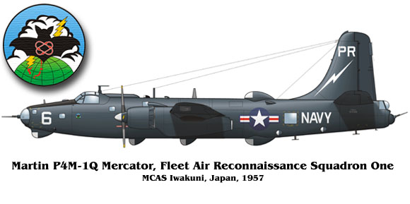

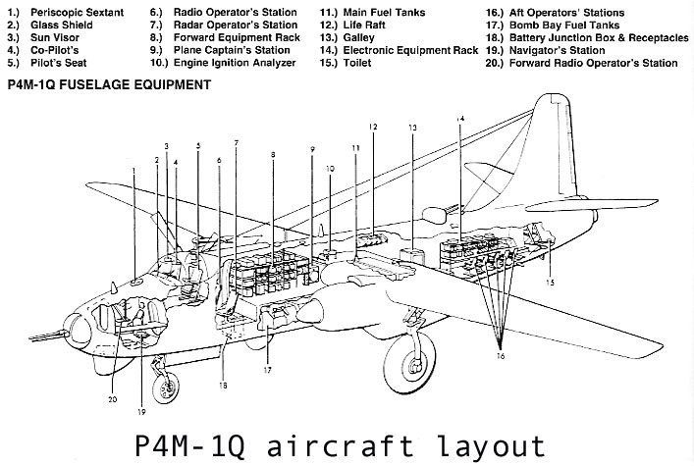

The P4M-1Q Martin Mercator was designed primarily for antisubmarine warfare, and competed with the Lockheed P2V Neptune for Navy procurement in the mid-to late-1940s. The aircraft first flew on 20 September 1946; the last of 21 aircraft bought by the Navy was delivered in September 1950.
VP-21 got the first aircraft. The P4M originally was designed for a nine-man crew. Its propulsion was provided by two Pratt & Whitney R-4360s, producing 3,250 horsepower,
Page 1of 6

and two Allison J-33s, 4,600-pound-thrust engines. It had an operating range of 2,000 miles and a ceiling of 17,000 feet. It could cruise at 150 knots or dash up to 340 knots with all four engines on line.
The Q-configuration was installed in the P4M-1Q that was delivered to the Patrol Unit/NavCom Unit 32G in February/March 1951 at Port Lyautey to replace a PB4Y-2 that was lost near Italy in February 1951. The back-end installation was unsatisfactory, so work to modify the configuration commenced immediately. Four APR-4s and four APR-9s were installed—-each with its own tuning unit and panoramic adapter. An improved intercom system isolated the cockpit and forward stations from the operators and the supervising evaluator. The evaluator could talk to each or all of his operators and the pilot; the pilot could override and be heard by all crewmembers for flight safety.
Each operator position also had a direction-finding capability and a wire recorder. The evaluator had a SLA-1 pulse analyzer that could be switched to receive video and audio signals from any operator position. A camera mounted on the SLA-1 camera harness was solenoid-actuated by the first video signal pulse so that a visual record of an intercept could be achieved. This was an exceptionally useful tool in cases where the signals were of very short duration because it permitted later analysis. Frequency coverage was from 50 to 10,750.
This configuration was incorporated in three additional P4M-lQs, which arrived to replace all of the PB4Y-2s by June 1951. Lieutenant Robert L. Ashford, U.S. Naval Reserve, was the original designer. The configuration eventually served as the basis for the modification of the WV-2 and A-3B aircraft to a Q-configuration (WV-2Q/EC-121M/and EA-3B). These aircraft became operational in the Tactical Electronic Warfare Squadrons, VQ-1 and VQ-2, a few years later.
R. C. M. Ottensmeyer

Commander Ottensmeyer served 28 years on active duty in a variety of aviation electronics assignments. He enlisted in 1939, made Chief Petty Officer on his first hitch, served on board the USS Monterey (CVL-28) and the USS Antietam (CV-36), and helped pioneer carrier on-board electronic warfare capability while assigned to VQ-2 at Naval Air Station Rota, Spain. He retired in 1967 and spent 16 years as a Technical and Operational Consultant with the Pacific Fleet.
******

I joined VQ-2 Oct 24, 1956 in Port Lyautey as an ATAN right out of "A" School. The squadron had four P4M-1Q's at that time. One was lost in Norfolk with four fatalities. That accident is well documented. I was aboard the P4M that is pictured so often lying starboard wing down on the runway in Naples. That accident was as benign as could be hoped for. The squadron C.O., Cdr R.R. Sparks and Lt Ned Rankin were in the cockpit. Capt. (then Lt) John McIntyre was aboard also. P4M crews were made up of five officers and ten or eleven enlisted. Pilot, Co-pilot, Radar Operator, Navigator, and ECM Evaluator. The radar operator and navigator were pilots, as well. The enlisted crewmen were the Plane Captain (later called the Flight Engineer); 2nd Mech; Electrician; Ordinance man; Radioman; and four or sometimes five ECM operators. There was occasionally a 2nd Electrician, though I don't know why.
Page 2 of 6

What happened in Naples, simply, was the starboard gear was not locked down. Since there was a J-34 in the nacelle where a wheel-well normally would have been, the strut folded straight out and up into the wing. The wing fairing was permanently attached to the strut and as a hubcap on the wheel. Thus, there were no wheel well doors. When up, only the tire was visible as a ring on the bottom of the wing.
Landing and roll out was normal that day in Naples until we started exiting the runway and the starboard gear just swung up into the wing, or rather the wing just settled onto the gear. Had we turned left off the runway, the landing gear would not have folded at that time, and since the plane had substantial "toe-in," it might not have folded at all, and the malfunction possibly would have been discovered. There was another Squadron P4M in the pattern and those guys had to divert to Rome for the night. (DAMN the good luck!) After an engine and prop change, the old bird was flown back to Port Lyautey, wheels down, for final repairs. On her first flight afterwards, she was out on a local training flight, minimum crew, and on the twelfth "touch and go, " the pilot lost control, exiting the runway on the starboard side, into and through a ditch, ripping the landing gear completely out. No fire, just a very bumpy ride. The aircraft was recovered and brought back over to our ramp where it was "cocooned," for shipment back to O&R Norfolk. As I recall, it was barged to Casablanca and shipped from there. Once in Norfolk, the decision was made to scrap her. At that point we were down to two P4M's and it was soon after that we were assigned two P2V-5F's. The P4M had a nose and tail turret with twin 20 mm cannon, and a dorsal turret with twin 50's. The dorsal turret was rarely installed, leaving us folks aft with a spectacular viewing port. After we moved to Rota, a plane came back from O&R. That terrific bubble had been replaced by a radome and had some new jamming equipment installed. I had been assigned to build a mock-up of the ECM compartment of the P4M to train operators, which occupied all my time. Subsequently I know nothing of that new gear.

J. Adron Joyner, CWO4, USN (Ret)

Page 3 of 6

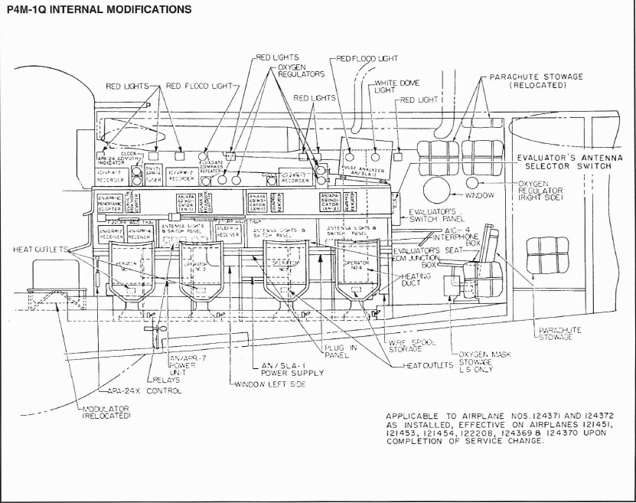

Page 4 of 6

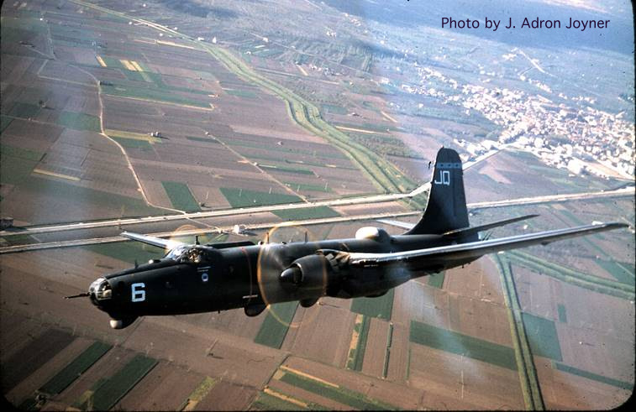

Page 5 of 6
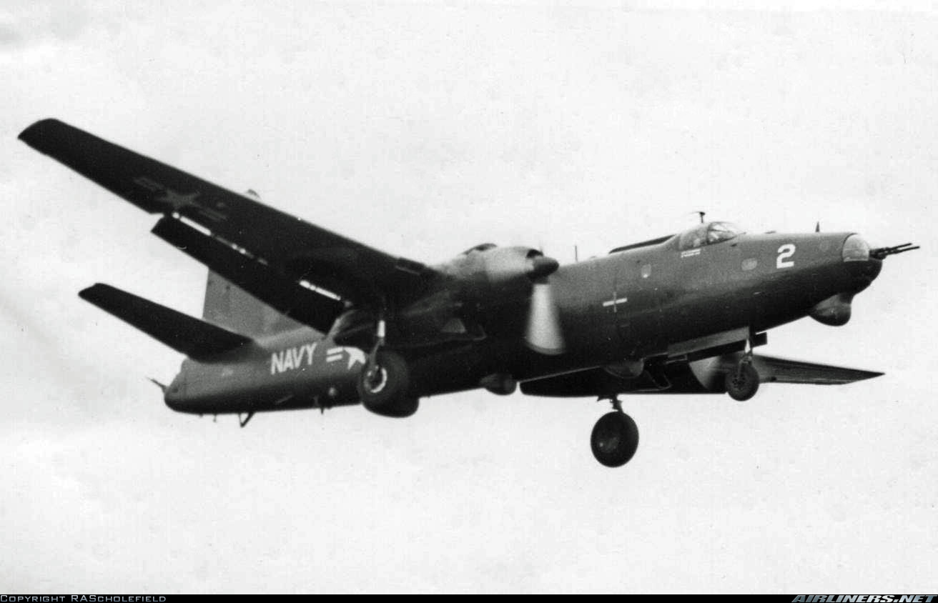

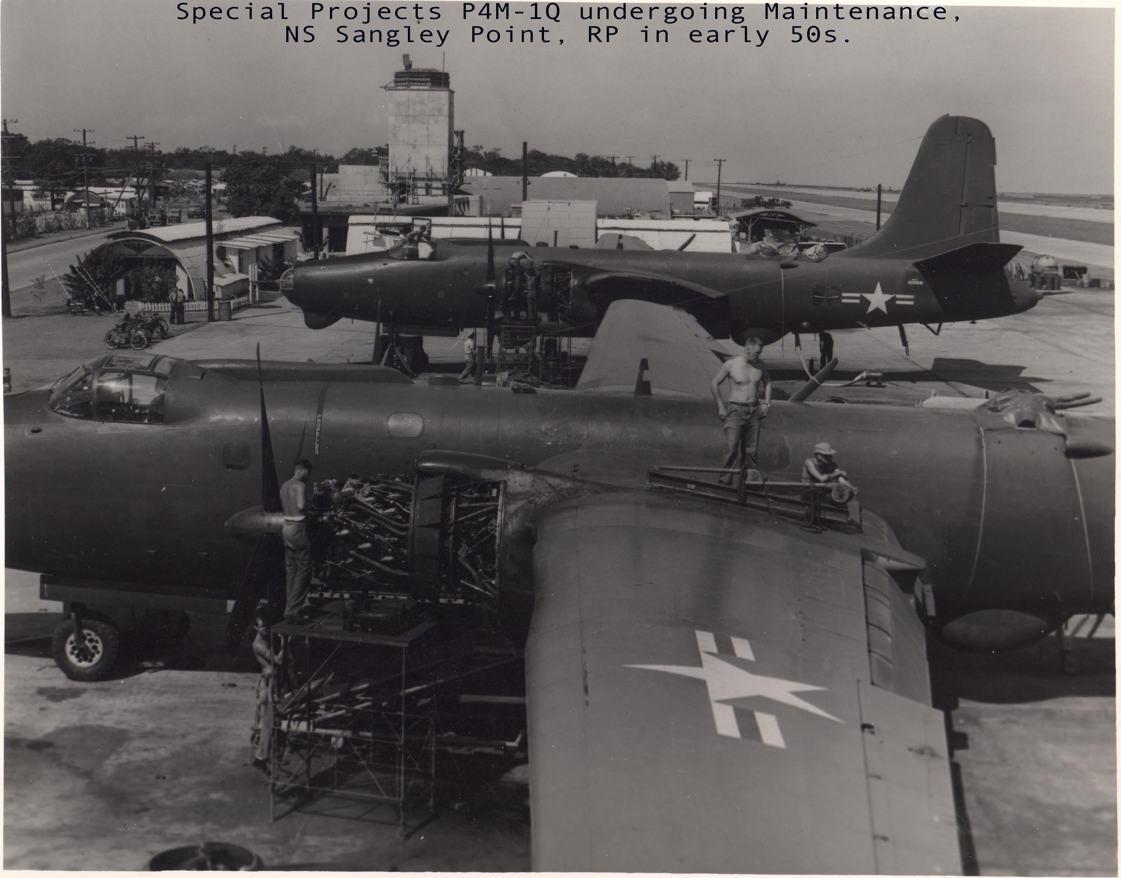
Page 6 of 6

