A3D-1Q Layout

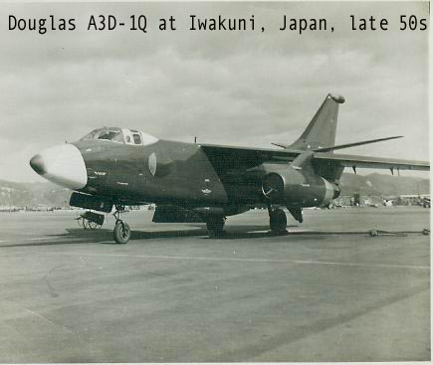

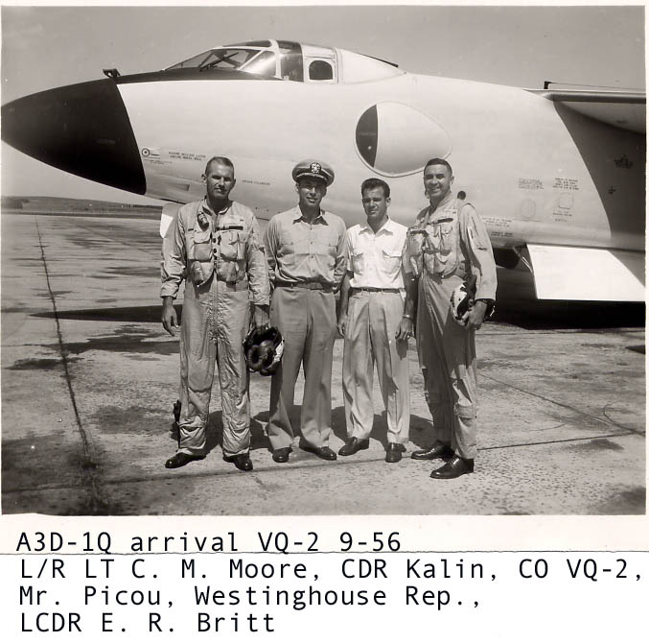
Photo from Don East, CAPT, USN (Ret)
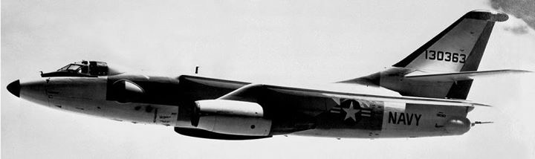

A3D-1Q at Port Lyautey, French Morocco

The layout of the A3D-1Q was as follows: The Officer Operator/Evaluator sat starboard side behind the B/N and the enlisted operator sat behind the pilot. The two operators sat facing aft, back-to-back with the guys up front. I don't recall what the Evaluator operated, but the enlisted operator worked with a pair of APR-9's, and as previously mentioned, the ALA-3. We did work with some Army ECM Specialists in Incirlik, but they flew the P4M's and later the P2V's. We were primarily keeping track of search radars which were moved up and down the north coast of the Black Sea, and trying to glean as much data about the fire control radars in the area as well. After Sputnik I, we concentrated on their space efforts.

When I joined the squadron, VQ-2 had two A3D-1Q's. The 1-Q had a pair of 20MM cannons in a tail turret, controlled from the cockpit by the BN. The A3D-1Q was indeed a four man aircraft. Pilot, Bombardier/Navigator, and two ECM operators - one enlisted and one officer, who was also the Evaluator. The enlisted operator was generally a senior Petty Officer, and I was the only one of my generation to get into that fraternity. My A3D "career" was cut short by the loss of both aircraft, one on approach to Incirlik AFB in Adana, Turkey with the loss of all four crewmen - well documented - and the other, again, in an accident on a local training flight in Port Lyautey. The aircraft sustained a broken back and sat on our ramp covered with a tarp for months. And I really don't remember what happened to it.

We got an A3D-1 in to replace the lost 1Q, and it only had three seats, with a "bucket seat" behind the pilot. Some reconfiguration was performed, but I don't really know to what extent. I was pretty busy standing code watches at Incirlik, maintaining my own gear and airplane, and scrambling whenever the Ruskies got ready to try another space shot.

The A3D-1Q had an ALA-3 signal analyzer instead of the APA-74 as in the P4M. The ALA-3 only had three sweeps and was considerably smaller than the APA-74, which had five. All other ECM gear was the same as the P4M, as I recall.

Adron Joyner, CWO4 USN (Ret)

A3D-1Q, P4M-Q and P2V-5F At Shemya

I worked on two P2V-5Fs during 1958 putting five operating stations in the aft cabin for telemetry collection on flights from Shemya. We started that effort in 1957 with P4M buno 124366 and an A3D 1Q buno 131363. We were operating the P4M at 33,000 feet for about twenty-five minutes and then would return to base at low fuel state. The basic configuration of the collection positions was four AN/FLR- 2 Nem's Clarke receivers and APA-74 Pulse analyzers used for signal Identification. We had a pair of VHF antennas mounted on the side of the aft fuselage that stuck out about four feet and were over 10 feet long. We also had an AMPEX model 807 "wideband" tape recorder. Prior to getting the -807's we used wire recorders.
So the operators could survive at the altitude, we also installed a complete gaseous oxygen system in the back end along with equipment racks, and virtually all the work was done in house with squadron folks. The project was headed by Lt. John Ballard and Lt. Bill Wickham ( I think that's right) Unfortunately the P2V at Shemya was struck when the hanger door fell on it during a late season typhoon, and right after that the US Army showed up with specially configured A3D 2-Q's.
The A3D-1Q was a real work of art. We constructed an "I" beam bar about 18 feet long to mount the same style antennas on as we had on the P4M and later on the P2V's. The bar was designed to mount in place of one of the twenty millimeter guns in the tail turret of the AERO 21B self protection gun/radar system. The bar went through the turret and into the inner a/c structure for rigidity. It was later determined the "bar" caused some internal structure damage and the “Q” basically retired it when the Army birds arrived.

Charles “Chuck” Christman, VQ-1 Special Projects

Fleet Air Reconnaissance Squadron TWO (VQ-2) and ECMRON
TWO ECM-2
I talked to some crewman who flew her and a Plane Captain from VQ-2 John Snook provided me some insight.
Five of the earliest A3D-1's BUNO #'s 130356, 130361, 130362, 130362, 130363 were delivered to NAS Norfolk shortly after acceptance by the Navy for conversion into the A3D-1Q Electronic Reconnaissance Aircraft. These bureau numbers were to be converted from A3D-1's to A3D-1Q's. This basically consisted of removing the rake from in front of the bomb bay doors, installation of the antennas (one of each side of the aircraft, one on the starboard bomb bay door, one on top of the vertical stabilizer), rerouting of some of the hydraulic plumbing (the bomb bay doors could be opened and closed by using the emergency hydraulic pump only and could not use the main utility hydraulic reservoir) and removal of the bombsite.
Both bomb bay doors could be opened. Generally, the starboard door with the antenna on it stayed locked up and only the port door opened. The starboard door with the antenna on it once unlocked would drop by itself due to the weight of the antenna on it without using the pump. However, the pump had to be used to close it.
The huffer start unit was carried on a bomb rack above the port bomb bay door. We did attach a curved tailpipe on it to direct the exhaust gases out of the bomb bay (the bomb bay racks were left in the -1Q after conversion from the -1). After starting both engines, the huffer was shut down, the hose thrown up into the bomb bay and the port door was closed using the emergency hydraulic pump (DC electrically powered pump).
The A3D-1Q could be operated from an aircraft carrier, but we did not do it. The reason given at the time was the fragility of some of the gear on board.
There were four seats in the A3D-1Q (same as the -1). The pilot forward left side, the navigator, forward and slightly aft of the pilot (no bombardier due to no (bombsite). The third seat was directly aft of the pilots seat on the left side facing aft. In front of him was the Aero 21 Baker gear that controlled the 20 MM guns on the tail (this was the same for both the -1 and -1Q). The fourth seat was on the right side facing forward. The back of the seat was the aft bulkhead of the cockpit. Who flew in these seats on a mission varied, but they were generally officers and enlisted from the AQ and AT ratings.
A3D-1Q were designed to perform Signals intelligence (SIGINT) is intelligence gathering by interception of signals, whether communications between people (Communications intelligence—abbreviated to COMINT) or from electronic signals not directly used in communication (electronic intelligence—abbreviated to ELINT).

