Squadron Logos of VQ-2

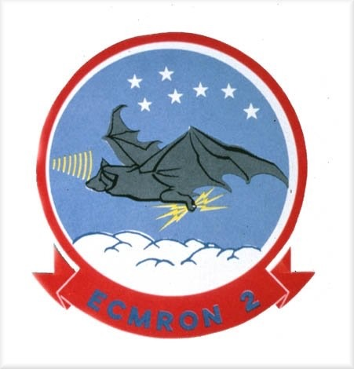

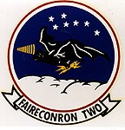

The "Electric Bat" was adopted in 1959 as ECMRON TWO's squadron logo. The bat symbolized the totally black Martin P4M-1Q Mercator, which initially flew at night and often unmarked. The background represents the blue night sky with the clouds and Big Dipper representing high altitude flight symbolizing undetected presence. The lightning bolts represent electronic reconnaissance. The outer ring is red for of the original red field of the squadron flag flown while VQ-2 was home ported in Port Lyautey, French Morocco. The red field duplicates the French Moroccan flag's solid red background with a centered five-pointed golden yellow star centered.
The squadron logo was designed by LTJG Carl Bockenhauer, who was killed in 06 OCT 58 in the crash of A3D-1Q Skywarrior Buno 130356 (JQ-1), staging out of Incirlik AB, Adana, Turkey. Also lost:
LCDR Charles M. Moore,
LTJG. Charles B. Lynch,
AQ1 Charles S. Stomski.

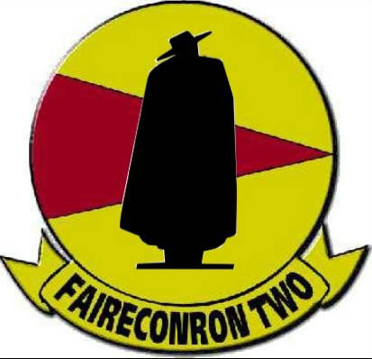

A logo (above) that has long been associated with VQ-2 is the Spanish Sandeman, a somewhat sinister silhouette of a man in a long cape and a Spanish influenced hat raked low over the figures eyes. The original rendering of the Sandeman can be traced to the mid-sixties when VQ-2 sent crews from Rota, Spain to supplement VQ-1s commitment in Vietnam.
Due to security considerations, squadron markings couldn’t be worn on the Det. To set VQ-2 personnel apart from their VQ-1 brothers, an innocuous logo was devised to suit this purpose! Dan Savcki writes; "My first deployment to Det B, Republic of Vietnam occurred in August 1966. The pilot was Jack 'Rip' Taylor, NAV LT Christesen, EVAL LCDR Bueche, PC Harry Curtis, Operators, Tim Ziller, Jeffery (JC) Park and me.
Tim said we needed a crew hat and "any ideas?". The road to Jerez (a town outside the base at Rota) was lined with Bodega billboards, Osborne Bull, Gonzales Bypass, Tio Pepe and the most obvious ringer for the squadron; The Sandeman. I said, “The Sandeman.” I think JC was the one who had the patch and hat made. Mine made it to about 1988 when it was stolen while I was at work.
It will be an interesting read to find out when and the circumstances of the squadron logo change to the real Sandeman. I assume the winery gave approval. I probably learned of the switch in the 90's. The old brain cells reactivated about our hats and just another tidbit, so no one would confuse us as VQ-1 and we couldn't put VQ-2 on, Ziller added SEF above the logo and TBSA in the back above the strap. The SEF stood for, Spanish Expeditionary Force and the TBSA was, The Bat Strikes Again.

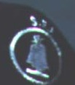
First prototype of Sandeman patch as it appeared on a ball cap in 1966. Not quite legible are the initials S. E. F. that stands for, Spanish Expeditionary Force

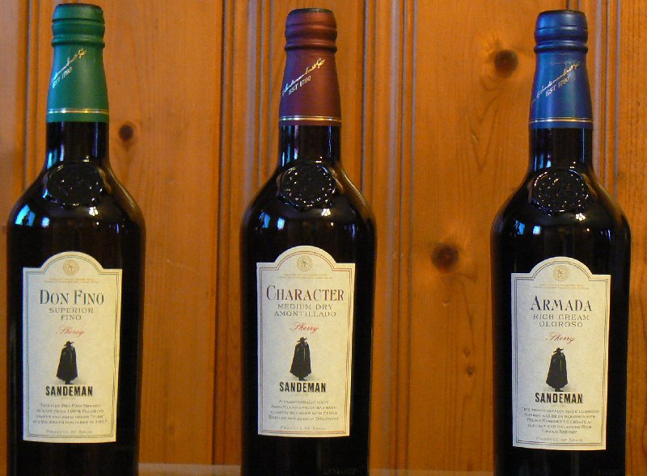
The Sandeman, as it appears on bottles of Sherry, the inspiration for the logo sported by VQ-2.

