VQ-2 Tour in early 1953
By LCDR John F. Hewson

At the time I was in the squadron, it was based in Port Lyautey, French Morocco, along with the French Foreign Legion.
Included in the P4M crews were three pilots, a language interpreter and those aft included a technical officer, and four technicians using wire recorders. We often worked at the advance base at Nicosia, Cyprus where the missions were to operate in bad weather and at night. We plotted aircraft and Russian RADAR in the Black Sea. On those missions the linguist would often hear, “shoot them down” or “let it go.” We also used bases in Wiesbaden, Germany, Gibraltar, Malta, Naples and Greece.
Our quarters on the base at Port Lyautey were Quonset Huts. Newly arrived wives were given a “welcome aboard” party in a French cabaret, served champagne, escargot in olive oil, and french bread in the Cork Forrest. We had an Arab “houseboy” who arrived daily at 6am to make and serve mademoiselle her breakfast in bed!
In Morocco the French developed the railroad, highways, resort hotels and modern facilities. The last was the fez, macrness, oujar and Casa Blanca. The base of the French Foreign Legion at Port Lyautey was like something out of Beau Jeste. Bugle sounds were played from early morning until taps. The Sultan of Morocco would parade his troops, brightly attired in red tunics, in from the desert, to compete with the troops of the French.
On one trip to Tangiers, the wives had their chance to ride camels. A Boy Scout troop was established at Port Lyautey. Our son got most of his merit badges there, leading up to Eagle Scout.

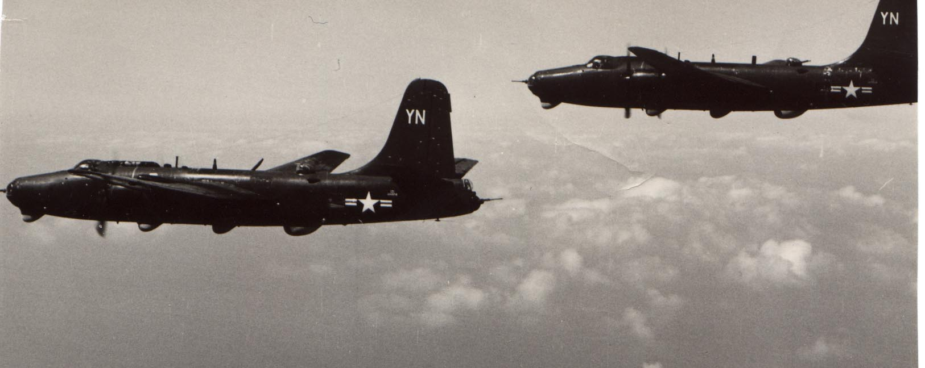
VQ-2 P4M-1Q photo taken in 1953 and was submitted by John Hewson. Notice the bogus tail letters on the vertical fin.

