A “Dog” Story on ECMRON ONE’s Move to Iwakuni, Japan

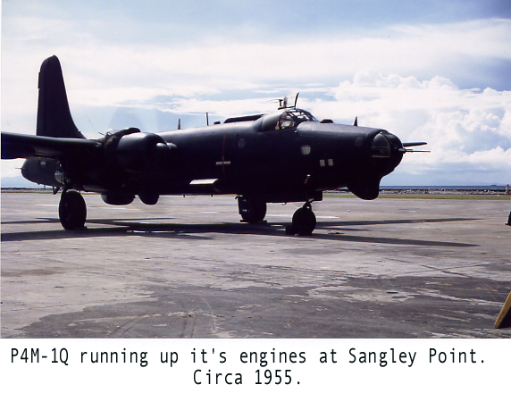

Skipper Hall had a great big dog, I think a boxer that must have weighed a 100 pounds at least. The morning we left Sangley, he brought him down to the airplane and we boosted him up by the cockpit. The skipper put his flight jacket down on the deck and the dog turned around about twice and lay down and went to sleep.
He didn’t stir until about four hours out when the ordanceman (Duke Carron) started cooking. Duke passed the dog a couple of raw steaks and he wolfed them down and went back to sleep. It usually took us about seven hours from Sangley to Iwakuni and I was starting to wonder what would happen if he walked over to some black box and watered it down? I didn’t need to have worried! When we landed at Iwakuni, we lifted him down and he trotted over to a main mount, lifted his leg and created a puddle about six feet across.

William “Bill” Langland, ADCS USN (Ret)

