VQ-2 in the Mid-Fifties

When Sputnik I went up, the whole world got excited, and we set up a permanent Det at Incirlik. We maintained a 24/7 code watch, reception only, to alert us when the Ruskies were going to launch. I don't know where the dude was or how he got his information, but he could, and did, tell us when there was a five minute hold in the count-down . . . really. Anyway, with at least two P4M's or later, two P2V's and an A3D to support on the other end of the Med from homeplate, we had a lot of coming and going.
We did indeed get an old P2V-3 to serve as a "COD." It ran back and forth delivering parts, people and mail. It was a cumbersome old bird, and watching it take off was like watching a "gooney-bird" learning to fly on Midway Island. First it would drag one wheel off, then it would settle back, then another straining attempt. Finally she would get all three wheels off the ground and you could almost see the wings flapping, struggling to stay airborne. She sure carried a lot of stuff up and down the Med, though.
When we got the P2V-5F's, we immediately began modifying them. We built "clothesline" antennae and hung them on the JATO racks on the starboard side. They were di-poles sticking out from the fuselage a good four or five feet and were about 12 feet long. I remember the pilots bitching about, "15 degrees trim just to stay on the runway during takeoff." We also built one for the A3D and hung it from both sides, sticking out the back of the Aircraft. That booger was built like the frame of a four-legged tee-pee, extending out the back of the plane eight or ten feet. (See image below) It's a small wonder we didn't kill more people than we did.

Adron Joyner, CWO4, USN (Ret)

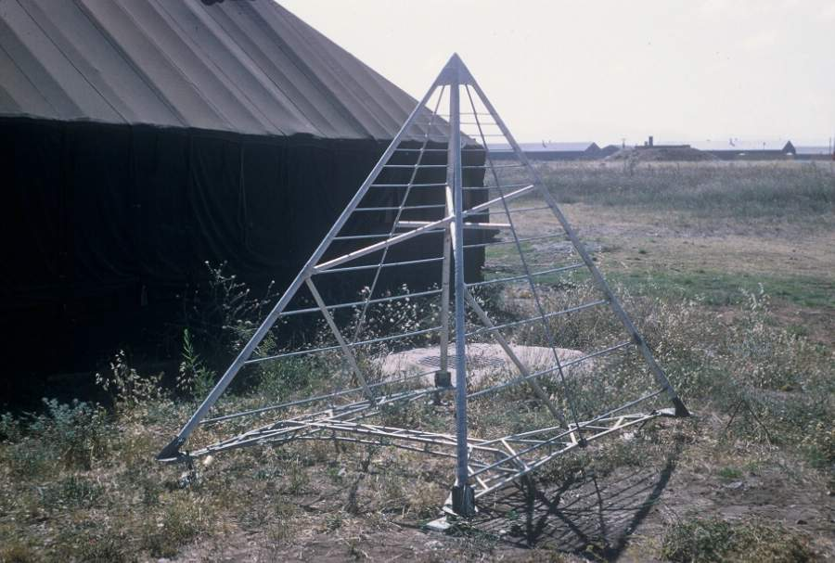

Fabricated antenna used on the A3D-1Q at Incirlik, Turkey

