Port Lyautey, French Morocco

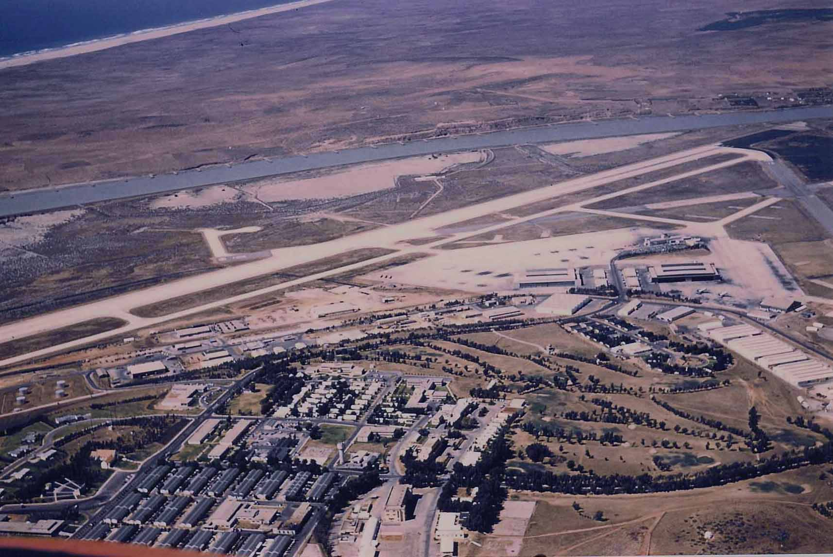

This picture of NAS Port Lyautey stirs many memories for me. After all, it was where I really began my Naval career, and where Bonnie and I laid the foundation for our life together. Beyond the runway lies the Sebou River, and, in the upper left corner, there is a glimpse of the Atlantic. It doesn’t appear to be so, but a range of hills between the river and the Atlantic blocked any view of the ocean from the base. Most likely, people who did not fly had no idea we were so close to that beach, which was deserted and stretched to Tangiers, 135 miles to the north. The beach was inaccessible, anyway, being cut off by the river to the south, and about a mile of sand dunes to the nearest road leading north. Pity . . . it was a beautiful beach and I made it one time, that trip being covered in another “page.”

To follow my memories of the base, start in the lower left corner of the picture. The red streak is most probably a reflection in the window of the aircraft from which this picture was taken. The building in the corner was the Navy Exchange, (first sidewalk). Behind the Exchange was the dry cleaner, a couple of other shops with the commissary on the far left end, out of the picture. You can see a back corner of the commissary protruding into the picture. Barracks folks didn’t patronize the commissary very much, but for Bonnie and I, it was our life’s blood. As I recall, we budgeted $20 per month for the commissary. (Impossibly low, it seems, but bread was nine cents.) The American Express banking facility (where we bought “Green” before going on detachments) was on the upper right corner of the Exchange building. The second sidewalk probably went to a rear entrance. We went up the steps from the street to a covered landing and turned right into the American Express, straight ahead into the main entrance of the Exchange, or to the left around the corner on a covered walkway. There was another entrance to the Exchange around on the left side, where the parking lot was. That street came in from the back gate and passed the MCB theater, swimming pool, EM Club, and Gymnasium, not shown. Going on past the Exchange, the “spoked” looking structure on the left, is the outdoor theater. The Chapel is next on the left, and it looks like we had plenty of parking for both. I think our barracks was the second from the street, directly across from the Exchange. That white structure amid the rows of barracks was the chow hall. All the buildings behind the row of trees in back of the chow hall belonged to the French Air Force. There was a Bocce Ball court there under the trees, where the older petty officers spent quiet evenings.

Back to the street in front of the Chapel - - That intersection was to the road coming up from the main gate, by the golf course, which is all that empty looking territory outlined by trees. It was not very green when the picture was taken. About halfway between the intersection and the water tower, our recreation center, the Oasis, was on the left, there about under the trees. On past the water tower, a street curves back to the left (towards the top of the page). That street dead-ends in the parking lot of the BOQ. I was there one time, a Sunday afternoon, while on duty driver duty, looking for one of the J.O.’s. He was out back in shorts, no shirt, waxing his “sports car“, a Triumph, and having a beer. I thought, “MAN! . . . what a way to live!”

The road across from the chapel went down the hill by the golf course through a line of cork trees on each side to the main gate. There was an intersection at the bottom of the hill where a road went to the hangars, by-passing the “base” so to speak. That was quicker and closer for me to go to work, but I most always went up the hill and around. There was a bus stop up there, across from the chapel, easily seen in the picture, which is why I went that way. I would stop and pick up five sailors waiting for transportation to the hangars. That old Plymouth had plenty of room. The lower road went along by the supply depot, visible on the right side of the picture. The Commissary maintained a “Quick-Stop” along there somewhere, milk, bread, eggs, etc.

Back to the intersection by the Chapel, proceeding towards the top of the page, the bus stop I mentioned is visible. Then moving on to the next intersection, I have no idea what those large white buildings on the right were. I don’t recall ever being on that street that circled around behind the chapel and exchange, so have no idea what was back there either. I guess we were so attuned in VQ-2 to minding our own business and not poking around where we didn’t belong, I didn’t explore as much as I normally would have. Now I wish I had.

Just past the next intersection, the building on the left with the curved drive was FICELM or Fleet Intelligence Center, Eastern Atlantic and Mediterranean. That’s also where the NIS folks hung out. (Naval Intelligence Service. Mostly, if not all, civilians.)

At the next intersection, a street turned to the right, but you can’t see it for the trees. It went to NAS Admin, a large building, hardly visible in the picture because it blends so well with the ground behind it. Those rows of little white buildings in the block across from the Admin building are Quonset Huts - - enlisted housing. Chief Smith lived in one of them and I was there once, on a weekend, again when I was duty driver.

Finally, down the hill past more of the golf course and, what I think was the Officer Housing area, to the hangars and terminal.

There are two things that date this picture for me to 1959-1961. First off, those small trees along the left side of the road were just knee-high bushes when we were there. It was called “Vultures Row,” and we would stop there and watch planes taking off or landing . . . particularly whenever someone had declared an emergency. The last time I was in Port Lyautey (1965 or 66), those trees were so tall and thick, you couldn’t even see the runway from there. The other thing dating the picture, for sure, is VQ-2 is gone. Our move to Rota was completed in early 1959. It looks like VR-24 had moved over to our hangar, near the terminal, as there are no planes over on their side and there are a couple on “our” ramp. They were flying R5D’s when we were there and had transitioned to R4Q’s (“Flying Boxcars), which those planes definitely are not, then to C118’s and C-130’s by the time they transferred to Rota in 1963.

Lastly, I am pretty sure Pete Owen made this picture. AL2 Owen was a legendary “homesteader” in VR-24, and spent, as I recall, nine years there. Not able to pass the AT1 or AT2 exam, he was eventually changed to RM2 and sent to NavComStaBagDad in Iraq. He then managed to pass the AT2 exam, finagled orders back to Port Lyautey, albeit VQ-2, where I knew him. Within months, he was back in VR-24. Both Pete and his wife, Rose, have now made their last “flight west,” but after retirement, they made a pretty good living organizing VR-24 and NAS Port Lyautey reunions. I saw him last at a reunion in Pensacola in 2001 or 2002.

Not shown in the picture - the area below - would be the MCB Theater, the EM Club, the swimming pool, gymnasium, football field, and NAS theater, where movies were shown when it got too cold for the outdoor theater.

Life in Port Lyautey was an absolute joy for Bonnie and me. Our standard of living was actually higher than it had been back home in Tennessee. Neither of us had had indoor plumbing back home, for instance. The Moroccans liked us and the French tolerated us. Despite the occasional long detachments to the other end of the Med, we were happy. We might spend one week-end on Media Beach and the next one skiing up in the Atlas Mountains near Ifrane. With flight pay and a generous “overseas” allotment, we had no money problems as we very likely would have had stateside. Plus, with it taking two weeks to get a letter to and from home, parental interference was non-existent.

A couple of times we took the mail plane to Gibraltar for a few days, then the ferry over to Tangiers, and finally back to Port Lyautey by train. In the summer of 1958 we took a Med Cruise aboard the MSTS Alexander Patch, and spent a week in Naples and Rome.

The Moroccan countryside was a wonderland for week-end touring. Gasoline was about 12.5 cents, the roads were good, and hotels were very inexpensive. The locals treated us very well and we always tried to return their courtesy. Never once was I concerned about our safety or well-being, although at times there would just be the two of us out in the “boon-docks” among the natives.

For a couple of love-struck kids (19 & 16) who had just made good their escape from the backwoods “hills and hollers” of East Tennessee, Morocco was a glorious three year honeymoon.

J. Adron Joyner, CWO4 USN (Ret)

