VQ-1 Pilots Fly The TV-2 - Page 34 - Naval Aviation News - January 1958..." WebSite: http://www.history.navy.mil/nan/backissues/1950s/1958/jan58.pdf [12AUG2004]
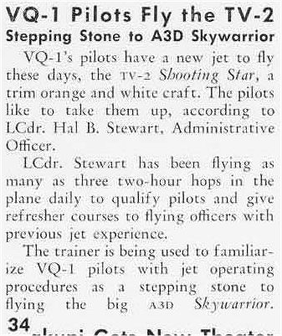

Donald L. Morgan writes: Hal checked me out in the TV-2 in January 1958. He left the squadron soon thereafter and for many months I was the only aviator checked out in “my plane”.

Page 1 of 2

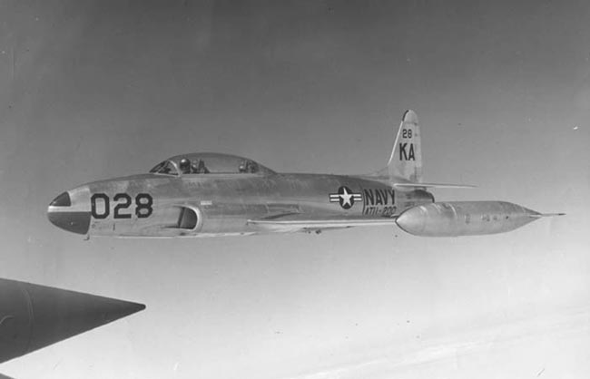
Representative photo

Page 2 of 2

