VQ-2 P2V-5F Operations at Incirlik, Turkey

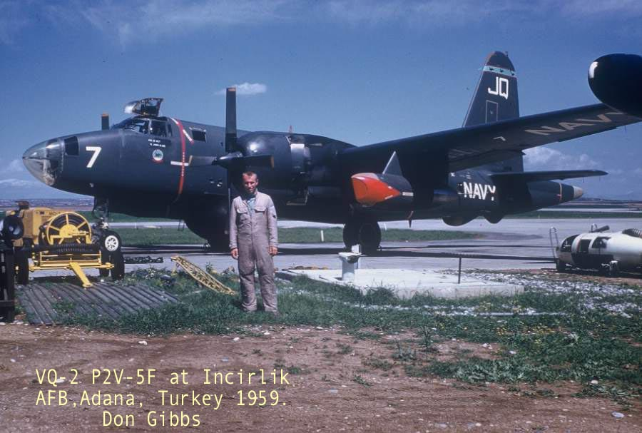

P2V-5F Operations in VQ-2 by Don Gibbs

My tour of duty in VQ-2 started in April 1958. I was assigned to a P2V-5F crew as a flight electrician. Other people on the flight crew that I remember was the plane captain, Norm Brown, second mechanic, Art Shrock, and radar, George McMurtrey.

A lot of our flying was done out of a detachment at Incirlik, Adana, Turkey. On the missions we flew from there we usually had Army operators (SAD-2 I believe) flying in the backend.

Some of the missions were pretty interesting to say the least. Altitude was a premium for signal coverage so we would go as high as we could with the two R-3350 reciprocating engines turning and two J-34 jets burning. This would get us to about 28,000 feet, but with the jets on the line, we couldn’t stay on station very long. The shortening of the mission certainly didn’t bother me. The aircraft was unpressurized, so at that altitude some of us were dependent on portable (walk-around) oxygen bottles in order to breathe. Besides that, all we had were summer flight suits or dungarees that didn’t provide much warmth at 28K.

I remember another time, when returning from a mission in a P2V-5F, the landing gear was lowered and a malfunction in the starboard nose wheel door caused a failure in the linkage for that door. The landing gear worked fine, but the door wasn’t attached to anything.

As replacement parts were a long way away, both in time and distance, we came up with a temporary fix. We attached ropes to the front and rear brackets which were still on the door. On takeoff, the electrician and 2nd mechanic (both expendable, I guess) would be in the nose tunnel crawl way. There, we had a broom handle that we used to hold the door open until the landing gear came up. Once the gear was up and locked, we pulled the door closed with the ropes, and then secured the door in the up position.

On landing, we had to untie the ropes and then push the door open with the broom handle. We would then notify the flight station and they would lower the landing gear. Once this was done, we had to hold the door open with the broom handle to prevent damage to the door.

I don’t remember how many missions we had to do this on, but it took quite awhile to get the parts as they were not high usage items, plus we were on Detachment and the logistics weren’t that good.

In 1960 the P2Vs were on their way out as new A3D-2Q and WV-2Q aircraft were starting to come on board. I left VQ-2 in October 1960.

