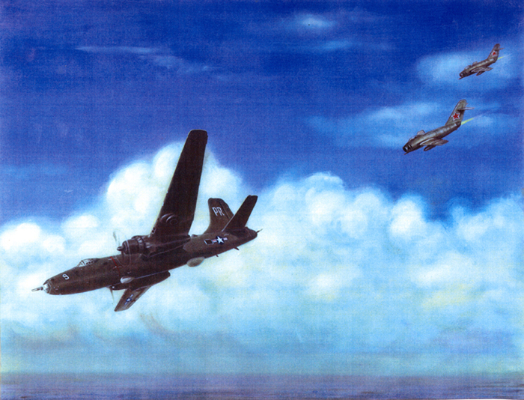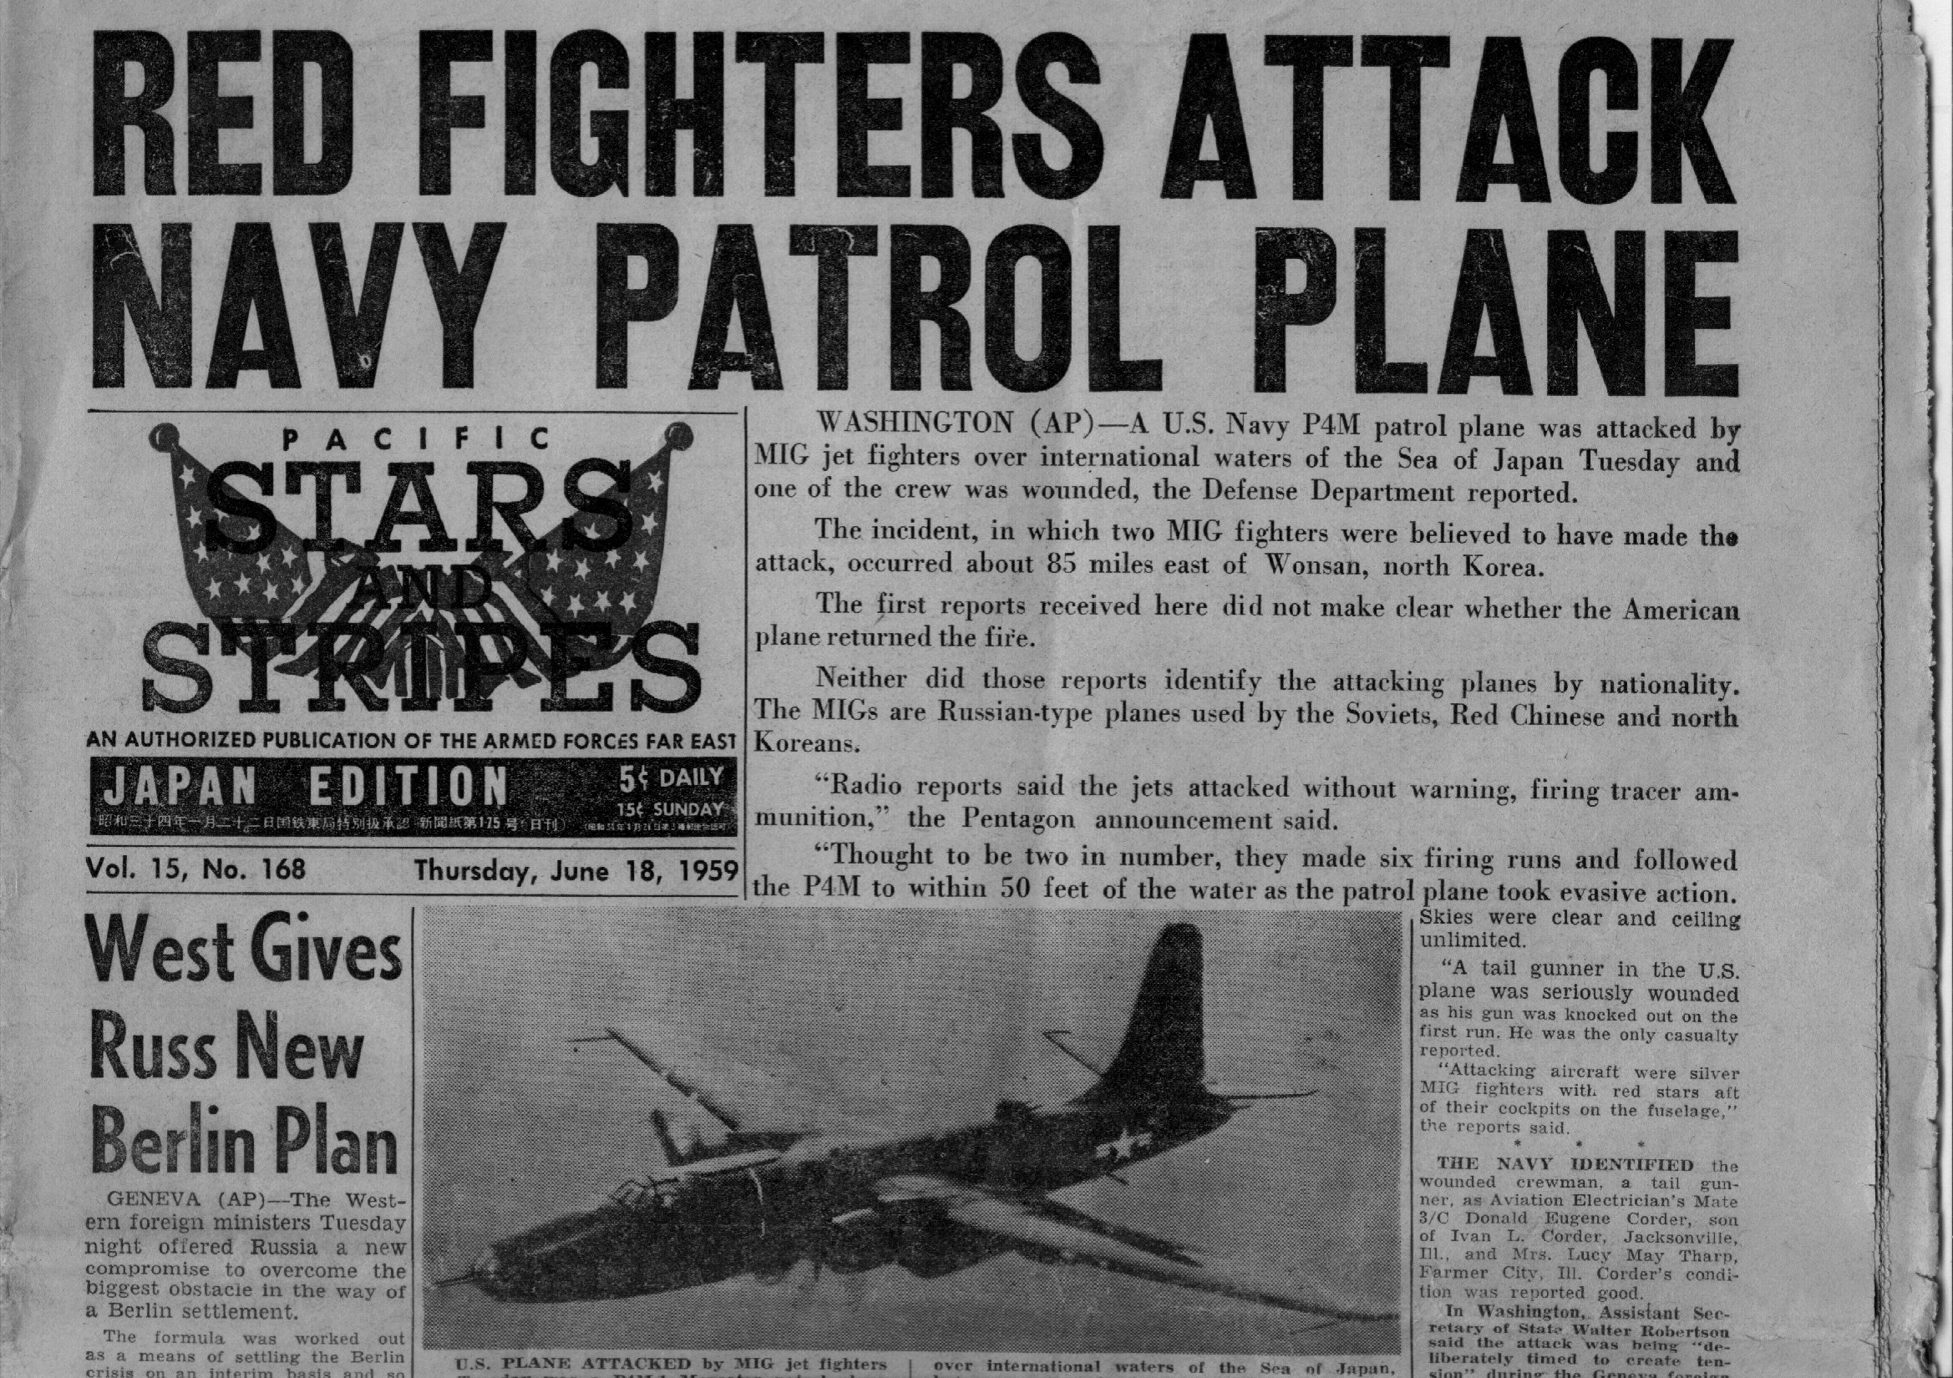
Page 1of 5
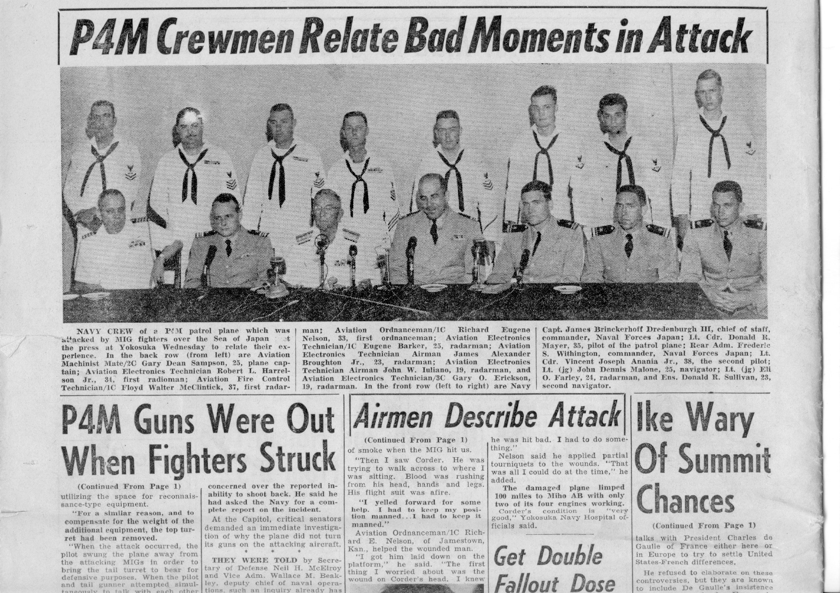

Page 2 of 5
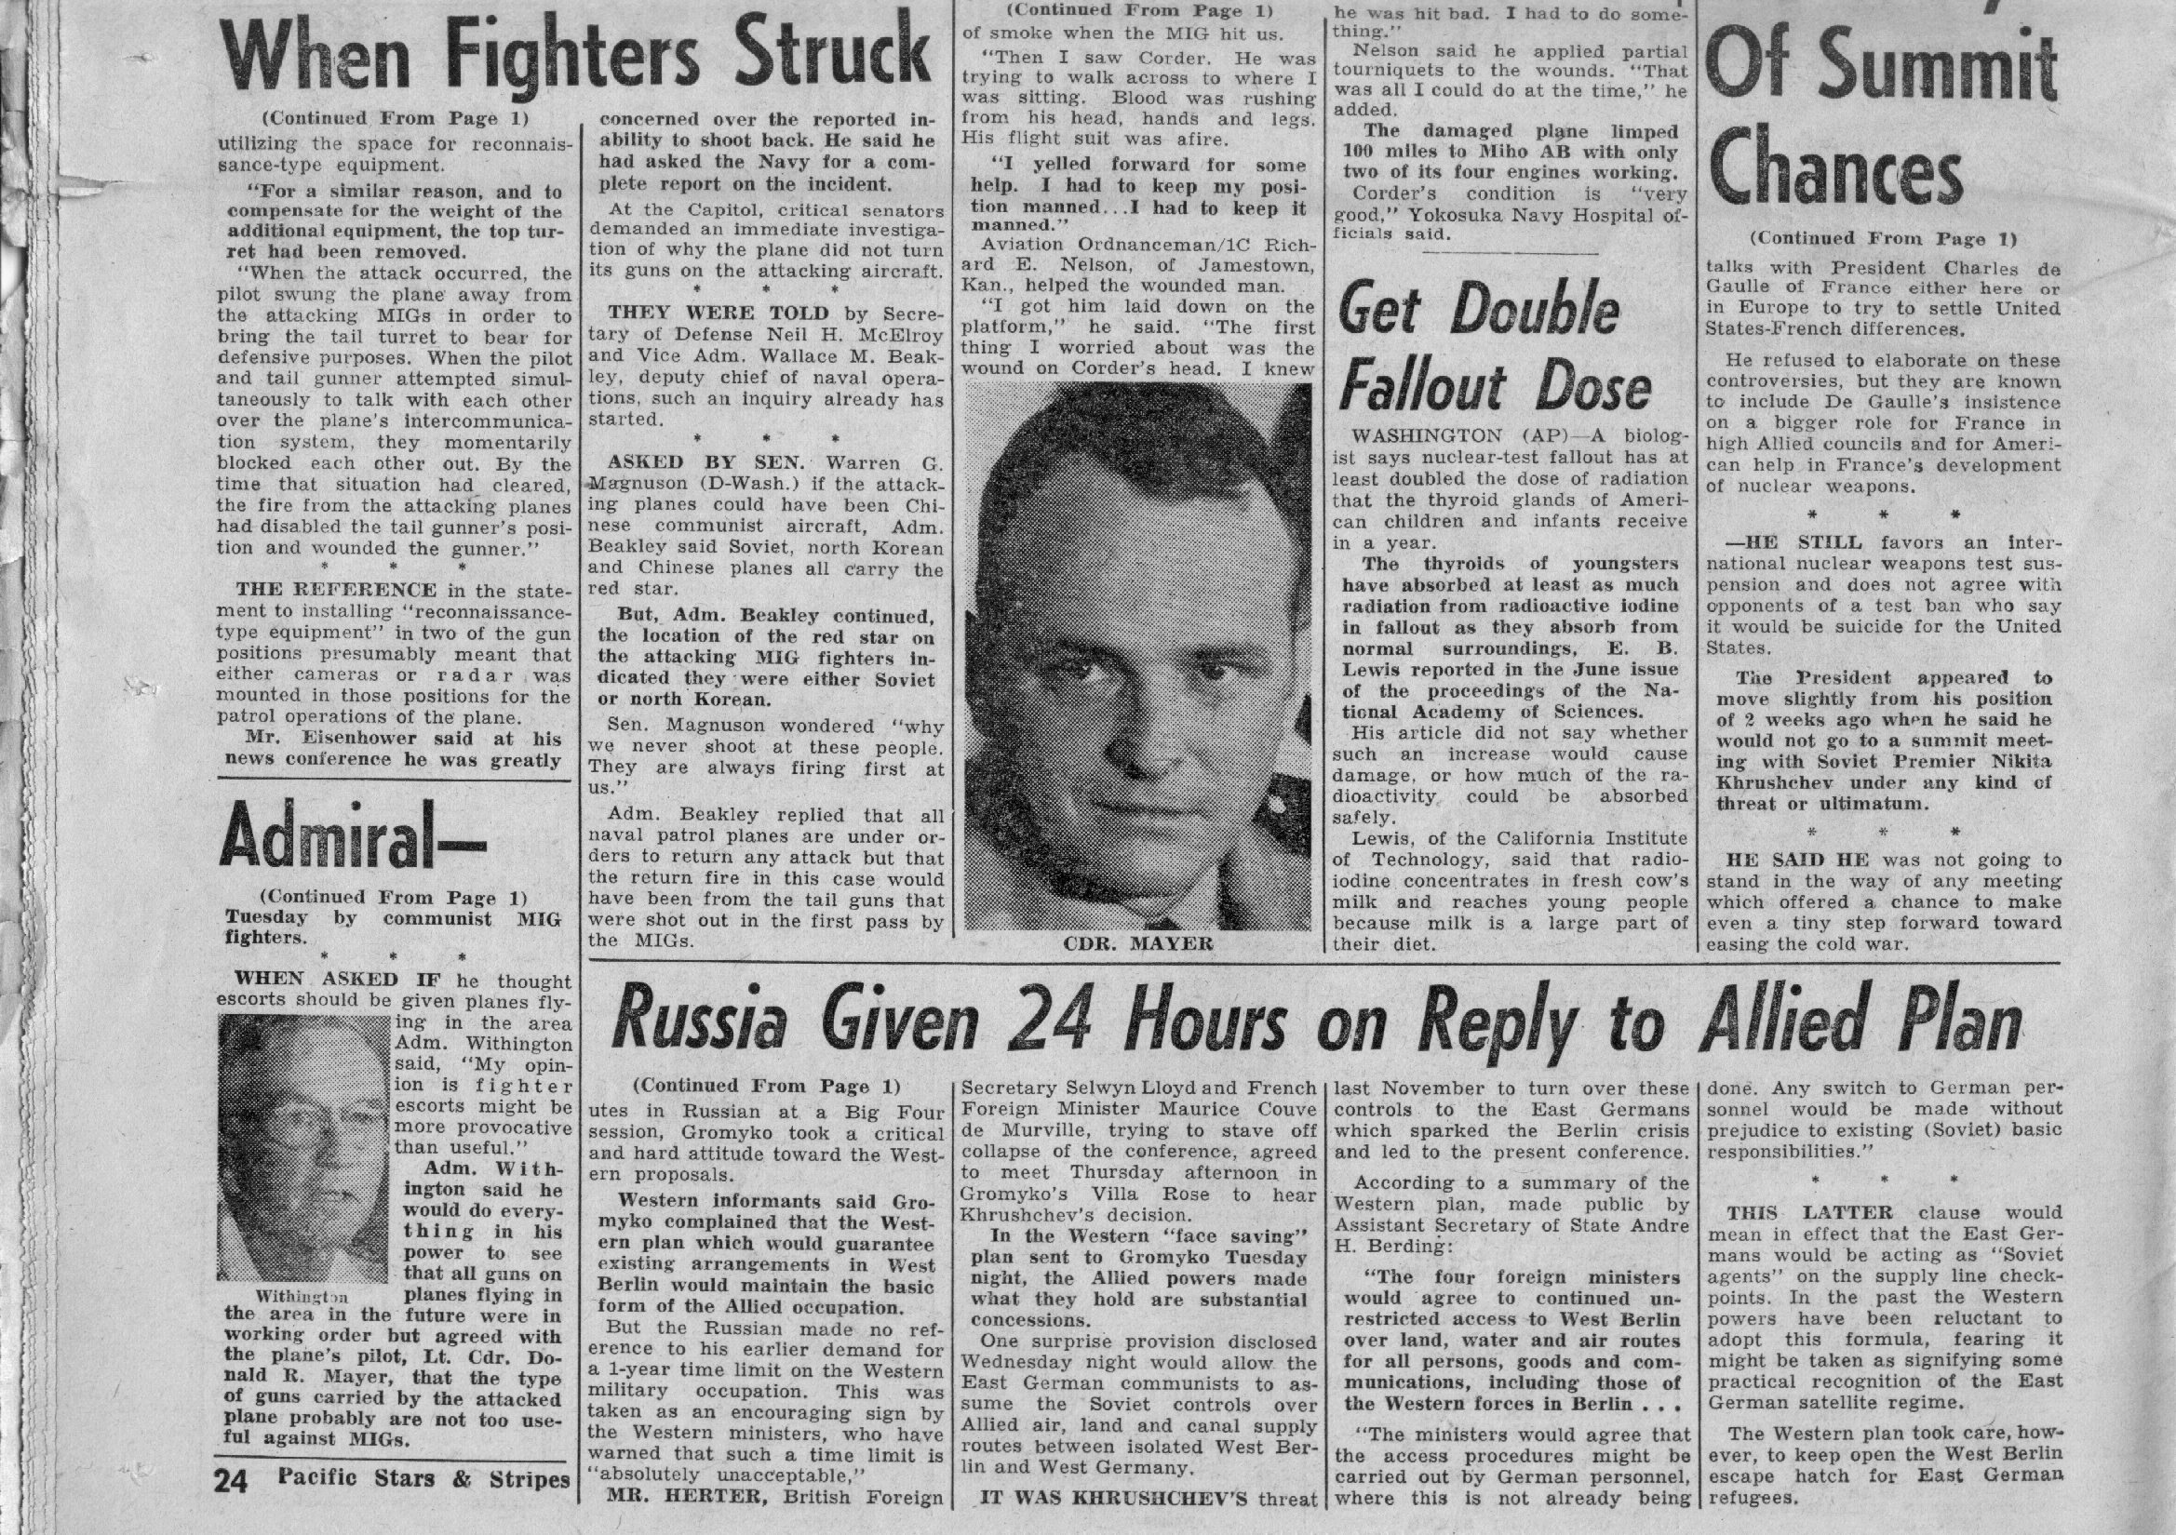

Page 3 of 5
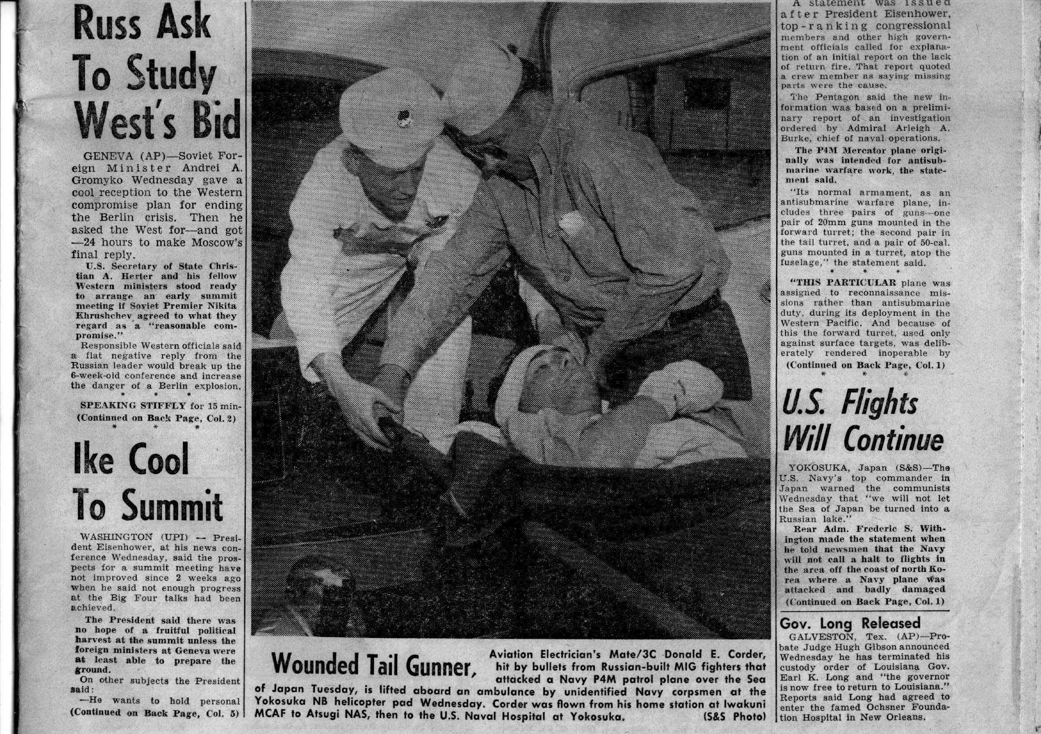

Page 4 of 5

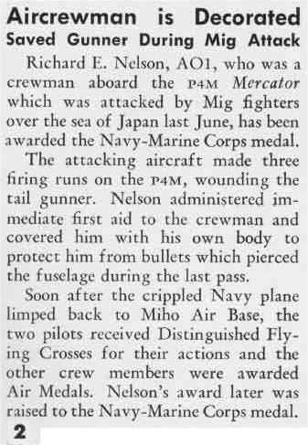

Page 5 of 5

Maritime Patrol Association Hall of Fame
Captain Vince Anania, USN earned the Distinguished Flying Cross after successfully landing a VQ-1 P4M-1Q and saving a crew of 14 when two MIG fighters off of the North Korean coast attacked the aircraft in June 1959. The aircraft suffered extensive damage to the fuselage and wings and lost operation of the starboard reciprocating and jet engines. With the rear tail gunner suffering more than 40 shrapnel wounds and the other crew members jettisoning as many items off of the plane as possible to lighten the load, CAPT Anania was credited with using all of his strength to keep the aircraft airborne for more than 300 miles to the nearest base where the crew landed safely.

