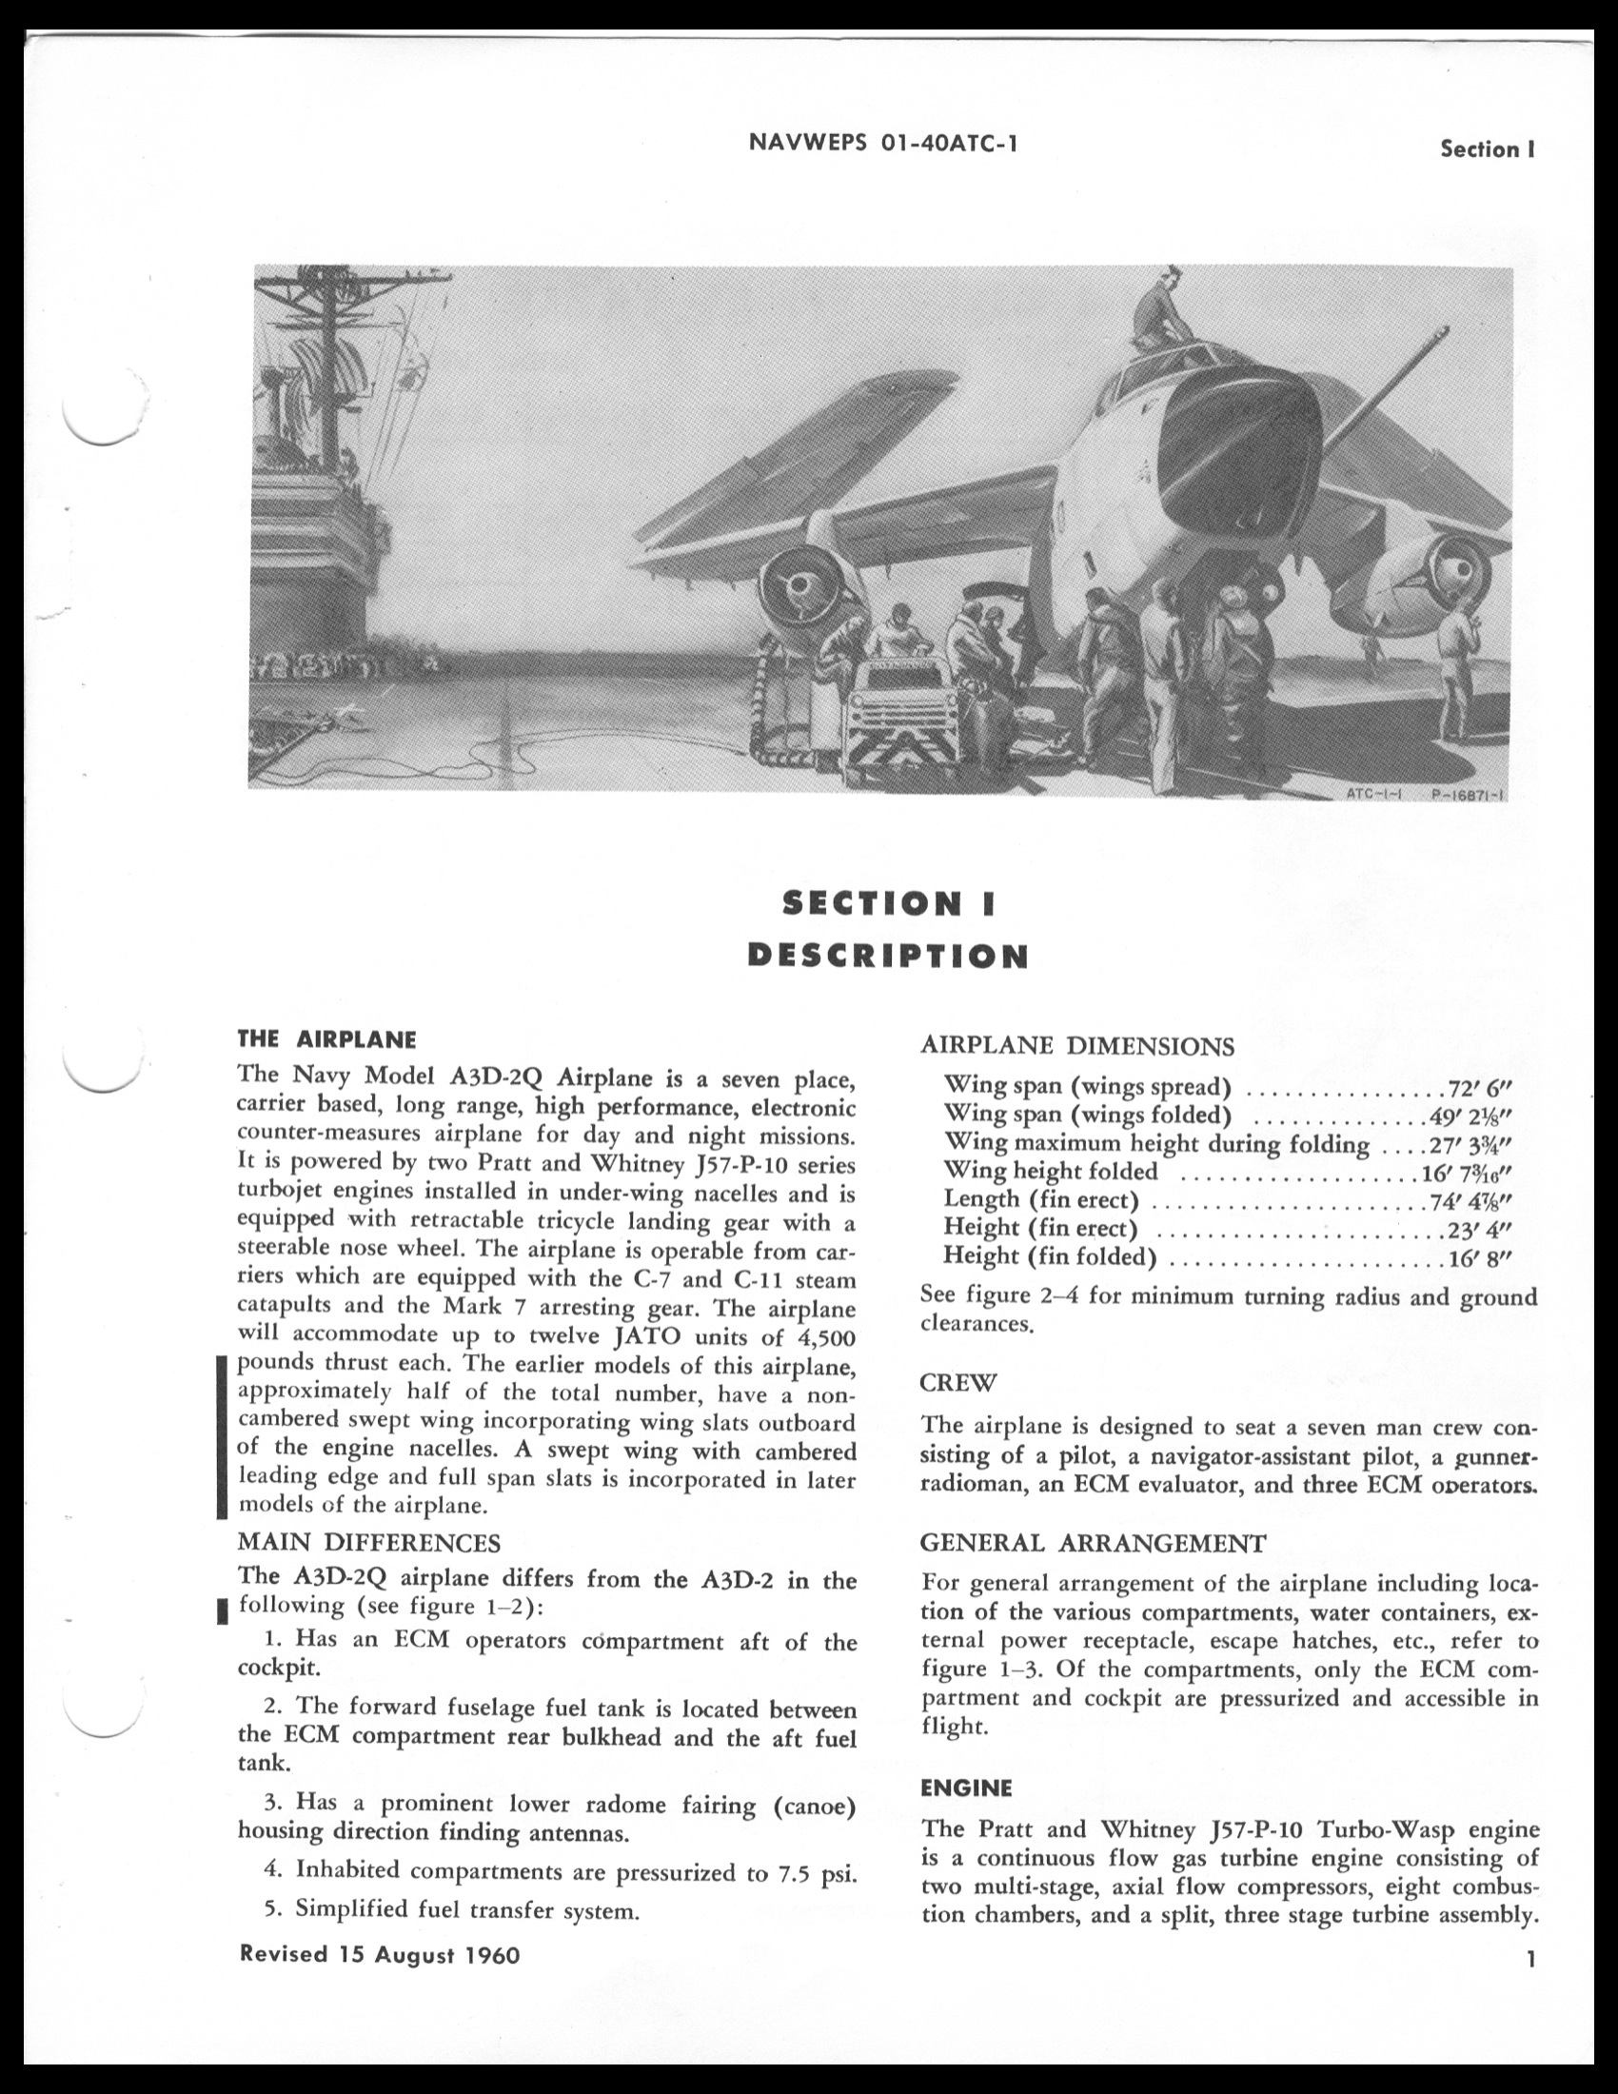

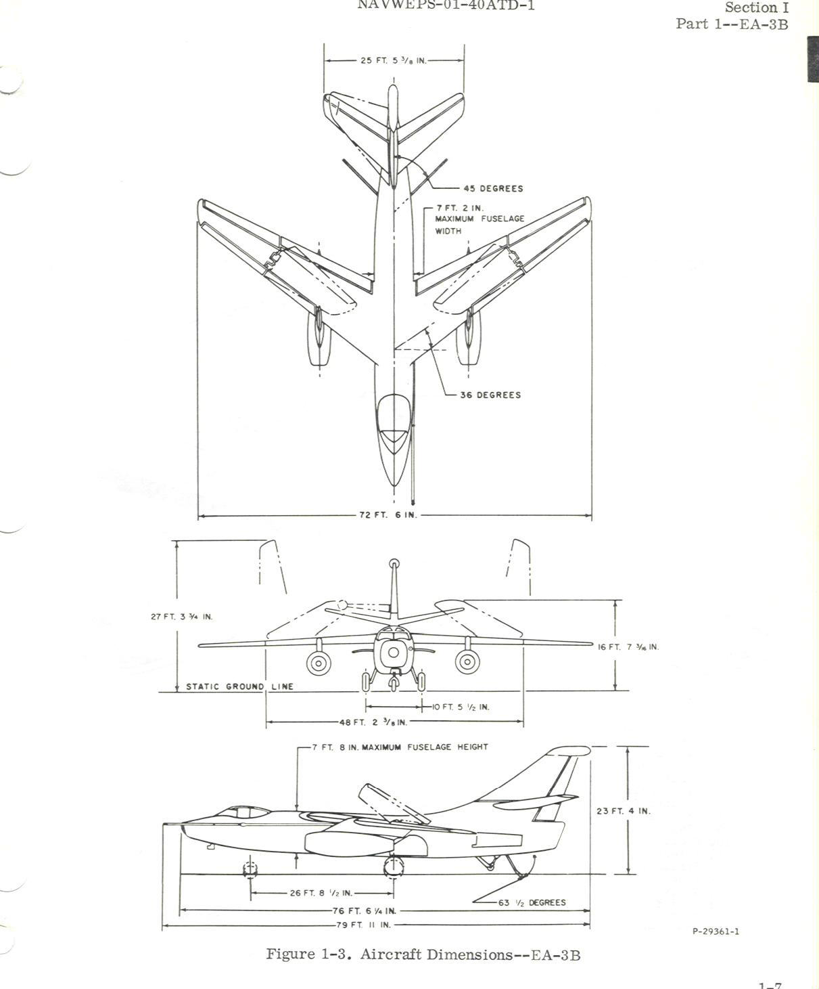

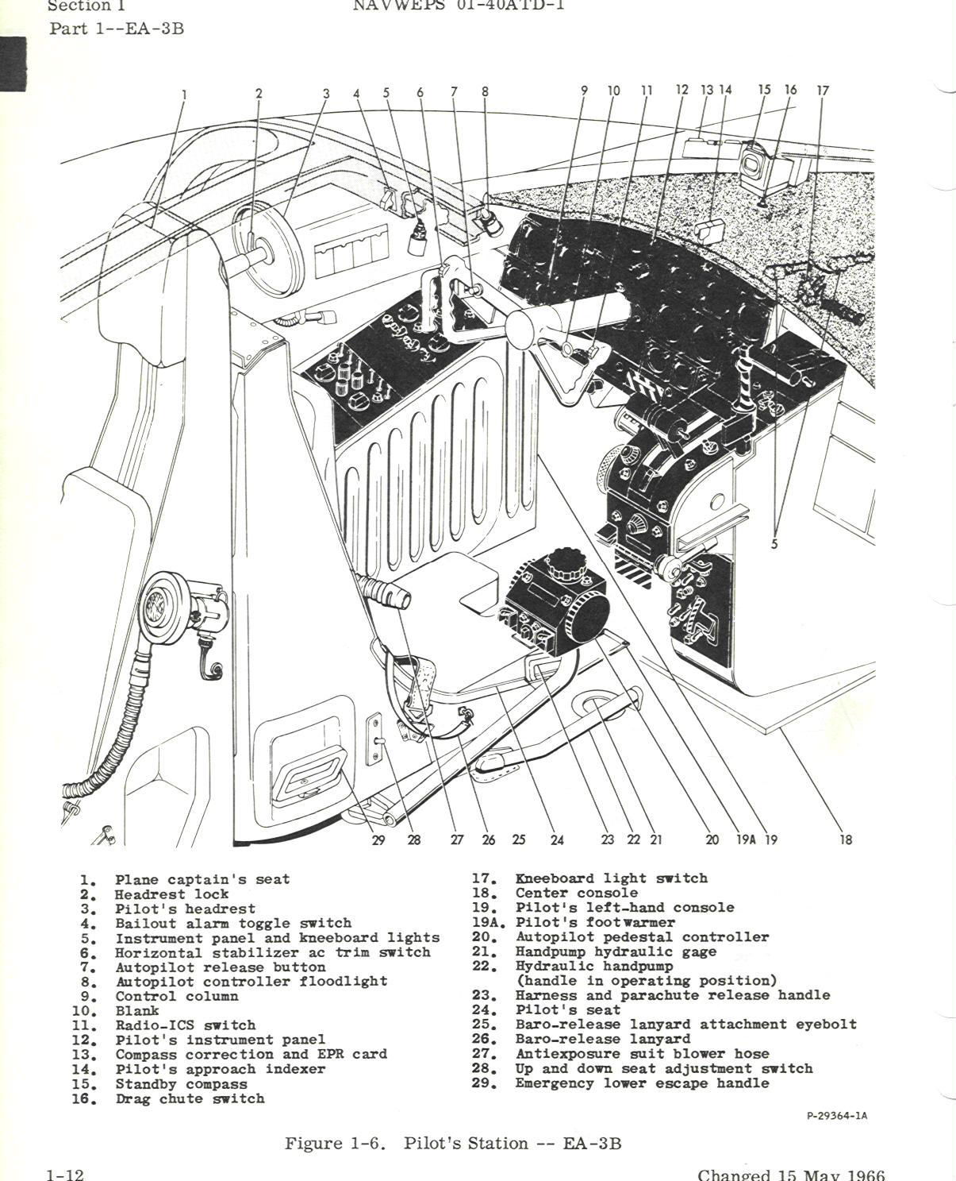

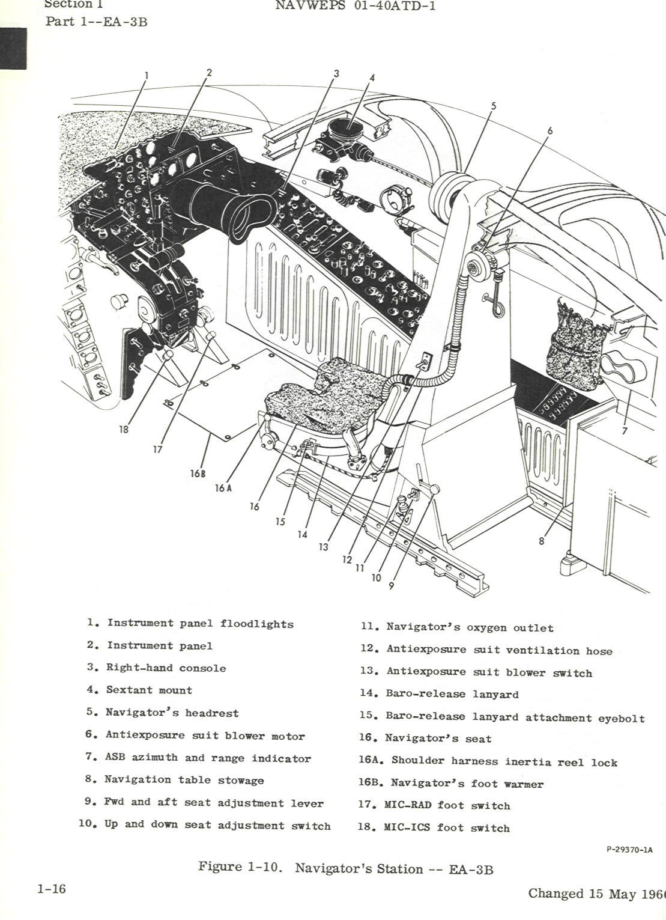

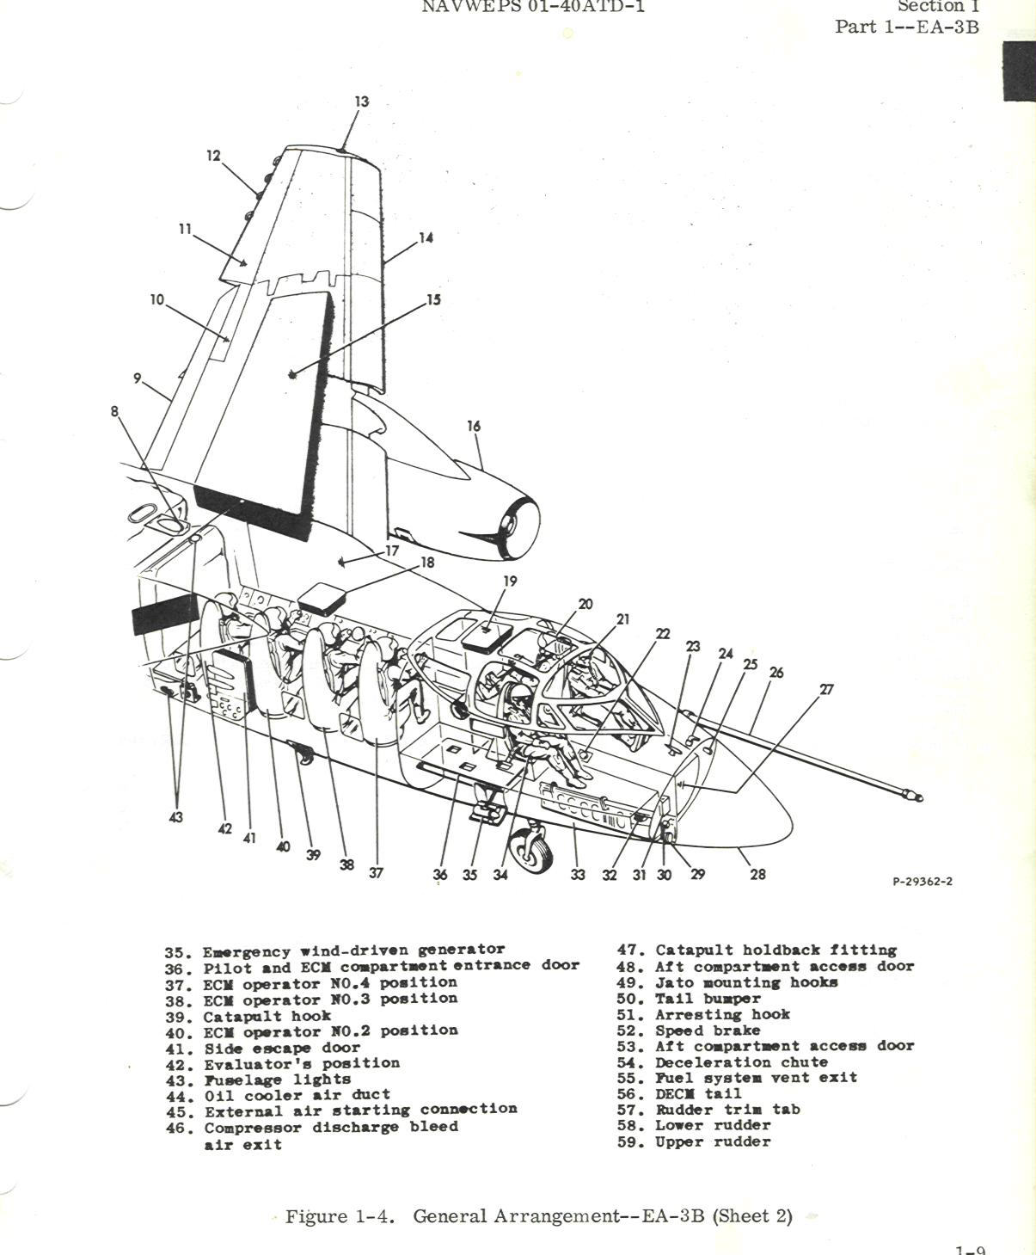

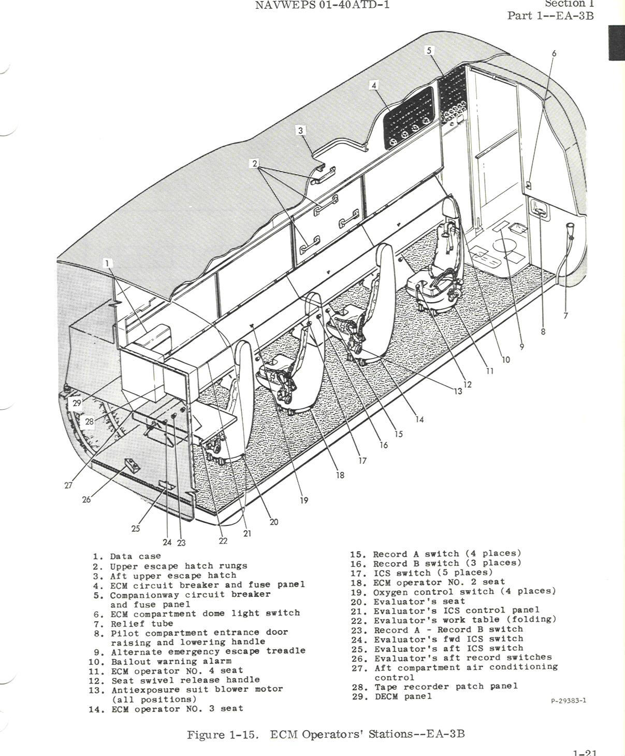

**From an EA-3B Evaluator**

The most I would say is that the EA-3B aircrew performed SIGINT reconnaissance missions in support of US Naval Battle Group, USMC, and US Army Troops ashore and at other times be tasked to fly National PARPRO SIGINT missions against targeted countries of interest. PARPRO missions were pre-planned sensitive reconnaissance’s events where any available National assets during the EA-3B on station time supplemented and provided coordinated flight following for the aircrew.  SEVALs pre-briefed, in-Flt tasked and coordinated the collection of targeted weapon systems during times of peace to ensure target country Air, Naval, Land and Electronic orders of battle were kept current.  During times of higher tensions, or all out conflicts, the EA-3B

aircrew upon determining that friendly forces were in danger could provide real time indication and warning via a suite of secure and/or clear radio transmissions to friendly forces in danger.  On station time off the coast of a target country typically lasted 4 hrs, excluding the time to transit to and from the host aircraft carrier or land based staging site.  The EA-3B Pilot was able to in-flight refuel and if needed, could extend on station for addition hours.  Should a USAF, RC-135 Rivet Joint SIGINT aircraft be departing or relieving the EA-3B, SEVAL's would make radio contact with the RJ mission supervisor to receive or provide a status or activities that were observed in the targeted area or country of interest and as the RJ departed, the EA-3B crew were all quietly envious that our USAF counterparts would be having dinner in a real restaurant tonight.

As for the life on the boat Andy, don't forget to include how the SEVAL could not go to our bunks until our post mission report was officially acknowledged as being released which could occur at mid-night or later.  How the 16mm movie of the night was a looked forward to event as was mail-call, the pop-corn machine, Sliders (greasy burger w/ cheese, bacon and an egg) and soft ice cream from the auto-dog machine (no need to explain the derivation of that name).  Lots more events that effected daily life around the ship: this was a time when females only came onboard during in-port visits, after a couple of weeks at sea, that homely bar girl was starting to look better in the mind's eye, racing to ship's store to purchase that new arrival was a big deal, PMS (Preventive Maintenance Schedule) was still a normal acronym as was the term "Cockpit".  Beer call (a ration of two cans once every 45 days) was permitted at the Ship's CO discretion and it was tough when the aircrew was extended at sea for over 100+ days with a tea-totter carrier CO.  Swim-Call, Steel Beach and Crossing the Equator were events not to be missed....etc, etc, etc.

John J. Anayannis VQ-2 1981-84 / VQ-6 1991-94

**From an EA-3B Plane Captain**

I operated pos.#3 ECM on operational missions in back end. Position #3 was largely X-band air intercept radars and fire control systems on aircraft (i.e. – Mig and some land-based missile ground to air defense systems. ECM positions in back end were numbered 1,2,3,4 with #1 being furthest aft which was the evaluator. The front-end cockpit positions were not numbered, however the 3rd crewman's position (plane captain/crew chief) had spook (CT) receivers incorporated in addition to DECM equip.

Richard B. McClellan VQ-1 1963-67 / VQ-2 1970-74

Macintosh HD:Users:allanprevette:Desktop:VQ Command History:EA3B Stories:EA3B recollections:John Bedford.pdf

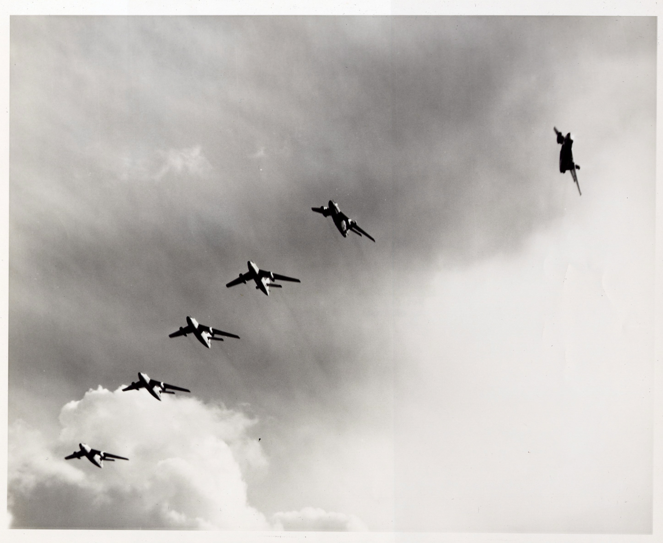

VQ-1 Flyby 1962

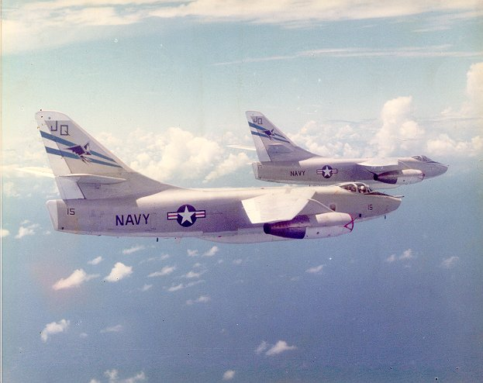

**VQ-2 EA-3B**

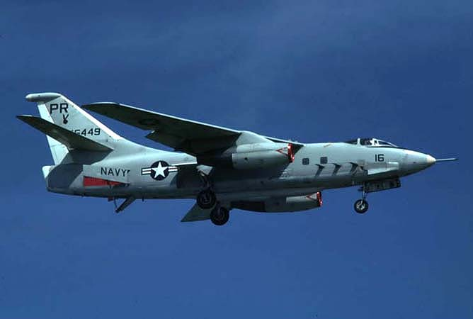

**PR-16 (formerly PR-9)**