LOCKHEED WARNING STAR WV-2Q/EC-121M
(Super Constellation)
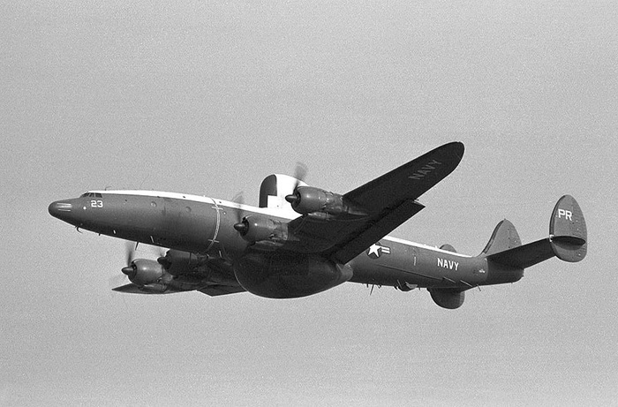

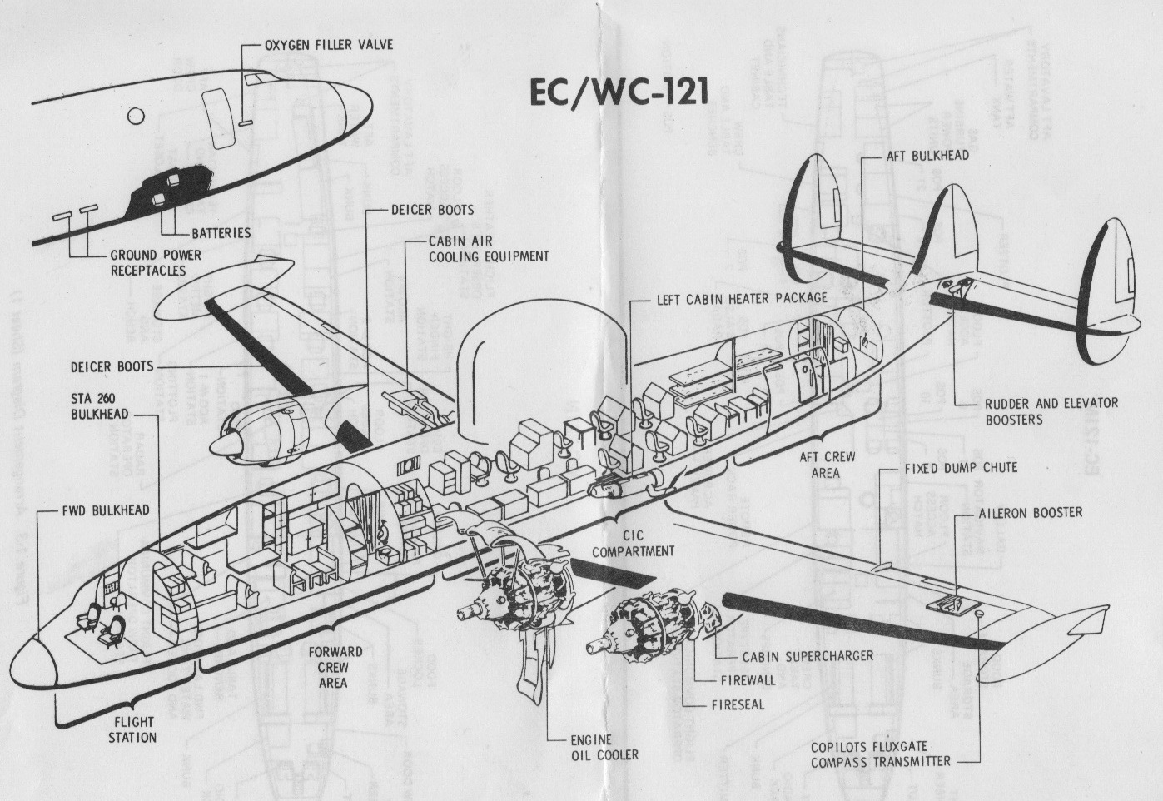
Cabin electronic compartment layout not representative of the EC-121M

General characteristics
- Crew: typically six flight crew, 11-25 radar crew
- Length: 116 ft 2 in (35.40 m)
- Wingspan: 126 ft 2 in (38.45 m)
- Height: 24 ft 9 in (7.54 m)
- Wing area: 1,650 ft² (153.27 m²)
- Empty weight: 69,210 lb (31,387 kg)
- Max. takeoff weight: 145,000 lb
- Power Plants: 4 × Curtis Wright R-3350-42 Turbo Compound 18-cylinder supercharged radial engines, 3,700hp each
- Fuel capacity: 8750 gal tip tanks on, 7550 tip tanks removed
Performance
- Maximum speed: 295 kts
- Cruise speed: 255 mph (222 kt, 410 km/h)
- Range: 4,250 mi (3,700 nm, 6,843 km)
- Service ceiling: 25,000 ft (7,620 m)
- Rate of climb: 960 ft/min (4.87 m/s)

The following are descriptions of the electronic configuration of the first generation WV-2Q/EC-121M aircraft received from Martin, Baltimore, Maryland in 1960 and the second generation LTV Modification that was done by E Systems at Greenville, Texas and started arriving at the squadron in late 1966.
Dale Clark was in VQ-1 when the unit first received the WV-2Q. Larry Brosh came in the unit as Dale was leaving. Lyle Fisher was in the unit at the end of the EC-121M era. It’s amazing to me that even after fifty years or so these gentlemen can recall, with such clarity, the working of the back end electronics!
Editor

The electronic configuration for four of eight original aircraft, modified by Martin at Baltimore, MD and assigned to VQ-1 in 1960, and designated WV-2Q, is as follows. The Navy bureau numbers were: 135747, 135749, 135751 and 135752. The remaining four aircraft of this configuration were assigned to VQ-2 in the same year. In 1962, the WV-2Q designation was changed to EC-121M.

Of the total radar frequency spectrum (P, L, S, C, X, K, Q, V) the six ELINT positions provided redundant frequency coverage over the technologically restricted radar bands (P, L, S, C and X). That would be roughly from DC to 10,750 MHZ. Coverage was primarily with the APR-13 and APR-9 radar receiver systems (designated ALR-8 when used together). The radar receiver system ALQ-28 was installed as a backup system for the ALR-8. It provided coverage over the same frequency spectrum as the ALR-8.

Although not identified by a position (because it employed the use of multiple positions), BIG LOOK was an essential part of the ELINT package. The system employed the use if the aircraft’s highly directional APS-20 search radar dish with a couple of the ELINT receivers to give a very accurate line to the targeted radar. A switch at the radar operator's position removed the mod trigger which prevented a two and a half million watt pulse from entering an ELINT operators receiver. Because the APS-20 antenna is designed for a specific frequency, it restricts the functionality of BIGLOOK.

POSITION 1 had P and L band receivers. This position receives signals from long-range radars such as Early Warning, Over the Horizon and Acquisition radars. These radar systems have low Pulse Repetition Frequencies (PRF’s), which allows the signal to travel a long range and back before sending out another pulse. Because these radars require high pulse power for long-range target acquisition, the low PRF is helpful in lowering the radar’s duty cycle (transmit time to rest time [a function of Pulse Width to PRF] for cooling). Also, because of the high power, these radars tend to have large side lobes (a function of power spilling over the edges or through the antenna) making it difficult for the ELINT operator to get a line to the target or determine a rate of rotation. This is an area where BIGLOOK was quite helpful.

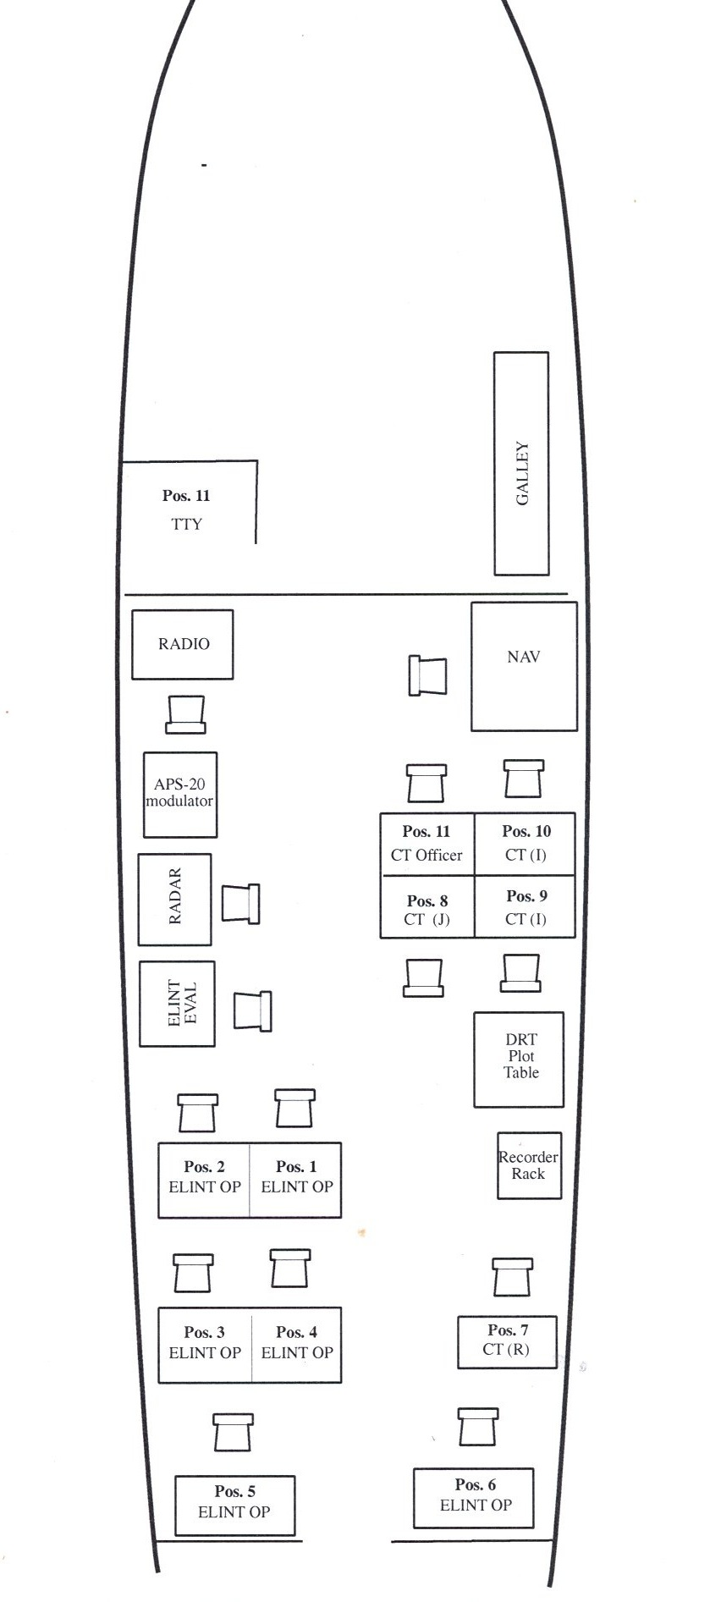

POSITION 2 had the ALQ-28 system with tuners covering the same frequency range as position 1. It was difficult getting accurate data with the ALQ-28 system and for that reason it was primarily used as a backup system.

POSITION 3 covered the S band. Some long-range radar systems were in this frequency range (such as five and seven beam systems like the Bar Lock family), but it also included fire control systems, missile guidance systems, IFF, beaconing systems and tactical air navigation systems. This was a very important position during the Vietnam War because the ground to air threat was much more prevalent than the air-to-air threat.

POSITION 4 again had the ALQ-28 system with the same frequency coverage as position 3, but the superiority of the ALR-8 system over the ALQ-28 rendered position 4 as a backup system also. However, the activity in this frequency band kept both positions busy.

POSITION 5 covered C and X band; This frequency range is where airborne fire control systems operate. Aircraft require smaller and lighter systems. As frequency increases, wavelength decreases. A shorter wavelength means smaller wave-guide, antennas and lighter equipment. Airborne fire control systems can also operate at higher PRF’s (more precise because shorter-range targets require less power for target acquisition, which reduces radar duty cycle. This position was extremely important when operating in the Sea of Japan because of proximity to Russia, China and particularly, North Korea.

POSITION 6 also had the X band coverage, but with the ALQ-28 system. As early as 1964, VQ-1 started experimenting with the Brigand system in Position 6. It rapidly became a major intelligence collecting system because it needed no new expensive equipment and provided an excellent assist in data collection.

POSITIONS 7-12 were manned by NSG personnel.

The WV-2Q’s as delivered, were equipped with TARS (Transistorized Automatic Recording System). The system was designed to automatically record frequency, PRF and Pulse Width of all intercepted radar signals. It also recorded all operator cuts of the intercepted signals. The concept was excellent, but it was a difficult system to maintain and was seldom reliable enough to chance replacing operator logs with it. With a proper training program, perhaps it could have become an important asset

Larry D. Brosh LCDR, USN (Ret)

Putt,

First, on the Willy, I totally agree with Larry's diagram of the ECM and NSG positions as being correct. A slight difference in equipment’s is that I believe the ALQ-28 was at position #1 vice #2. I called Frank Gallardo who was an ECM operator in crew 22 from August 60 to August 62 and he also remembered the ALQ-28 at position #1. But, both our memories are a little shaky on this so Larry is probably right. I also don't remember us using position 6, which as Larry's diagram shows is across the isle from position 5 on the starboard side and I also don't remember any equipment installed at that position (my memory?). I agree with the equipment and frequencies covered that Larry mentioned for the other positions. Three other important equipment’s that have not been mentioned are the pulse analyzers at each ECM position and also at the evaluator’s position. The number APA-74 comes into my mind for those pulse analyzers but again I'm not sure. Hopefully Larry can help us here. Another important equipment was the direction finding displays that used the directional antennas in the upper radome. APA-69 pops up in my mind but again I'm not sure. When I asked Frank Gallardo about these two equipment’s he wasn't sure either. The third piece of equipment that I'll mention is the Ampex tape recorder located at the recorder position on Larry's diagram. I remember it because as the AES on crew 22 I used to change a lot of tape reels. It was a large reel of tape, about 10 inches in diameter that would record the received signals that were received and were used by the evaluators after the mission to determine PRF / PW and scan rates. As Larry mentioned, the TARS recording system just didn't work for us so the Ampex recorder was used all the time. A little side note here is that we would have to keep the recording heads clean by using pure 100% alcohol. We were puzzled as to why it was disappearing so fast until we found out that some individuals were using it for other purposes (no names mentioned here but we did keep it locked up after that). Getting back to recorders, the NSG positions had their own individual recorders that were much smaller and were at each of their positions.

Now on to the P4M---- I only flew two missions in the P4M while at Iwakuni. The back end layout as I remember it was exactly as Bill had mentioned. We had four ECM positions facing outward on the starboard side with an evaluator further back from us. The equipment was the APR-9 and APR-13 but I don't remember which frequencies were covered at which position. I talked with David Scott who was in VQ-1 during the same time that I was and he flew some missions in the P4M before moving on to the EA3B. He also didn't remember which positions covered which frequencies. He did say that he remembered an NSG guy back by the evaluator and this has not been mentioned before.

Dale Clark CDR, USN (Ret)

I have been looking at the Willy inputs that you sent me. The "floor plan" of the ELINT and NSG positions is accurate as far as I know for the original Martin Aircraft configurations. But, by the time that I went to VQ-1 for my first tour in mid 1967, quite a few changes had been made to the ELINT positions. For starters PR-24 (new), 26, and 27 were the LTV configured back-ends. PR-25 got only a partial LTV mod, which may have been due to funding problems, probably not enough.
The pulse analyzer's in the Martin planes was in fact the APA-74 and the rotating DF antenna system was the APA-69. By the time that I got in the squadron the ALQ-28 was not used at all, which was position 4. We normally did not even man Position 4 while operating.
Position 1 was the BIGLOOK operator (Radar Operator). The reason for this was the APA-125 radar indicator was used for its two movable and displaceable cursors (IP-203/APS-20 only had one). The two cursors were needed for "base-leg" DF cutting that we used up in the Gulf of Tonkin. The base-leg procedure provided real-time and accurate DF cuts to the Plotter at the Plot Table right across from the BIGLOOK operator. The Plotter would plot the DF cuts as the Radar Operator took them.

Position 6 was the BRIGAND position with a IP-203/APS-20 indicator; his own tuners for L and S bands (TN-181/APR-13 and TN-129/APR-9. I think the position had a DF antenna capability too.

Position 7 (NSG CTR) was not located in the position that is shown. That position had been moved aft of pos 6 in the Martin birds or aft of the GTPU's in the LTV birds (the bunks that were there were removed) . The space where Pos 7 had been, was the space that was used to stack the cases of San Miguel for the return to DaNang from the R & R's at Sangley Point (remember that?)

The full LTV mod aircraft (PR-24, 26, 27) had the ULA-2 for a pulse analyzer for all the ELINT positions. The ALR-8 receiver system was retained for all of the ELINT Operators except Position 5 had a new receiver system that was solid state and YIG tuned and covered about 1 to 10 GHz (not sure of the upper limit) in four tuners. The system designation was G1187 (I think) that was an LTV part number. Scan Board fixed antennas (four quadrants) were added in the upper radome. The Scan Boards could be selected by any ELINT operator. Each ELINT operator could select DF, Scan Board or BIGLOOK antenna for use. The rotating DF antennas for the positions was still the APA-69 but there was a ALA-12 DF system in at least one position.

The NSG positions 8, 9, 10, 11 had LTV receivers in all of them. I think they were G175 VHF/UHF receivers.

C. Lyle Fisher, ATCS USN (Ret)

