Lockheed EP-3B “Batrack”

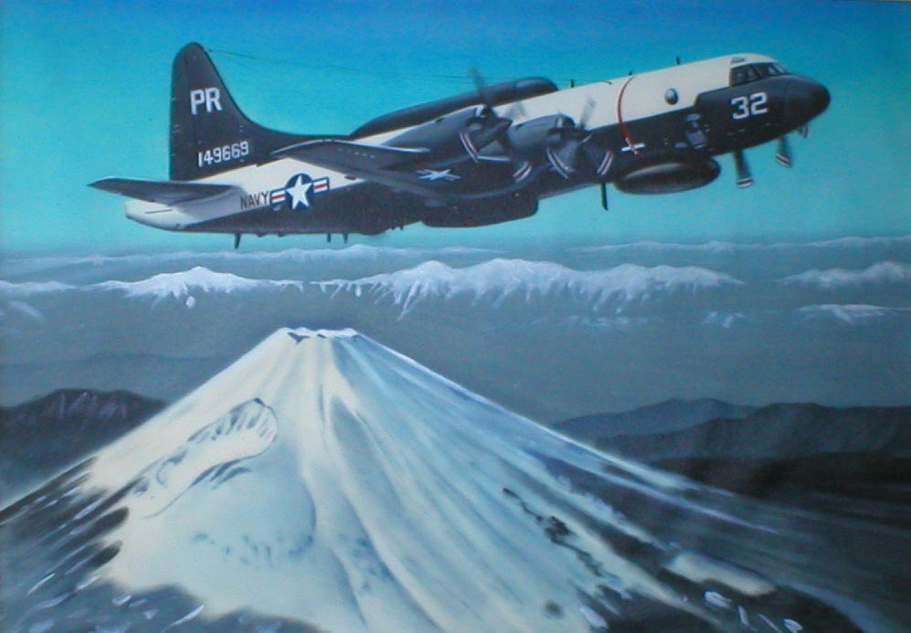

Page 1 of 8
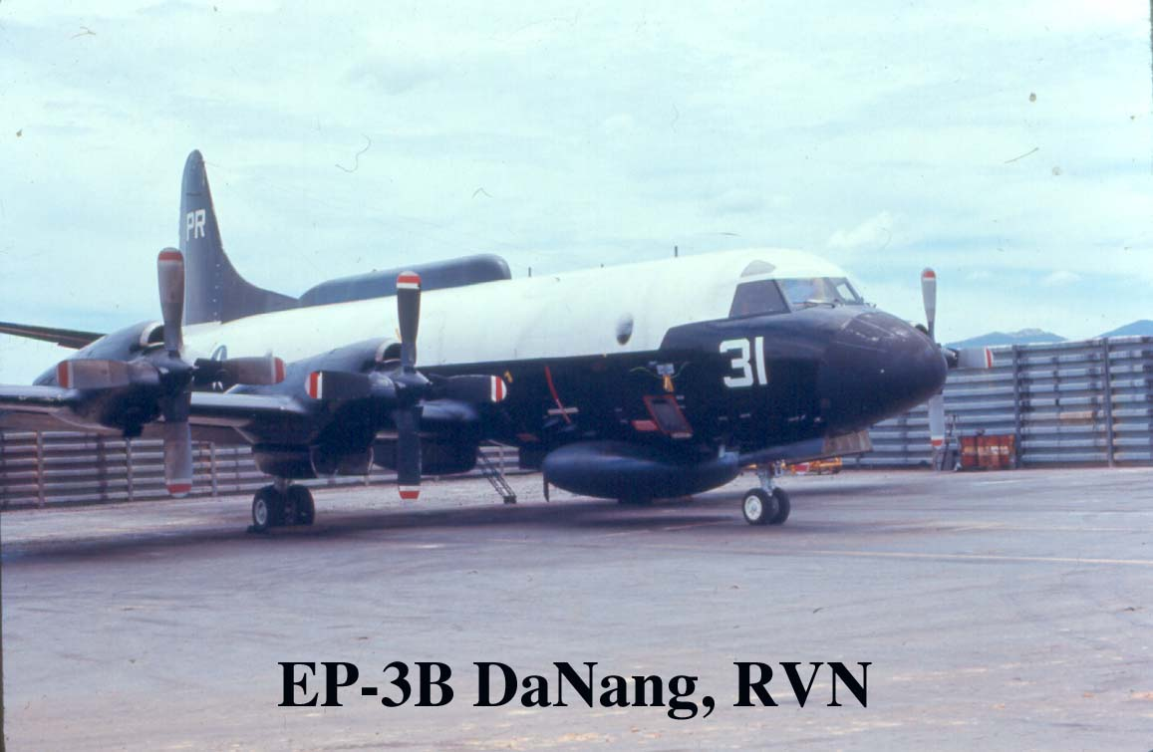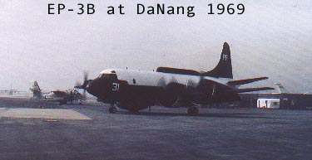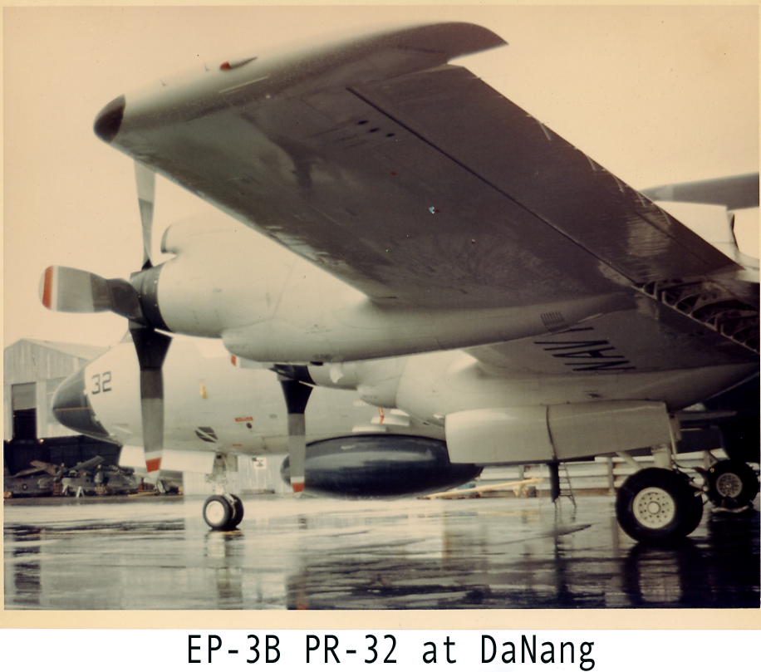
Page 2 of 8

Page 3 of 8

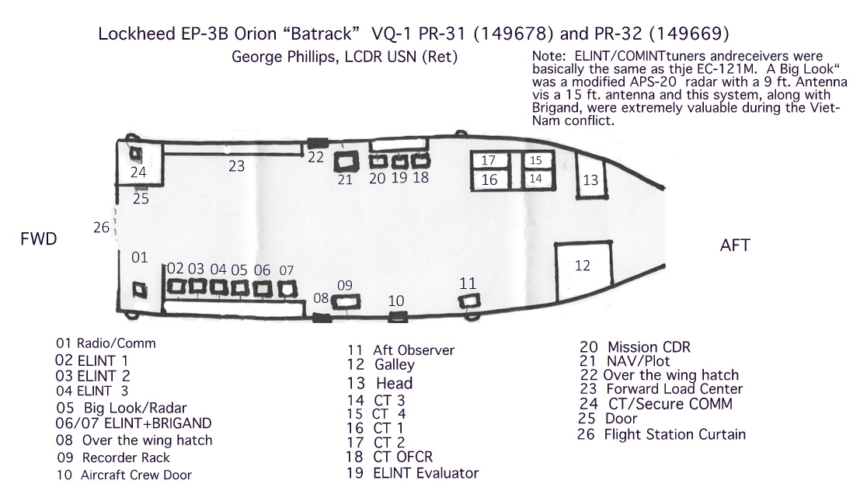

PR-31, BUNO 149678 and PR-32 was BUNO 149669. The Lockheed serial numbers were 5010 (PR-31 and 5019 (PR-32). PR-32 was the first to leave Burbank with John Cavanaugh as pilot and me as FE. I think Roy Ellis was also part of the crew as FE. Chet Fiene and Don Gibbs were also part of the Burbank crew and were the FEs on PR-31 when it was flown from Burbank to Atsugi. These were the only aircraft that were EP3Bs, all the rest were EP3Es. Dick Flake AFCM USN (Ret)

Page 4 of 8

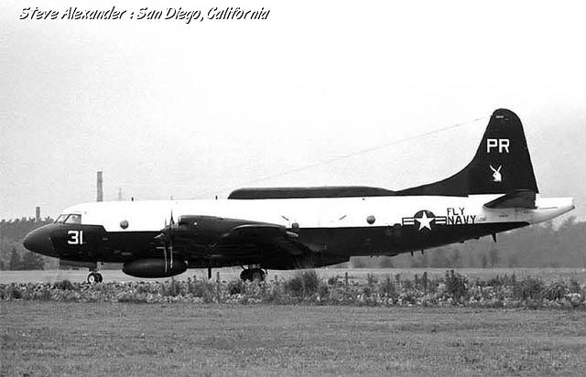
Page 5 of 8
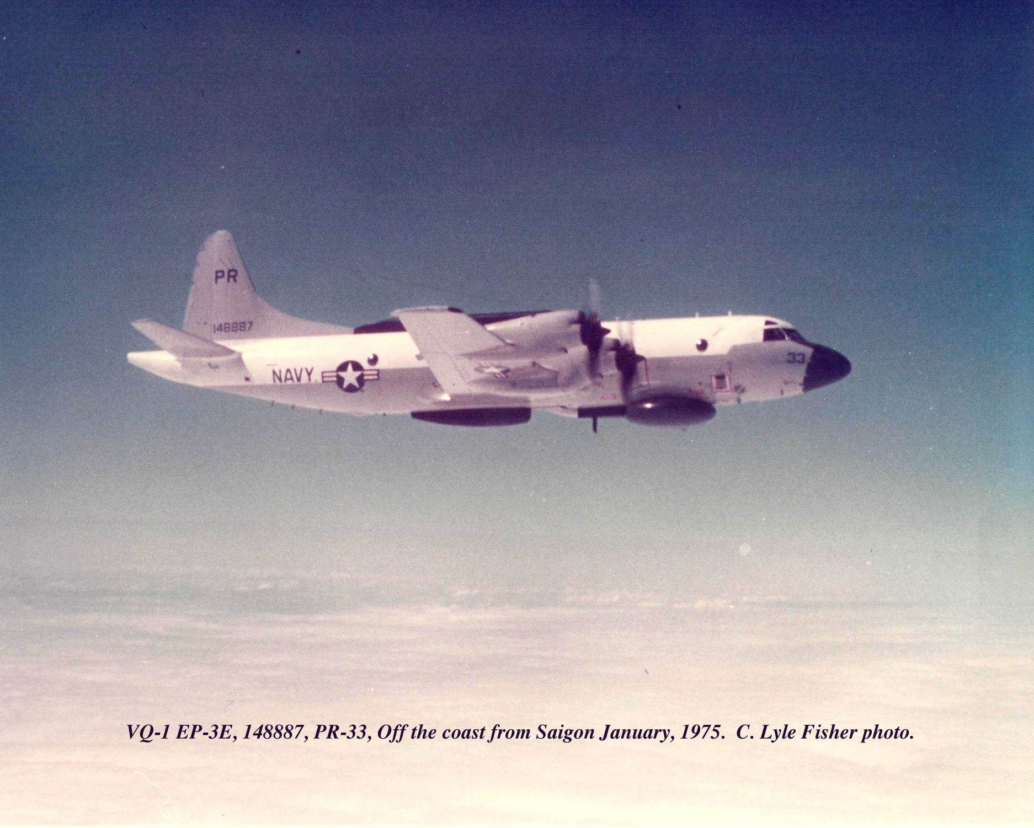

P-3E DEEPWELL

The following configurations are applicable to the four EP-3E aircraft that were scheduled to be delivered to VQ-1, on Guam, in 1974 (see note below). These four aircraft were: PR-33 (148887); PR-34 (150497); PR-35 (150498); and PR-36 (150501). Three additional EP-3E DEEPWELL aircraft were modified by Hayes International, Birmingham, Alabama and delivered to VQ-2 after delivery of these four to VQ-1. It is believed the VQ-2 EP-3E DEEPWELL aircraft were the same or very similar to VQ-1's DEEPWELL aircraft.

EP-3E ELINT and COMINT Systems

The primary ELINT receiver collection system in the EP-3E was the ALR-44 (0.5-18 GHz). The tuners were all solid state and YIG (Yttrium iron garnet) tuned. The ALR-44 frequency coverage band was implemented with six, octave width tuners. Each ALR-44 position did not have all six tuners. Two positions had dual SR-212 manually tuned receivers that covered the VHF/UHF bands. One position had a limited K, Ka band capability. The pulse analyzer in each ELINT position was an IP-1159. Each ELINT position also had a PEDCOG that was used for accurate PRF measurements. The direction finding (DF) system was new with new designed antennas. The DF antenna pedestals were an older, but improved ALA-12 system. The DF antennas were located in both the lower and upper canoes. The BIGLOOK position had an ALR-52 instantaneous frequency measurement (IFM) system in addition to the ALR-44. The APS-20 transmitter was retained for the radar but one of the ALR-44 tuners was used for the receiver. The smaller lower radome of the EP-3 would accommodate only a 9 1/2-foot antenna reflector, compared to the 171/2-foot of the EC-121's. Each ELINT position operator could select a DF antenna system, a left-right fixed antenna, or could select the BIGLOOK antenna.
Page 6 of 8

The ELINT Operator positions were known as, "The Inline". The six operator positions were in the forward section on the port side of the backend. The six operators sat side-by-side and faced outboard. The forward most position was Position 1 and had the ALR-44 system. Positions 2 and 3 each had two SR-212's for the VHF/UHF bands. Position 4 was the BRIGAND position. Position 5 had the ALR-44 system. Position 6 was BIGLOOK with ALR-44 and ALR-52 IFM systems. Directly behind the BIGLOOK operator and facing outboard on the starboard side was the Tactical Evaluator position (Position 7). The Evaluator position was just aft of the P-3 electrical load center. Aft of the BIGLOOK operator and facing aft was the Analysis Position (Position 8). Position 8 was normally manned by a squadron provided CTT (Technical-branch). Position 8 had a spectrum analyzer (HP8555) that could be used as a receiver. The Position 8 operator could also select video from any of the ELINT positions.

The ALR-60 DEEPWELL COMINT receiver system was early digital computer technology. The DEEPWELL system was built by Sylvania, Mountain View, California. The ALR-60 contained two digitally tuned receivers that would be programmed to alert the operator when a specified or requested signal became active. At the same time that the operator was alerted by the computer, the computer would also start one of the audio recorders to record the active signal. Each of the DEEPWELL operators also had two manually tuned SR-212 receivers that were used for searching for, or monitoring other signals of interest. The DEEPWELL system contained 15 open, reel-less audio recorders. The reel-less design was used to decrease the starting inertia for the reels and the recorder. Thereby decreasing the lag time between the command from the computer and the actual start of the recording. At the end of the mission a down-load or dubbing function for the mission had to be performed - by the computer - because only the computer knew on which audio recorder (1 of 15) the various segments of an event were located. The various segments of an event could be located on a number of different recorders. If the computer failed during the mission download, the entire mission could be lost. It was virtually impossible to recover a mission if the dubbing or down-load function failed. The definite weak-point of the system was the audio recorders and the computer.

The COMINT Evaluator was next to, and aft of the Tactical Evaluator (Position 7). To the right of the COMINT Evaluator and aft were four more operators. All were facing outboard on the starboard side of the aircraft. The COMINT Evaluator (Position 9) and the next three positions (Positions 10, 11, 12) were the DEEPWELL operators. The last position aft (Position 13) was the CTR (R-branch) operator. Position 13 operator had two SR-509 receivers.

Between the Tactical Evaluator and the COMINT Evaluator was the control box for the ALD-8 system. The ALD-8 was a VHF direction of arrival DF system that used spiral antennas that were located in the upper canoe. The system was never very effective. It was, however somewhat better than the ALD-6 system that had been installed in PR-27 in late 1967 after the major LTV modifications were completed. In PR-27 the spiral antennas were installed in empty tip tanks. The empty tip tanks created an unforeseen flight problem. The empty tip tanks created lift that flexed the wing up which decreased the lift of the rest of the wing. The resultant was discovered on the first flight from Da Nang to Khorat for PR-27. While over Laos, it was always good to be as high as the EC-121M would go. PR-27 could not get above 10,500 feet in climb power and high blower. The empty tips were removed and PR-27 would then go to 17,500 feet like the other squadron EC-121's.
NOTE:

The Delivery Delay of PR-34 to VQ-1
Page 7 of 8

PR-34 (150497) should have been the first EP-3E to arrive on Guam for VQ-1 in 1974 but it had a major disaster occur on the day that it was to have departed from NAS Moffett Field for Guam.

C. Lyle Fisher

Page 8 of 8

