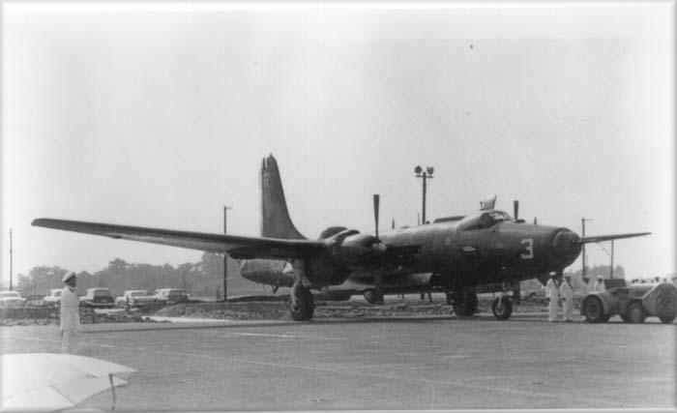

**Last VQ-1 P4M-1Q is retired at NAS Atsugi, 23 July 1960**