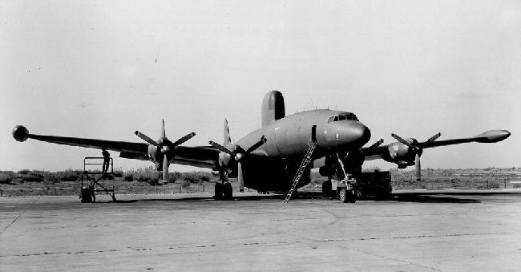

22 MAY 62 - WV-2Q (EC-121) Super Constellation, Buno 131390 (JQ-15). Squadron VQ-2, based at Rota, Spain; staging out of Wiesbaden, West Germany. It was suspected that the aft crew door failed and the tail section separated from the aircraft.

Fatalities: Lcdr. Conner M. Petrie Jr., Lt. Jack L. Duvall, Ltjg. Marvin R. Armstrong, Lcdr. Charles A. Patschke, Ltjg. Robert Poole, ADRCA Eugeno George, ADR2 Michael Kostiuk, ATCA Jared M. Rose, ATCA Thomas E. Young, AT1 Gene P. Bartram, AM1 Martin J. Brennan, AMH1 Gerhard K. Heimerl, AT2 Donald R. Ballard, AT2 Gerald R. Carlton, AT2 Jamos W. Tyler, AT2 Ronald P. Wajda, ATR3 Edward N. Hawkins, ATS3 Orville R. Malone, AE3 Timothy D. Steward, ATN3 Lee P. Strong, ATR3 Joseph H. Watkins, ATRAN Gilbert J. Austin. [ARMY Fatalities:] SP5 F.L. Breshears, SP5 R.J. Hoos, SP4 E.M. Mcgreal, SP4 R.A. Lewis.

Page 1 0f 2
On 05/22/1962, WV-2Q took off from Furstenfeldbruk, West Germany on a “training” mission flying along the CZECH border. The rear cargo door failed, coming open in flight resulting in the tail separating and departing the aircraft in-flight. Aircraft crashed 1 and ¼ mile southwest of Markt Schweben, West Germany.
In a bizarre incident one of the crewman happened to be in the aircraft's head, which was all the way aft in the tail. When the empennage broke off at the main cargo door point, the intact tail section, (with its single passenger) was reported by several witnesses to have "Flown" in a wide ARC after the breakup and made a semi-controlled "Landing" in a large freshly plowed farm field. The crewman apparently unhurt up until this point was thrown from the tail section directly into a tree, "the only tree in the whole field" where he was killed instantly from a broken neck.

Page 2 of 2

