Early Vietnam Operations by EA-3B Skywarrior Aircraft

All this information is taken from my flight log books. My tour in VQ-1 was from March 1962 to July 1965.

As far as Vietnam goes, my crew and I made six deployments under OPCON (Operational Control) of TF 77.

First trip: 26 January to 22 February 1963. We were involved in jamming SAM, surface-to-air missile sites, and also disabling airborne missiles. Good success on both occasions. We were flying from the USS Kitty Hawk, CVA-63. We flew 11 missions.

Second trip: 21 March to 30 March 1963, USS Kitty Hawk. We flew seven missions.

Third trip: 19/20 August 1963. Special mission assigned by CTF-77. USS Constellation , CVA-64. Four flights from the USS Oriskany, CVA-34.

Fifth trip: 15 May to 18 June 1964. Flew 13 flights, including lead jamming on operation "Rolling Thunder." Flew RADAR suppression flights over Laos "Plainne des Jahres." Awarded Distinguished Flying Cross by CTF-77 for 6 June 1964 mission from USS Kitty Hawk. ADM Brinkley, CTF-77, was the presenter. We did good! We changed to USS Constellation, CVA-64, for the Laos missions.

Sixth Trip: 3 February to 19 February 1965. Flew 15 operational flights from USS Ranger, CVA-61, and USS Coral Sea, CVA-43. Heavy operations.

This is all that I can come up with now with the crew in the Vietnam operations. The crew helped me earn two DFC, four Navy Air Medals and two Unit Citations with Combat V. Whenever we weren't doing the carrier work down south, we were doing our share of chasing Russian missiles out of Shemya, Alaska. I flew a total of 308 combat/operational flights for VQ-1.

We must also remember the carrier guys and crews in Vietnam.
LCDR Roy New
LCDR Dick Zick
LCDR Bob Jones
LCDR Lindsey Smith
LCDR Jeff Richardson
Page I of 4
I hope this helps on the squadron history. It was the highlight of my career, and it was brought about by fine people and dedicated Americans.

Ted Cunningham, CDR, USN (Ret)

Ted Cunningham’s EA-3B crew patch

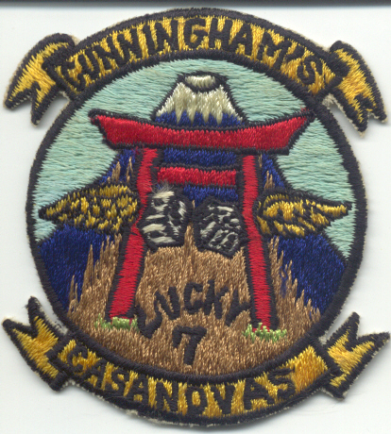

Page 2 of 4

