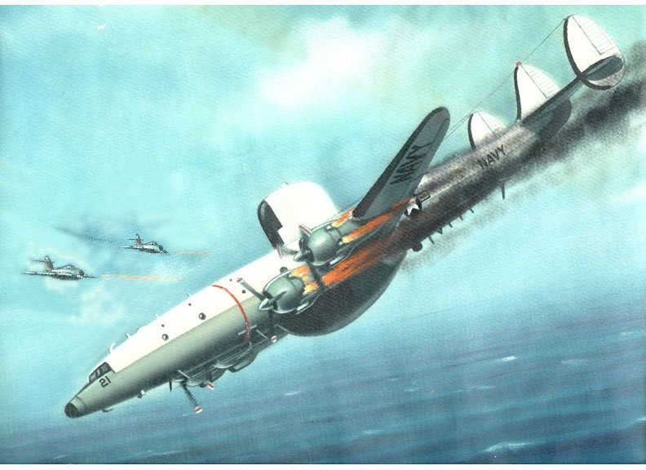
From Wikipedia

Flight of Deep Sea 129
Beggar Shadow mission

At 07:00 local time of Tuesday, 15 April 1969, an EC-121M of the U.S. Navy's Fleet Airborne Reconnaissance Squadron One (VQ-1) took off from NAS Atsugi, Japan, on an intelligence-gathering reconnaissance mission.[2] The aircraft, Bureau number 135749, c/n 4316,[ bore the tail code "PR-21" and used the radio call sign Deep Sea 129. Aboard were 8 officers and 23 enlisted men under the command of LCDR James Overstreet. Nine of the crew, including one Marine NCO, were Naval Security Group cryptologic technicians (CTs) and linguists in Russian and Korean.
Deep Sea 129's assigned task was a routine Beggar Shadow signal intelligence (SIGINT) collection mission. Its flight profile northwest over the Sea of Japan took it to an area offshore of Musu Point, where the EC-121M would turn northeast toward the Soviet Union and orbit along a 120-nautical-mile (222 km) long elliptical track. These missions, while nominally under the command of Seventh Fleet and CINCPAC, were actually controlled operationally by the Naval Security Group detachment at NSF Kamiseya, Japan, under the direction of the National Security Agency.
LCDR Overstreet's orders included a prohibition from approaching closer than 50 nautical miles (90 km) to the North Korean coast. VQ-1 had flown the route and orbit for two years, and the mission had been graded as being of "minimal risk." During the first three months of 1969 nearly 200 similar missions had been flown by both Navy and U.S. Air Force reconnaissance aircraft off North Korea's east coast without incident.
The mission was tracked by a series of security agencies within the Department of Defense that were pre-briefed on the mission, including land-based Air Force radars in Japan and South Korea. The USAF 6918th Security Squadron at Hakata Air Station, Japan, USAF 6988th Security Squadron at Yokota Air Base, Japan,and Detachment 1, 6922nd Security Wing at Osan Air Base monitored the North Korean reaction by intercepting its air defense search radar transmissions. The Army Security Agency communications interception station at Osan listened to North Korean air defense radio traffic, and the Naval Security Group at Kamiseya, which provided the seven of the nine CTs aboard Deep Sea 129, also intercepted Soviet Air Force search radars.
Interception and shootdown]
At 12:34 local time, roughly six hours into the mission, the Army Security Agency and radars in Korea detected the takeoff of two North Korean Air Force MiG-17s and tracked them, assuming that they were responding in some fashion to the mission of Deep Sea 129.[4] In the meantime the EC-121 filed a scheduled activity report by radio on time at 13:00 and did not indicate anything out of the ordinary. Twenty-two minutes later the radars lost the picture of the MiGs and did not reacquire it until 13:37, closing with Deep Sea 129 for a probable intercept.
The communications that this activity generated within the National Security network was monitored by the EC-121's parent unit, VQ-1, which at 13:44 sent Deep Sea 129 a "Condition 3" alert by radio, indicating it might be under attack. LCDR Overstreet acknowledged the warning and complied with procedures to abort the mission and return to base. At 13:47 the radar tracks of the MiGs merged with that of Deep Sea 129, which disappeared from the radar picture two minutes later.
Initial reaction
At first none of the agencies were alarmed, since procedures also dictated that the EC-121 rapidly descend below radar coverage, and Overstreet had not transmitted that he was under attack. When it did not reappear within ten minutes, however, VQ-1 requested a scramble of two Air Force Convair F-106 Delta Dart interceptors to provide combat air patrol for the EC-121.
By 14:20 the Army Security Agency post had become increasingly concerned. It first sent a FLASH message (a high priority intelligence message to be actioned within six minutes) indicating that Deep Sea 129 had disappeared, and then at 14:44, an hour after the shoot-down, sent a CRITIC ("critical intelligence") message (the highest message priority, to be processed and sent within two minutes) to six addressees within the National Command Authority, including President Richard M. Nixon and National Security Advisor Henry Kissinger.

14-APR-69
SQUADRON: FLEET AIRBORNE RECONNAISSANCE SQDN ONE (VQ-1)
AIRCRAFT: EC-121M, BuNo 135749, PR-21, "DeepSea Two One"
LOCATION: SE of Chongjin, North Korea.
EVENT: Shot down by two North Korean MIG fighters over the Sea of Japan.
LOSS: 31 of 31-man crew killed:
Marshall H McNamara, ADRC
Timothy H McNeil, ATR2
John A Miller, CT3
John H Potts, CT1
Richard T Prindle, AMS3
Richard E Smith, CTC
Philip D Sundby, CT3
Richard E Sweeney, AT1
Stephen J Tesmer, CT2
David M Willis, ATN3
Hugh M Lynch, SSGT, USMC
Frederick A. Randall, CTC
James Leroy Roach, AT1

LCDR James H Overstreet
LT John N Dzema
LT Dennis B Gleason
LT Peter P Perrottey
LT John H Singer
LT Robert F Taylor
LTJG Joseph R Ribar
LTJG Robert J Sykora
LTJG Norman E. Wilkerson
Louis F Balderman, ADR2
Stephen C Chartier, AT1
Bernie J Colgin, AT1
Ballard F Connors, Jr, ADR1
Gary R DuCharme, CT3
Gene K Graham, ATN3
LaVerne A Greiner, AEC
Dennis J Horrigan, ATR2
Richard H Kincaid, ATN2

