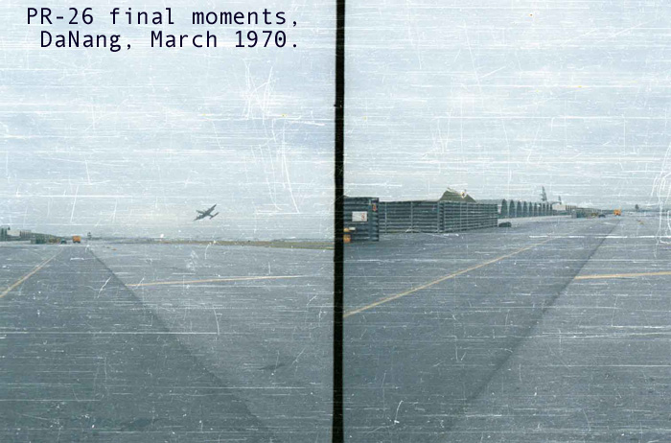

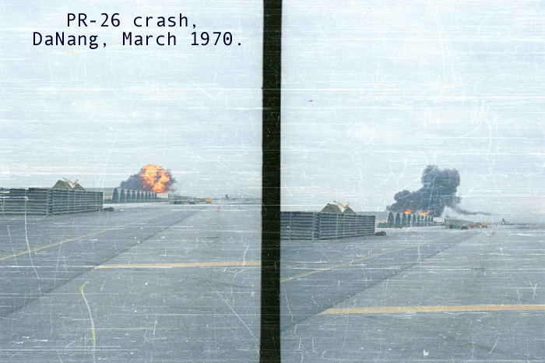

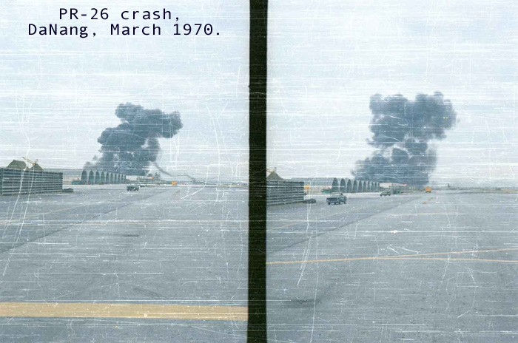

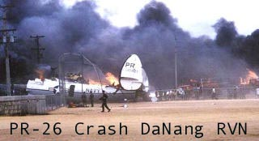

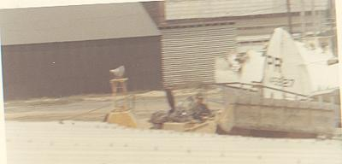

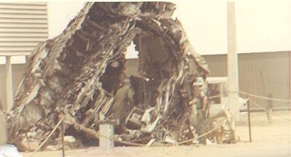

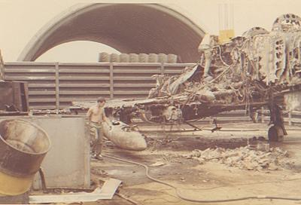

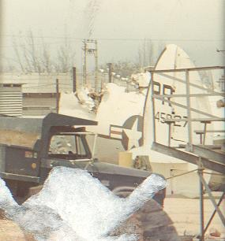

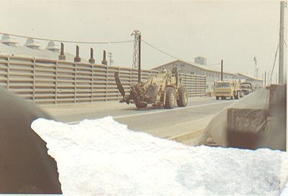

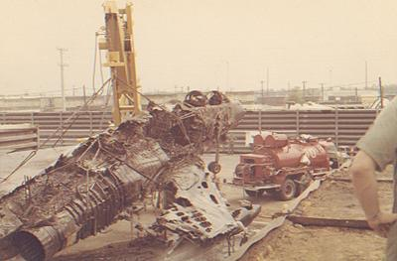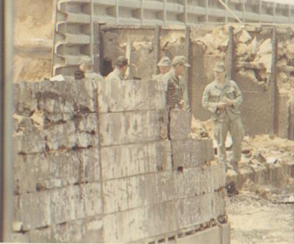

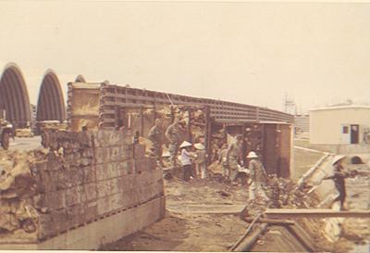

The number of fatalities in this article is in error. Twenty three actually were lost.

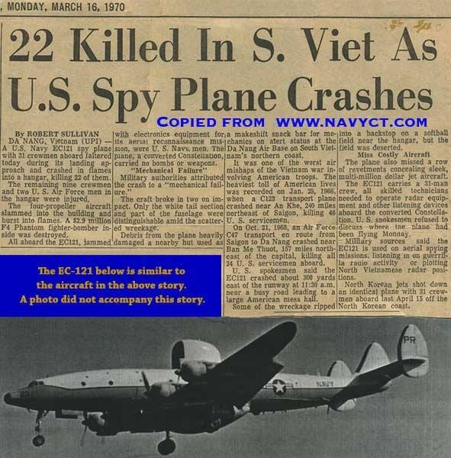

PR-26 Crashed at DaNang, March 16, 1970

LCDR Harvey C. K. Aiau USN
LCDR Harry C. Martin USN
LT Robin A. Pearce USN
LT George L. Morningstar USNR
LTJG Charles E. Pressler USNR

LTJG James M. Masters Jr. USNR
LTJG Jean P. Souzon USNR
ADRC William John Risse USN
ADR1 Arthur “D” Simmons USN
ADR1 Donald Wayne Wilson USN
AT1 Larry Overton Marchbank USN
AE2 Floyd E. Andrus III USN
AMS2 William P. Bletsch USN
ATN2 Guy Thomas Denton USN
ATN2 Joseph S. Saukaitis USN
ATN2 John S. Schaefer USN
ADR2 Stuart J. Scruggs USN
ATN2 Barry M. Searby USN

ADR3 Gregory J. Asbeck USN
ATN3 John Macy Birch USN
ATN3 Ben Allen Hughes Jr. USN
ATN3 Thurle E. Case Jr. USN
ATN3 Ralph S. Purdum USN
Survivors
ATCS Robert K. Ishler
LT Delivan (Del) Young
ATR2 Don Holder
LTJG Val S. Watkins
ADR2 Hugh G. Shannon
AEAN Charles M. Bingham
ADR2 Steven E. Westacott
AE2 Dean A. Merrill

