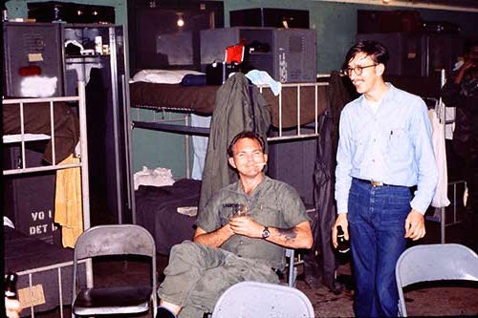

A Vietnam Story 1970
By Chuck Landers
A number of years ago, I received an “all-expenses-paid” tour of Southeast Asia from a relative named “Uncle Sam.” I’m sure a great many of us in my age group got the same invitation. Uncle failed to mention that the sunny climes of Vietnam were interspersed with high temperatures, typhoons, and the occasional rocket attack.
At that time, I was a crew chief plane captain on a U.S. Navy reconnaissance aircraft at DaNang, Vietnam. Our plane was hard down at the time, for a propeller change. I assisted the mechanics swap out the old prop for our new refurbished, shiny one.
We were scheduled for an early daylight test flight for the new propeller. Very tired after a ten-plus-hour flight that day, plus the maintenance hours of swapping out the propellers, I decided to crash out in the mechanics’ hootch that night.
The hootch was basically a “conex box” (a shipping container) with a couple of workbenches, some toolboxes, and a small parts bin. But it had air conditioning.
As we were settling down, I heard a jingling noise. I rose up to see John “Augie” Augustynowicz, one of the younger mechanics, dangling this thing over my head. I asked Augie what the hell is that? He proudly announced it was his “rocket stopper.”
I looked at this “charm,” which consisted of a bathtub stopper, his ID dog tags, and an expended bullet from an M-16 rifle – pretty hokey, huh? I looked at Augie dubiously, and he announced, “It works. – I’ve never been hit by a rocket.” I had to admit that it sounded logical to me.
The next morning, while our plane was up for a quickie check flight, I wandered over to the area where the carrier fighter and attack planes came into the flight line to refuel and re-arm. I found some loose ammo lying on the ground, and asked a BB stacker (ordinance man) if I could have one. He readily agreed. A 20 mm round is pretty hefty, like 3/4 of an inch in diameter. I set about to make my own version of a rocket stopper.” This was a live round, so I wrapped the casing in a thick rag, and very carefully drilled a hole through it – oiling and wetting my drill periodically so it wouldn’t explode – and emptied out the powder. I put a chain through the hole, and buffed the casing with Brasso and Never Dull metal polish. To this I added my ID dog tag, and a purloined stopper. (Info: I never saw a bathtub in Vietnam.) This was a work of art. Never have you seen such a shiny bullet. That very night, while wearing my newly created amulet, we had a rocket attack on our base. As I ran for our bunker, I tripped and blew out a flip flop (shower shoes), and landed on my new good-luck charm – directly in my chest. I limped into our sandbagged bunker with bleeding toe, (tore my toe nail), and clutching my chest from my good-luck-charm bruise. My friends all thought I’d been hit.
When they looked at my rocket stopper they all proclaimed, what a dork (dork was not a Navy word then) I was – because the primer of the 20 mm round was still intact.) I had neglected to fire that.
Later that morning, around 3 a.m., I took my talisman to our work area to disarm my amulet. (In my skivvies, flip-flops, along with my toy and flak vest.)
I once again wrapped this work of art in thick rags, and clamped it in a vise. I smacked the thing about three times with an awl and a ball-peen hammer. Nothing. Then the last smack produced a flash, a terrific bang, and smoke was all over the place. I was immediately surrounded by several perimeter guards with shotguns, M-16s, pistols, etc. – all aimed at me. I lamely tried to explain my rocket stopper, to no avail. But I carried my rocket stopper with me the rest of my tour in beautiful Southeast Asia, courtesy of my rich Uncle Sam. Must have worked. I never got hit with a rocket.

