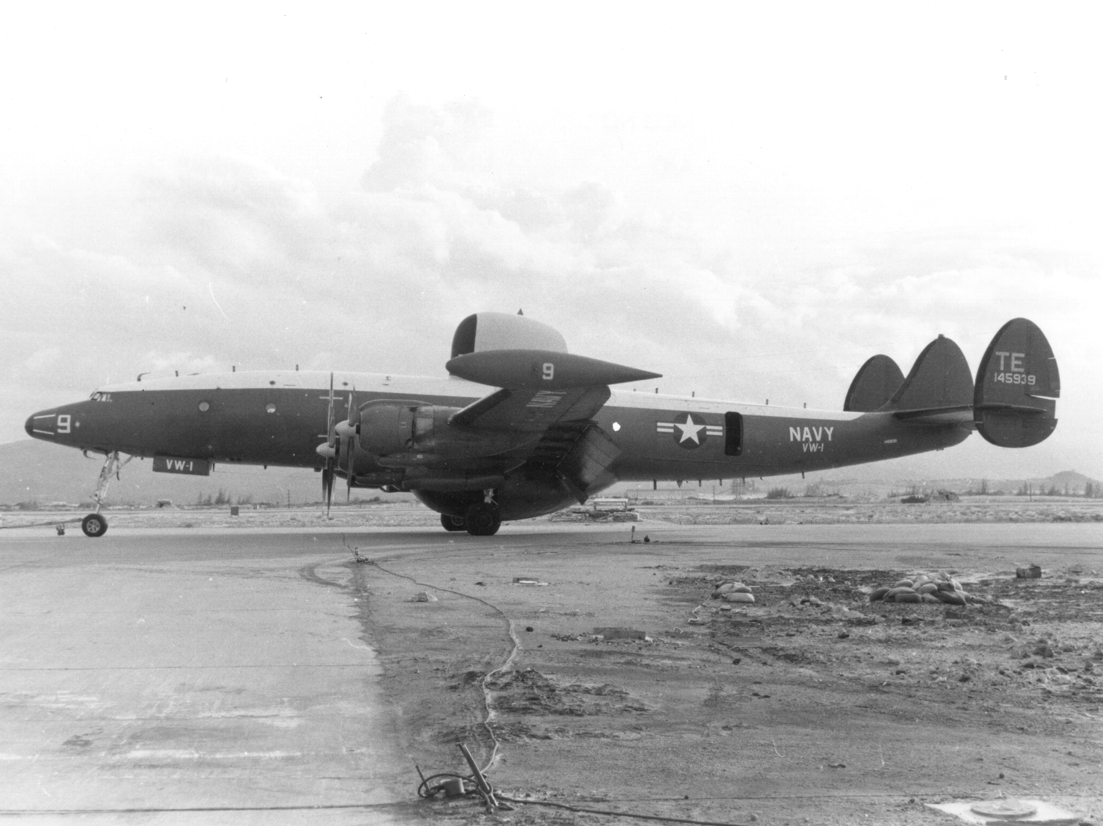

VW-1 EC-121K aircraft in Vietnam, probably in the mid to late 1960s

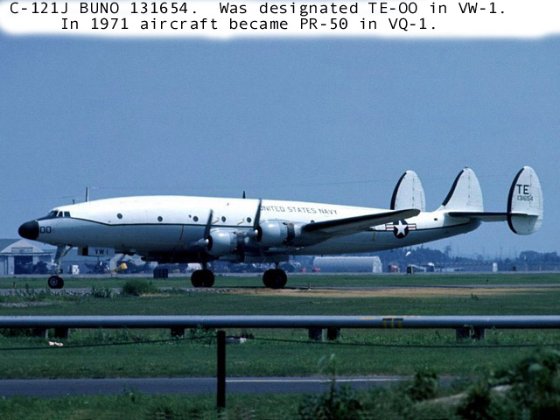

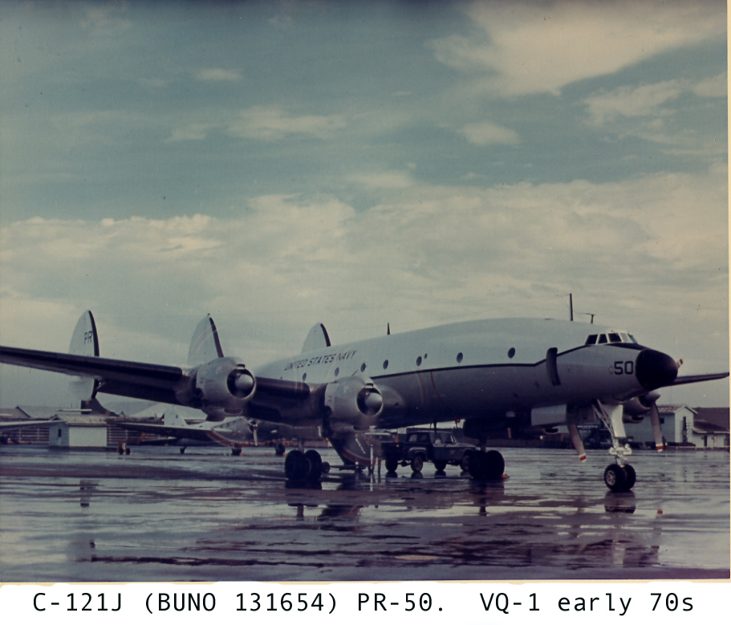

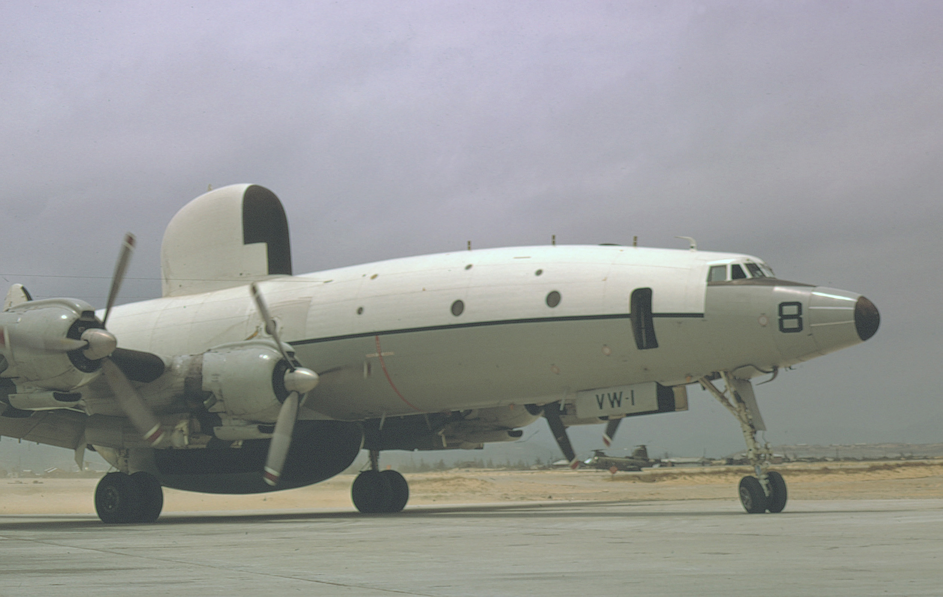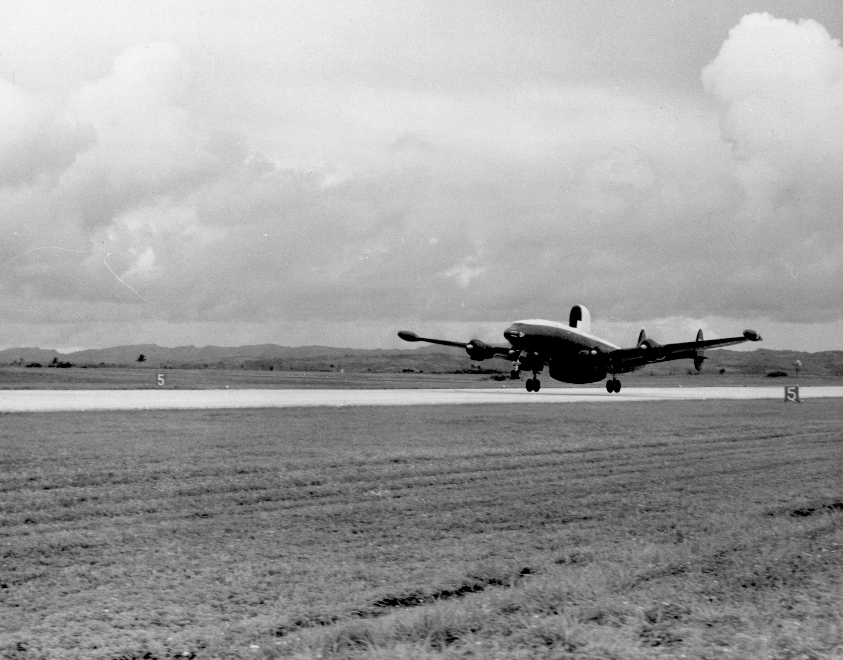

VW-1 EC-121K aircraft, location unknown

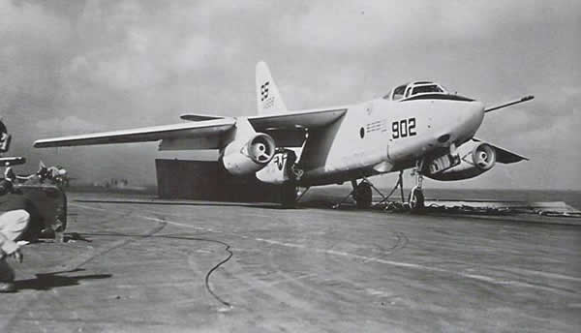

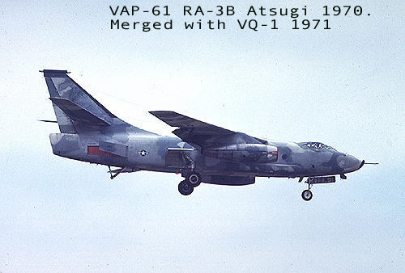

[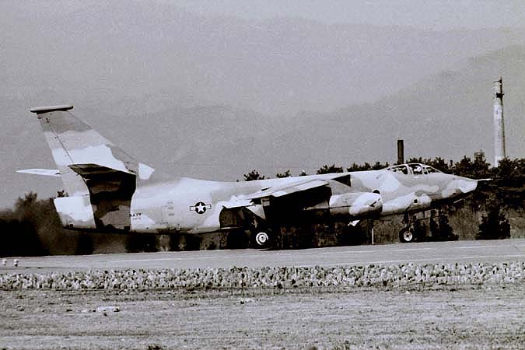](http://www.google.com/url?sa=i&rct=j&q=&esrc=s&source=images&cd=&docid=AZYfJKytHbKurM&tbnid=xeOCpJH9fBqroM:&ved=0CAUQjRw&url=http://www.vaq34.com/vaq34/gd210.htm&ei=5IvOU5OZMoSIogTZxILQBg&bvm=bv.71447997,d.cGU&psig=AFQjCNFumNq3ifSEQvCDXJtBj0RO7CTi4Q&ust=1406131555586572)

