VQ Detachment Atsugi 1971-1991
OIC
1971-1972 LCDR P.D. Smith
1972-1975 CDR L.R. Lamb
1975-1977 LCDR B.K. Pierson
1977-1980 LCDR J.T. Mitchell
1980-1983 CDR R.E. Atwood
1983-1985 CDR C.E. Epley
1985-1987 CDR R.E. Leonard
1987-1989 CDR J.E. Russell
1989-1991 CDR B.L. Clark

The Det was comprised of 7 Officers, OIC, 2 Intel Officers, 1 Operations Ofcr, 1 EW Ofcr, 1 Maint Ofcr and a SPOD Ofcr. 33 Enlisted, 1 SCPO, 1CPO, the rest evenly divided between the Comm Center/Admin and Maintenance.

The det also had a large contingent of TAD personnel from Guam including a Maint Chief usually a flight engineer, and additional maintenance personnel as well as several non rated as duty drivers, and mess attendants. This flight engineer and the det pilots and sevals provided substitutes when needed for the deployed flight crews.

Offices were in several locations Maintenance in the Hangar which moved several times. Special Projects, located in a metal building across from the Hangar, was eventually moved to building 181. The det headquarters building was in the Northern half of Building 181which was shared with the Naval Security Group Detachment. In 1983 SPOD was moved from the warehouse building near the hangar to building 181.

Building 181 was a nondescript building located on the side of the golf course that housed the det until 1991 when the det was moved to Misawa. Building 181 was shared with the Defense Mapping Agency which held the Southern half and NSG Det and VQ-1 Det who held the Northern half. In the squadrons half the East side was VQ the West NSGD. The SCIF, comcenter, briefing room was shared by both dets.
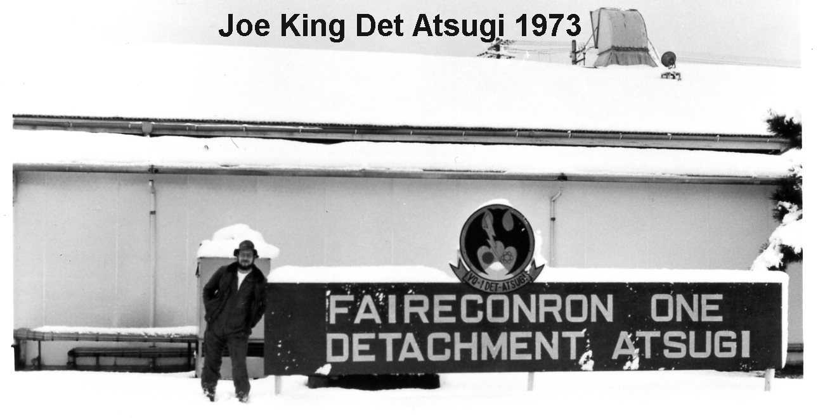

The VQ Detachment was made up of 7 Officers, the OIC I believe always a pilot, a Maintenance Officer 0-3, two Intelligence Officers 0-3 & 0-2, an EW Officer 0-3 always a SEVAL, Operations Officer 0-4 a pilot, SPOD Officer 0-4 always a SEVAL. In addition SPOD had two civilians, Elmer Akerberg, who retired in the early 90’s, Chuck Christman, who left in the late 70’s and was replaced by Larry Sharpe. Larry Sharpe developed severe MS and retired in 1989 (I believe) and was replaced by Mark Franklin, who stayed on until SPOD was moved to Guam in the 90’s.

During the late 70’s through the mid 80’s the Det Atsugi normally had two EP-3’s on site with a crew for each aircraft. Normal flying was 6 missions per week at 10.5 hours each. Detachments from Atsugi to other sites were common with 2 to 4 missions per month in Korea, others to Misawa, Kadena, Shemya and Midway. During the Iranian Hostage Crisis while the planes moved to Diego Garcia the missions and aircraft deployed to Atsugi decreased. The det frequently hosted the Squadrons VA-3/VP-3 used by Com7thFlt. About once a year two or three of the squadron EA-3’s would deploy to Atsugi for special mission training. With CTF-72, located a few miles away in Kamisaya, being the operational commander of VQ the OIC was frequently called over to provide input to the staffs’ plans and to brief them on squadron operations.

In 1983 an inspection of our secure facilities in Bldg 181 determined that we did not meet even the minimum requirements for a SCIF. Contacting the NAF CO and his construction people we were told that if we got the proper paper work started and could get priority we could get the facility upgraded in 7 years. To the shock of the base personnel and the help of CINCPACFLT we were moved to project 1a on the construction list for all Westpac. Project one was already in work. As a result contracts were let and we took over the Southern part of the building and moved SPOD into that section. The Squadron and NSG spaces were completely renovated and the comcenter and SCIF were significantly enhanced. The entry was moved from the North end of the building to the center and all entry from the lobby was strictly controlled while a fence was placed around the former entrance and back of the building. Separate controlled entry was made into SPOD, the Comcenter, the SCIF and the NSG spaces as well as to the general admin spaces. Work and movement was completed by 1984. One humorous part of this project was that the Japanese construction company notified us that the bathroom spaces were not adequate. Because of the location of the plumbing we had to place the bathrooms off the lobby between the lobby spaces and SPOD with entry from both sides. Since we had limited space and we had several women working in the building we needed two bathrooms. Being fair we divided the available space in half for each sex. The construction crew looked at the limited space and informed us that the ladies needed a larger room. After much discussion the Japanese informed us that the additional needed space was for the ladies “crying room”. We modified the space giving the ladies their required space.

In 1979 the det moved from Atsugi to Yokota for several months while Atsugi’s one runway was resurfaced.

A tale of two Typhoon Parties

In October 1979 Super Typhoon Tip formed in the South Pacific and marched toward Guam. Normally as one of the VQ Squadrons P-3 Aircraft Commanders I would have been assigned to fly one of the aircraft to a safe destination out of the reach of the oncoming storm. Having just returned from a month where my crew had flown 246 hours it was decided that the crew deserved a rest and should stay and weather the storm on Guam at what was fondly referred to as a ‘Typhoon Party’. As luck or good fortune would have it Tip did not intensify as much as predicted and the impact on Guam though sever did little damage to the base or housing area. After the typhoon passed Guam we continued to fly training and relocation missions, mostly to Japan, making sure we stayed well away from the now raging Typhoon. As it turns out considerable activity of interest was occurring in the Sea of Japan at that time, and because of runway repair activity in Atsugi, VQ missions were being flown out of Yokota Air Force Base. The Det had set up maintenance and operations in a small office near the flight line there and intelligence was handled at 5th Air Force headquarters. The Dets one EP-3 came down with a problem requiring a change of the number one engine. On the 18th of October with a minimum crew I flew a replacement EP-3 from Guam to Yokota where the deployed crew fueled it and flew to Osan, away from, you guessed it, a fast approaching Typhoon Tip. Now let me set the scene, Super Typhoon Tip is approaching bore sighting the Kanto Plain, due to hit early the next morning, permanent Det personnel have headed back to Atsugi to be with their families, an EP-3 sits on the ramp with the number one engine removed, and there are no hangars or tie downs anywhere on Yokota airfield. The plan was to position the aircraft into the expected winds, tie the nose down to the large Buddha tractor, drink coffee and wait it out. Nothing goes according to plan and Murphy’s Law held true. The winds did not come from the predicted direction in fact they were 90 degrees off that heading. From inside the building we watched in horror as the winds started bouncing the aircraft up and down jerking the Buddha as it tried to point into the wind. Something had to be done and the only thing we could think of was to get the plane started and use the thrust from the engines to hold the plane down. Accordingly, I was transported on a second Buddha to the aircraft and climbing on the roof of the Buddha was able to get inside the aircraft (luckily the wind was hitting the opposite side of the aircraft). Up front soaking wet I started the number two and three engines and noted with pleasure that with about 1,000 hp on each engine the bouncing stopped. Only one big problem remained. As many will tell you I do like to drink coffee and had pretty much drained a large pot before starting this adventure. Now alone in the cockpit, cold and wet I did not have the luxury of being able to go back and check out the facilities. Hours later after the major blow had dissipated I secured the engines and made my way back to the head, unable by then to straighten up. Murphy was again in charge and the urinal, honey bucket even the trash can had been removed. Desperate and without even a ladder to get down from the plane, I threw open the door and added to the still falling raindrops with a relieved smile on my face. Some Party!

Typhoon Tip formed on 4 October and passed 28 miles South of Guam on the 9th, shortly after passing Guam Tip rapidly intensified and reached peak winds of 190 mph and a worldwide record low sea level pressure of 25.69”. At its peak strength, it was also the largest tropical cyclone on record with a diameter of 1,380 mi. Rainfall from the typhoon breached a flood-retaining wall at a USMC training camp in Japan, leading to a fire which injured 68 and killed 13 Marines. Elsewhere in the country, it led to widespread flooding and 42 deaths. 44 were killed or left unaccounted for due to shipwrecks offshore. Tip finally broke up near Alaska on the 21st of October.

Another semi humorous incident occurred not sure of the year but an alarm went off in bldg 181 and everyone evacuated the building, standing around just outside in the parking lot. Base security arrived and set up barricades and a do not cross line. The base CO showed up and marched across the line only to encounter a rifle pointed at his chest. Not a happy camper he was shocked to find that not only was the rifle pointed at him but that it was loaded and that the security force had shoot to kill orders. The base CO of NAF Atsugi was generally a helicopter pilot and few of them had clearances above Secret so they had little to no idea what went one at this piddling, little detachment. He called the OIC and the base security officer into his office looking to rake someone over the coals for his humiliation and violation of his not loaded weapons rule. The security officer presented the CO with the standing orders that required loaded weapons and a secure perimeter if case of alarms in the building. The OIC tried to explain why without providing too much detail. In the end, the orders stood.

Same Atsugi CO, different incident. Air Force One arrived at Atsugi (the president having been dropped off already) with the Chairman of the Joint Chief’s and his deputy on board. As soon as they stepped off the plane they ordered the CO to take them to the VQ-1 Det. Flabbergasted, the CO wanted to know why and he was told they needed to go to the comm center. The CO informed them that he had the comm center, not VQ. They insisted because his comcenter could not meet their requirements. The CO was left in the lobby while they entered the SCIF and conducted their business. This was the first time the CO learned that a separate comm center was located on his base.

In 1991 the OIC accepted a new hangar on the east side of the field that would have contained both the VQ and NSG Detachments with a new SCIF and all the maintenance spaces required. Before they could move into the hangar a new carrier had arrived and the Commander Air Wing Five decided that he needed all his Air Wing in one location. At the time the new S-3 squadron was located in Misawa. The proposed solution was to move VQ-1 Det to Misawa and give the new hangar to the VAQ squadron. Admiral Bull later said that was the worst move he had ever made but the S-3’s moved to Atsugi and VQ-1 Det was moved to Misawa.

At the Atsugi O Club the detachment had its own table and generally the same waitress. The menu contained one item known as the VQ-1 Special. It was a hamburger steak and was quite good. Kenny and Charlie manned the bar in the club. The maître d’ was Akita-san.

