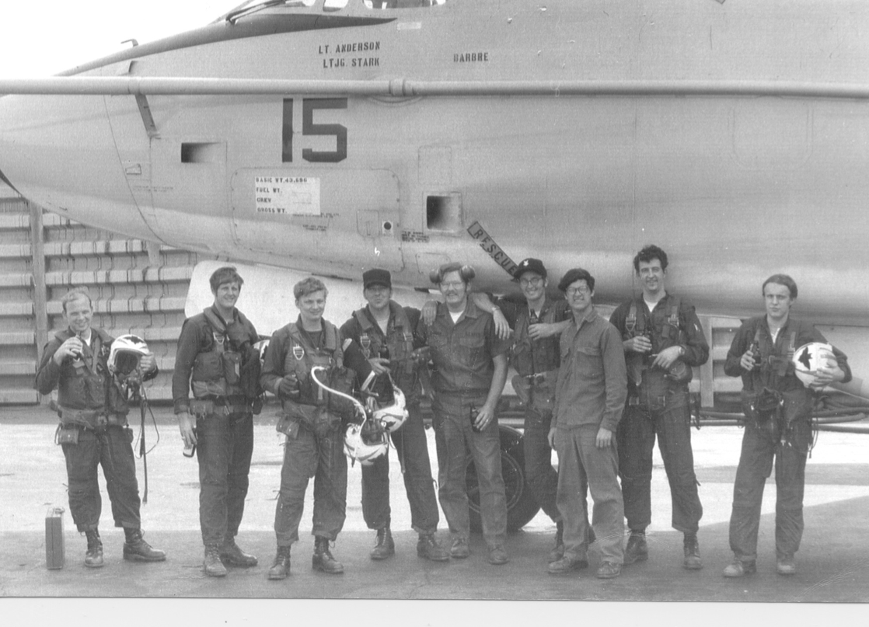

Last EA-3B combat mission of the Vietnam War, 1 Feb 1973,
DaNang, RVN.
Aircraft BUNO 144854, CREW 2 (left to right):
LTJG Steve Berbeck (Seaval), LT. Ken Anderson (Pilot), LTJG
Tom Stark (Nav), PO2 Bobo, (Backend ECM), AMS2 Andy
Barbre (P/C), PO2 Wilson, (Backend ECM), Airman Bockman
(Backend ECM) CTI2 Gary Nelson and CTISN John Phipps.

