A Thumbnail History of VQ-1’s PR-29
(Watching the Russians while the Russians watched us)
Robert Fritzius, LT USNR (retired) VQ-1, 73-75

Sometime in fourth quarter of 1974, the Soviet AGI, one of whose jobs it was to monitor Polaris submarine activity in the approaches to Guam’s Apra Harbor, had no installed underwater listening capability but used passive acoustic sonar buoys with radio links for that task.
VQ-1 Special Projects established a radio receiver post at COMNAVMARIANAS in-tercept and record the AGI’s sonar buoy transmissions. From this elevated, mid-island, location it was about 11-12 nautical miles to the AGI in its typical operating area. Guam Area Reports were transmitted up the chain daily based on signals analysis.
To get closer to the action (4-5 nautical miles to the AGI) an AC power line was extended to the tip of Orote Peninsula and a maintenance van was transported there to house, power and shelter monitoring equipment and crew operators. This new site permitted visual tracking of AGI activity. A precision-focus telescope at the site allowed daytime bearing and distance tracking of the AGI. A Brigand (bi-static radar receiver using FAA radar from the northern end of the island as the illuminating source) was added to give day/night position tracking of the AGI and other local surface contacts. The maintenance van, turned observation post, was christened as PR-29. This monitoring/tracking activity continued long after the acoustically impaired AGI was spelled off.
The Guam Area Reports, which continued to be transmitted daily, were ultimately instrumental in the Navy’s implementing an improved underwater acoustical defensive posture in the Guam area.
Most likely Chuck Christman came up with the idea. He gave us our initial "what to do" for the first listening post in Agana Heights. Chief Williams may know about the naming of the trailer. I think I was on detachment while the van was being installed.
(I transferred out PCS on 30 Oct 1975 and have no knowledge of PR-29 activity after that date.)

Chuck Christman, Special Projects Civilian
It was started because a brand new Soviet designed sonar bouy washed up on the beach (date of manufacture was early that year), and SUBRON 15 was paranoid about the bad guys trailing the "Boomers." Among other things PR29 had the best VHF/UHF receiver we had on hand, and folks in REWSON provided this. As I recall we never heard anything on it, it had a panoramic display of activity so the operator did not have to randomly tune looking for Soi's. One time three fresh Soviet sonar buoys were noted turning on as one of the USN boomer came into port. Hoping enough time has passed so they won’t put me in jail, it has been a very long time. I think it was between Tim Connolly (VQ-1 XO) and SUBRON 15. It got a lot of attention at CPACFLT and C7F.
Chuck Christman, Crab

Ron Williams, ATCS
I was responsible for setting up, equipping and running the trailer on Orote point. It was a project that Capt. Connelly tasked me with after I quit flying. After I set it up in 1975 I soon after transferred back to the states. I wasn't aware that they gave it a call sign. All I know it was on a muddy piece of land that overlooked the established embarkation point for the nukes out of the Naval Station. When I operated it our biggest intercept was that the VP squadron’s trailers were emitting signals from their briefing rooms and possibly giving away their mission briefings. It was fun setting it up but a pain in the rear running.
Ron Williams

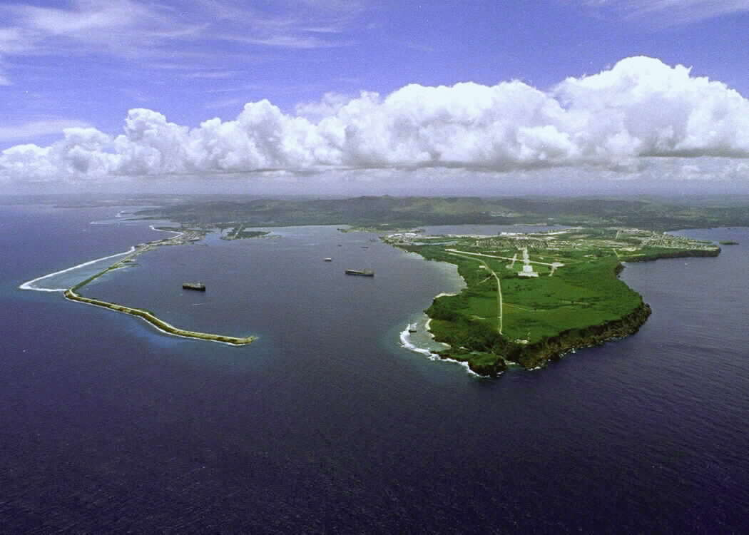

Arote Point Guam

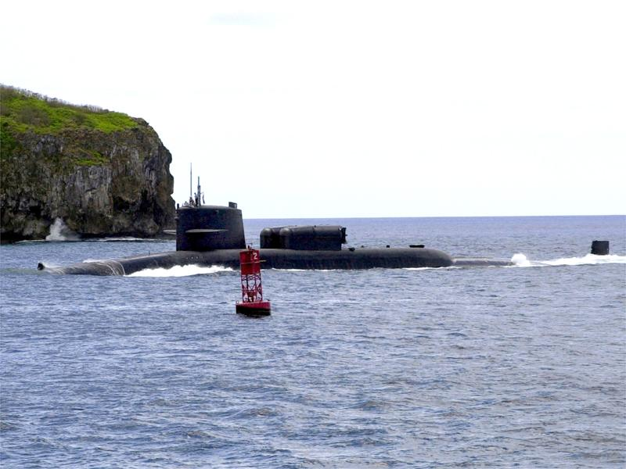

Nuclear Submarine passing by Arote Point

