23 JAN 85 - VA-3B Buno 142672 (PR-111) Skywarrior. Squadron VQ-1. Lost in flight 134 miles NE of Guam. Fatalities:
Cdr. John I. Mitchell, CO of VQ-1
Cdr. Robert E. Delateur
Lt. Marshall M. Laird
Lt. Carlos A. Miller
Ltjg. Richard A. Thomson
AMSC John T. Clar
AEC David K. Nichol,
AT3 Thomas J. Jorgenson
AD3 Thomas J. Degryse
(Taken from Chuck Huber’s listing of VQ-1 and VQ-2 accidents 1950-1987)

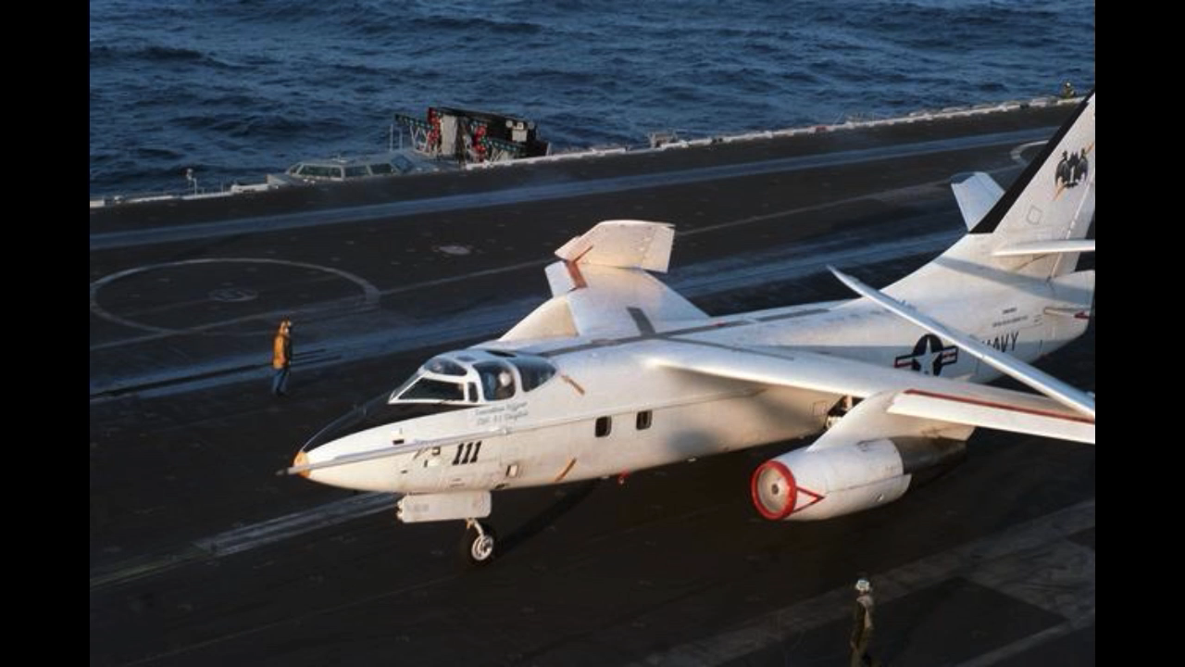

January 23, 1985 Loss of VQ-1 VA3B
The Death of a Commanding Officer
CDR John T. Mitchell assumed command of VQ-1 in March 1984. Ten months later, on 23 January 1985, he and eight other VQ-1 personnel were killed when the squadron VIP aircraft was lost at sea en route to Guam from Atsugi. CDR Mitchell was piloting the VA-3B when it disappeared from a radar-tracking screen approximately 125 nautical miles north of Guam.
The subsequent JAG investigation, completed in September, reported the Skywarrior took off from Atsugi at about 1000 Guam time. Twenty minutes later the crew contacted the VQ-1 detachment at Atsugi and reported an air turbine motor (ATM) was malfunctioning. The VA-3B continued on its course and stayed in radio contact with Navy officials, first on Iwo lima, and then on Guam. At 1230 Guam time the navigator reported the starboard ATM was shut down and the port one was heating up. Seventeen minutes later the aircrew requested permission to descend from 33,000 to 20,000 ft. Four minutes later, at 1251, radar contact was lost with the stricken aircraft.
A massive air and sea search and rescue effort failed to locate any trace of the VA-3B or its crew and passengers. Presumed dead were CDR Mitchell; LCDR Robert E. Delateur; LTs Marshall M. Laird and Carlos A. Miller, LTJG Richard A. Thomson; Senior Chief John T. Clark; Chief David K. Nichols; POs Thomas J. Jorgensen and Thomas J. Degryse. Thus, CDR Mitchell became the first incumbent VQ-1 commanding officer to be killed in the line of duty.
An endorsement to the accident investigation by VADM James E. Service, Commander Naval Air Pacific, summed up by saying: “Although the exact cause of the mishap cannot be determined from available information, dual ATM failure with resultant flight control problems is the conclusion best supported by the circumstantial evidence.” The ATMs provide power for the hydraulic pumps, which in turn power the flight control surfaces.
CDR R.E. .“Bob” Claytor, the executive officer at the time of CDR Mitchell’s tragic death, became the new CO and led the squadron through the next 16 months until relieved in May 1986 by CDR Earl Smith. At this writing, CDR Smith is scheduled to relinquish command to CDR Marcus Williams in August 1987.
"A History of U.S. Navy Fleet Air Reconnaissance"
By CAPT Don C. East, USN
Originally printed in "The Hook" in spring of 1987 issue

Jan 23,1985 loss of Triple Sticks. This one is well documented, but I will remind folks that the crewmembers onboard the aircraft that day were largely P-3 bubbas just hitching a ride to Guam. Skipper Mitchell was revered by the squadron, along with the others lost that day. I was at work that day when I learned that my neighbor, an A-3 crew chief was launching on a SAR mission. I jumped into a flight suit and headed to the hangar. We launched a P-3 as well as the A-3. We searched day and night for seven days not finding as much as a seat cushion. There was some speculation during the investigation that the P-3 crewmembers riding in the back of the aircraft couldn’t’t have gotten out during a ditching situation. We filled an A-3 on the ramp with P-3 bubbas like myself, and proved that we could evacuate the aircraft in less than 30 seconds…. albeit sitting on the ramp without the fear and adrenaline of a ditching at sea. I’m not sure whether we know what really happened to that aircraft that day…ran out of fuel or lost both ATMs and couldn’t maintain controlled flight, but we certainly lost nine great Americans.

Bill Beard AVCM (NAC) USN Ret.

