This excerpt taken from Bill Crane’s History of Army NSA, ASA and 1st SAD

“Just to let you know…. prior to your stint in ASA as a back ender in some of the more modern aircraft, there were some of us in SAD 2 flying out of Adana (Turkey) in P2Vs and P4ms in 58, 59 & 60 out of Rota, Spain with ECMRON 2. During that time there was only one of us on each flight. There were no Army or Navy Aircrew wings for us. I have photos of our aircraft during that period provided by Don Gibbs USN that I will forward to you. I was at Adana when Powers (Francis Gary Powers) was shot down with the U2, used to watch him take off and land. Another ASA pers and I were the only Army pers involved with the mission and lived off the side of the runway in Squad tents we shared with the Navy crews when they rotated every 3 weeks”
“Photo credits should go to Don Gibbs USN Air crewman...these surfaced only last FEB from a box in his attic and are the only ones known to be in existence of the P2Vs and P4M in our operation at Incirlik AFB in Turkey.... time period 1958-1960, note the B47 in one photo, this was the Aircraft operated by the Air force we competed with. Don is crewman shown in the foreground of one of the first photos in his tan Navy flight suit.

“If my memory serves me, the SAD's were not activated until 1963-64, even though Army troops had been sitting ELINT positions in VQ aircraft since '58 (maybe as early as '57). I recall during my tour in the Missiles & Space Branch, Headquarters USASA (Jul'63-Jul'65) having some staff actions which I think were the "activation" of the SAD's-. - I recall the Detachment Commander~ a black dude, Captain I think, spunky and proud-- a lot of fun to have around, and I suspect he ran a good show. (The “black dude might have been SSgt Gene E Thomas. The Captain was Robert C Newland who was indeed spunky. We called him ‘bouncing bobby’)

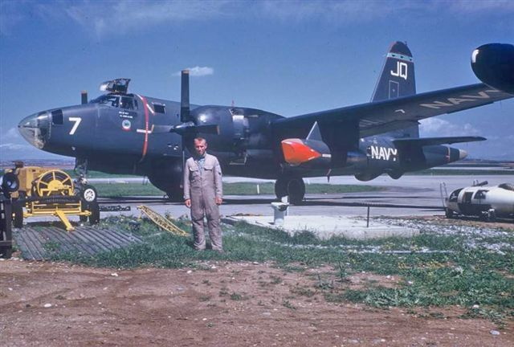
VQ-2 P2V-5F at Incirlik, Turkey Photo by Don Gibbs
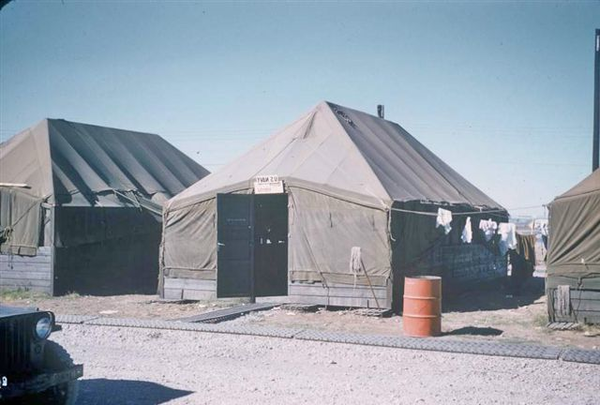
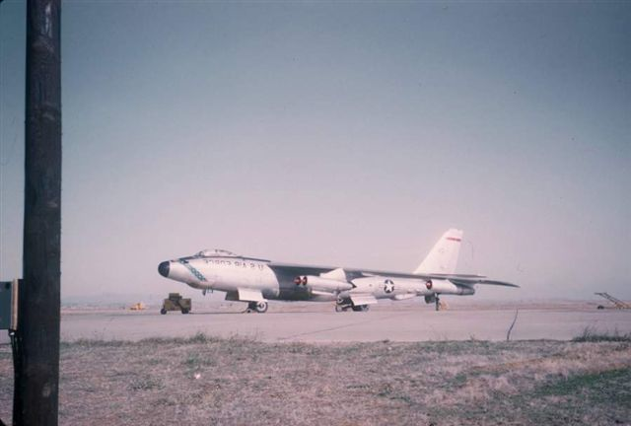

Billeting and a USAF RB-47 at Incirlik, Turkey in the late 50s. Photos by Don Gibbs
“My first involvement was in 57-58. At that time the ELINT operators were assigned to TUSLOG Det-4, Sinop, Turkey and rotated in TDY (temporary duty) status to Incirilik. I arrived Sinop Sep/Oct'57 and immediately became OIC (Officer In Charge) E-Ops (ELINT), but I don't recall if we had already had some flights with ECMRon-2 in P4M Mercator and P2V aircraft or if that didn't come until early '58. I do recall several occasions ~ our ELINT troops flying in those aircraft before the first EA3 Skywarrior showed up at Adana-- it also seems to me that all this occurred before the squadron moved to Rota (Spain). We were chasing missile telemetry and beacons and fusing signals associated with the Soviet missiles and space program. These signals were short lived and not routinely available, sometimes "early warning" wasn't sufficient to get the slow movers from Adana out over the Black Sea in time and at an altitude to get the early missile launch/f1ight signals of interest. Enter the A3DQ before an ELINT configured A3 was available; we (me, one of our maintenance troops, an EDL engineer and a Navy aviation-mechanic) replaced the nose radar with a dipole (antenna) cut to 55 MHz. It was too long to fit across the width of the random enclosure, so we simply folded it accordion style until it would fit--. I also recall getting aluminum foil from the Air Force mess to put on the random bulkhead (to) act as a reflector. The A3 carried only three--, two up front to drive and bomb, and one EM in the back (flying backwards) as radioman (I. think he was also called the "airplane captain??). A VHF (Very High Frequency) receiver was installed in front of the operators seat, but the HF (High Frequency) radio (used to "receive instructions") had to be under the operator seat-- and to change/adjust freqs on the HF (which seemed to need done frequently) you had to get out of the operator seat (using a small walk around oxygen bottle) and get down on the deck to look under the seat. Another "interesting" aspect of that A3 experiment was that to get the SOI (Signal of Interest), we had to fly directly towards the signal source-- which often was head-on to the coast line, versus parallel-- but at least we got there faster and higher.”

