NSA, ASA and 1st SAD

World War I: COMINT (COMunications INTelligence)

Bill Crane

In its infancy 1917-1919
When the First World War broke out in 1914, all the major combatants were using wireless. Unfortunately, the lack of really secure ciphers made wireless transmission risky. If intercepting telegraph traffic was simple, with wireless it was almost unavoidable. Messages were broadcast over the airwaves, and anybody could pick them up. In fact, before wireless, one of the problems in cryptanalysis was intercepting enough messages to permit reasonable analysis. After wireless, the problem was sorting through the flood of messages that poured in over the airwaves. Despite the lack of security, there was often no alternative to wireless, since it allowed governments to communicate with warships at sea and armies on the move.
On the first day of the war, a British ship dragged up Germany's transatlantic telegraph cables and cut them. From that time on, the Germans had to use radio links or telegrams sent through neutral nations, and both methods left them open to interception. As the Germans had advanced into Belgian and French territory where telegraph lines had been cut, it forced them to rely on wireless. The French and British, in contrast, only absolutely needed to use wireless to communicate with ships at sea.
At the outbreak of the war, Britain had no formal code breaking operation. The British Admiralty's Intelligence service began to intercept German wireless messages and quickly recognized the need for a formal cryptanalysis organization. Volunteer code breakers were found in the country's naval colleges. The French actually had formal code breaking groups, five of them, in place before the war, but after the outbreak of hostilities the French built up their "Bureau de Chiffre" (Cipher Bureau) in particular. Both the British and French established radio listening and radio direction finding stations. The Germans, in contrast, did not become serious about such matters until 1916, when they set up their own radio-intercept organization, the "Abhorchdienst".
The U.S. had no formal code breaking organization although a few people were engaged in cipher work at Riverbank Lab in Geneva, Illinois. The lab was founded by George Fabyan, a millionaire cotton merchant and honorary Colonel. Originally founded as a genetic research lab, Fabyan also sponsored cipher work by a small staff trying to find and break ciphers supposedly used in Shakespeare’s plays. When war broke out in Europe Fabyan offered to put his cryptographers and laboratory at the disposal of the government. Riverbank became the "unofficial" cipher bureau until the MI-8 was established. William F. Friedman was part of the staff at Riverbank and began teaching cryptography classes there. In 1918 Friedman was commissioned and joined Pershing's AEF Headquarters where he worked on code breaking as part of the AEF Radio Intelligence Section.
When the U.S. declared war on April 16, 1917 it almost immediately took actions to strengthen its weak intelligence organization. On April 28th the Army Chief of Staff issued a memorandum directing the formation of a code and cipher decryption unit, called the Cable and Telegraph Section, or MI-8, within the Military Information Section (MIS). At this time the MIS was under the War Department General Staff (War College Division) headquartered in Washington D.C. While a gifted Regular Army officer, Major Ralph Van Deman, quickly revitalized the Military Information Section (MIS), the MI-8 (Cipher Bureau) was organized under the lead of Herbert Osborne Yardley. MI-8 was assigned the dual mission of making and breaking codes. On February 9th 1918 the MIS was re-designated as the Military Intelligence Branch (MIB) and on August 26th 1918 it was re-designated as the Military Intelligence Division (MID). Van Deman's MID was America's first complete, national level intelligence agency. It used HUMINT, SIGINT and, to a lesser degree, IMINT (IMagery INTtelegnce) to collect information. It also had counterintelligence, mapping, and security agencies.
The Signal Corps began training radio intelligence enlisted members at Camp Alfred Vail (founded in 1918 and renamed Fort Monmouth in 1925). Almost all intercept/DF (Direction Finder) operators en route to Europe received their training at the Signal Corps School.
While Ralph Van Deman was organizing a workable Army level intelligence unit back in Washington in 1917, our forces arriving in France were facing a while different set of challenges. General Pershing (Commander AEF) and his staff immediately recognized the need for a tactical intelligence system. MAJ Dennis E. Nolan was placed in charge of intelligence for the AEF. Using the French System, the first G2s/S2s were created in the fall of 1917. Regardless of the value placed on intelligence during the war, the U.S. military followed it's normal pattern of demobilizing forces in peace time, to include intelligence personnel. The intelligence personnel in the AEF (Radio Intelligence Section) and MI-8 were demobilized, with the officers going into the newly crafted 'MI Officers Reserve Corps'. Active duty intelligence slots were filled by detail; it being assumed that intelligence work was a function of command and could be performed by any Regular Army officer. MAJ Van Deman and part of his MI-8 staff survived the demobilization by being transferred to the State Department as civilians. In August 1919 Herbert Yardley moved the 'Black Chamber' (MI-8) to New York.
When General Pershing became the Army Chief of Staff in 1920, he used his former AEF staff organization as a model for the General Staff. There were now a G1, G2, G3, and G4 of the Army. Unfortunately, G2 wasn't an equal partner. The Military Intelligence Division of the Army Staff was cut back to 20 officers. Due to Congressionally-imposed restrictions on the number of general officers permitted to serve on the General Staff, the G2/Military Intelligence Division was normally headed by a Colonel while the other Division's had a General officer as their head.

Between the World Wars:
1920 – 1941
(note: text in parenthesis and italics are my comments for clarity)
The 1920's saw two more significant technological milestones - in 1921 the first electronically transmitted photograph (facsimile) was sent by Western Union and in 1927 the first television is demonstrated.
Although the responsibility for Army code and cipher compilation transferred to the Signal Corps in 1920, the MI-8's code and cipher compilation solution section continued as a covert cryptanalytic agency jointly funded by the War and State Departments. Still under Yardley's control, the MI-8 scored a number of significant triumphs in the 1920's. Most notable being it’s managing to decrypt the Japanese diplomatic code in time to strengthen the U.S. negotiating position during the Washington Peace Conference.
In August 1921 an agreement was reached between the Military Intelligence Division and the Signal Corps, which consolidated code and cipher compilation under the Office of the Chief Signal Officer and left to the Cipher Bureau (MI-8) the job of code and cipher breaking.
On 30 June 1929 the MI-8 (Black Chamber). Black Chamber was an old French phrase for any government agency that opens and reads mail.) It was discontinued due to two factors. The Army had come to the conclusion that Yardley's small operation, with its aging civilian staff, was not well suited to meeting the War Departments future needs. At the same time, a new Secretary of State, Henry L. Stinson decided that decoding of foreign diplomatic communications was unethical. President Hoover apparently agreed with Stinson's alleged, yet oft-quoted statement "Gentlemen do not read each others mail" and returned the agency to a military orientation under the Army Signal Corps. The Military Intelligence Division transferred the “solution” functions and the files from MI-8 to the Signal Corps, which formed a new section combining the duties of the defunct Cipher Bureau (MI-8) with those of the Code and Cipher Compilation Section, Office of the Chief Signal Officer.
The Signal Intelligence Service (SIS) was the new organization formed in 1929 to assume the functions of the disbanded MI-8. Located in the Munitions Building in Washington D.C., it received its funding from MID and the Signal Corps. William Friedman served as its first director with one of his first tasks being the set up of an adequate program to provide training for officers in cryptology - known as the Signal Intelligence School. In July of 1934 a trainee of the Signal Intelligence School, 1st LT W. Preston Corderman (who will become the first Chief of ASA), was made an instructor at the school, which had previously been conducted by Mr. Friedman and his civilian assistants. It was formally organized as a separate section. From this time on the Signal Intelligence Service and school was staffed with military and civilian personnel.
The SIS's first decade of operation was during a time marked by reaction against the participation of the U.S. in world affairs. The War Department was hard hit and it was extremely difficult to obtain the necessary funds for expansion of SIGINT (SIGnals INTelligence) activities. This changed when the mounting European crisis of 1938, which culminated in Germany's invasion of Poland on 1 September 1939, accelerated the Army's planning for mobilization and expansion in the event of an emergency. In these plans the SIS was the first element in Washington's whole War Department establishment to be augmented in personnel, space and facilities. With the end of its funding difficulties, the SIS began its expansion.
During the late 1930's the SIS opened five Signal Service Detachments under the supervision of the Signal Officer in their respective Corps areas. Their mission was to supply intercept material for training use at the Signal Intelligence School. In 1938 the Army's first tactical signals intercept unit, the 1st Radio Intelligence Company, located at Fort Monmouth, New Jersey, was formed.
By the time the U.S. entered World War II, Friedman and his small organization (SIS) had not only invented new electromechanical cipher machines of unparalleled security for U.S. communications, but had succeeded in breaking the PURPLE cipher system that carried most secret Japanese diplomatic messages.
Another pioneer in the Signal Corps, COL William Blair, director of the Signal Corps laboratories at Fort Monmouth, patented the first Army radar in 1937. Mass production of two types of radar sets began before the U.S. even entered the war. Along with the Signal Corps new tactical FM radio, also developed in the 1930's, radar was the most important communications development of World War II. Radar would be used extensively on aircraft and ships during the war.
The rapid increases in personnel experienced by the Signals Intelligence Section (SIS) soon brought about an overcrowding of the space allotted to it in the Munitions Building. Additional space was sought, first in the Munitions Building, then in the Pentagon, and finally in nearby Virginia. In June 1942 the Army purchased Arlington Hall Station, which was to serve as headquarters for the SIS and the 2nd Signal Service Company. The Army also acquired Vint Hill Farms in 1942 and a COMINT (COMunications INTelligence) intercept station (referred to as the Eastern Primary Monitoring Station) was activated at Vint Hill along with the Signals Interception and Deciphering training school. The Signal Corps began constituting a few signal intercept units designated as Signal Service units but it wasn't until the U.S. involvement in World War II that large numbers of these units were constituted. On 14 April 1942 the 2nd Signal Service Company was reorganized as the 2nd Signal Service Battalion.

World War II:
The importance of COMINT is fully recognized
The British began using airborne radar prior to U.S. entry into the war. The Germans, who could not at first understand the British night-fighters ability to find German bombers at night, were mislead by a rumor that John Cunningham, the Royal Air Force's most successful night fighter pilot, had developed phenomenal night sight by eating large quantities of carrots.
The surprise attack on Pearl Harbor by the Japanese on December 7, 1941, brought America into the war and immediately focused attention on intelligence shortfalls within the U.S. Entering the war, the Army's intelligence organization consisted of two elements - the Signals Intelligence Service (SIS), which would be re-designated the Army Signal Security Agency (SSA) in July of 1943 and was based at Arlington Hall Station, and at the Army Staff level, the G2/Military Intelligence Division (MID) located in Washington D.C. .
In the aftermath of Pearl Harbor, there was a general reorganization of the War Department General Staff. All operating functions of G-2 were placed under a separate Military Intelligence Service (MIS) which controlled all field intelligence units. The Military Intelligence Service created a tightly compartmented Special Branch to evaluate (and later, disseminate) intelligence product derived from SIGINT. The Special Branch was organized from a section of the Far Eastern Branch of the MIS. Its primary mission was to exploit and protect "MAGIC" intercept - Japanese diplomatic code traffic. COL Carter W. Clarke was designated the branch Chief with COL Alfred McCormark serving as his deputy chief. By June 1944, the staff of the Special Branch had reached a strength of 382, larger than all other intelligence production elements within the MIS put together. Several factors led to the decision to discontinue the Special Branch at that time and the MIS absorbed its functions.
As the war went on, communications intelligence became the single most important intelligence source, and the Special Branch rapidly expanded. Finally, in the summer of 1944, MIS was reorganized, and SIGINT made available to additional intelligence analysts. The MIS provided intelligence analysis to the U.S. and allied commands by providing intelligence staffs at a tactical level (down to Battalion). These staffs were usually comprised of small teams (detachments) of HUMINT (HUMan INTelligence) and PHOINT (PHOto INTelligence) specialists. On the tactical SIGINT side, Signal Corps units were responsible to the SSA and did the intercepts. These units were designated as Radio Intelligence Companies or Signal Service Companies and concentrated on exploitation of enemy low and medium level encryption systems. In December 1944 the Military Intelligence Service (MIS) assumed operational control of the Army Signal Security Agency (SSA), leaving the Signal Corps to carry on the administrative functions. Under the SSA/MIS, intelligence elements were assigned directly to operating forces at Army and Corps level in the field.
During World War II, the Signal Security Agency (SSA) was created to intercept and decipher the communications of the Axis powers. When the war ended, the SSA was reorganized as the Army Security Agency (ASA), and it was placed under the leadership of the Director of Military Intelligence.

Post World War II
On May 20, 1949, all cryptologic activities were centralized under a national organization called the Armed Forces Security Agency (AFSA).[ This organization was originally established within the U.S. Department of Defense under the command of the Joint Chiefs of Staff. The AFSA was to direct Department of Defense communications and electronic intelligence activities, except those of U.S. military intelligence units. However, the AFSA failed to achieve a centralized communications intelligence mechanism, and failed to coordinate with civilian agencies that shared its interests (the Department of State, CIA, and FBI).
In December 1951, President Harry S. Truman ordered a study to correct AFSA's failures. Six months later, the four members finished and issued the Brownell Report, which criticized AFSA, strengthened it and resulted in its re-designation as the National Security Agency (NSA). President Truman formally established the agency in a memorandum of October 24, 1952, that revised National Security Council Intelligence Directive (NSCID) 9.
Since President Truman's memo was a classified document, the existence of the NSA was not known to the public at that time. In recognition of its ultra-secrecy, the NSA was known in the U.S. intelligence community as "No Such Agency"
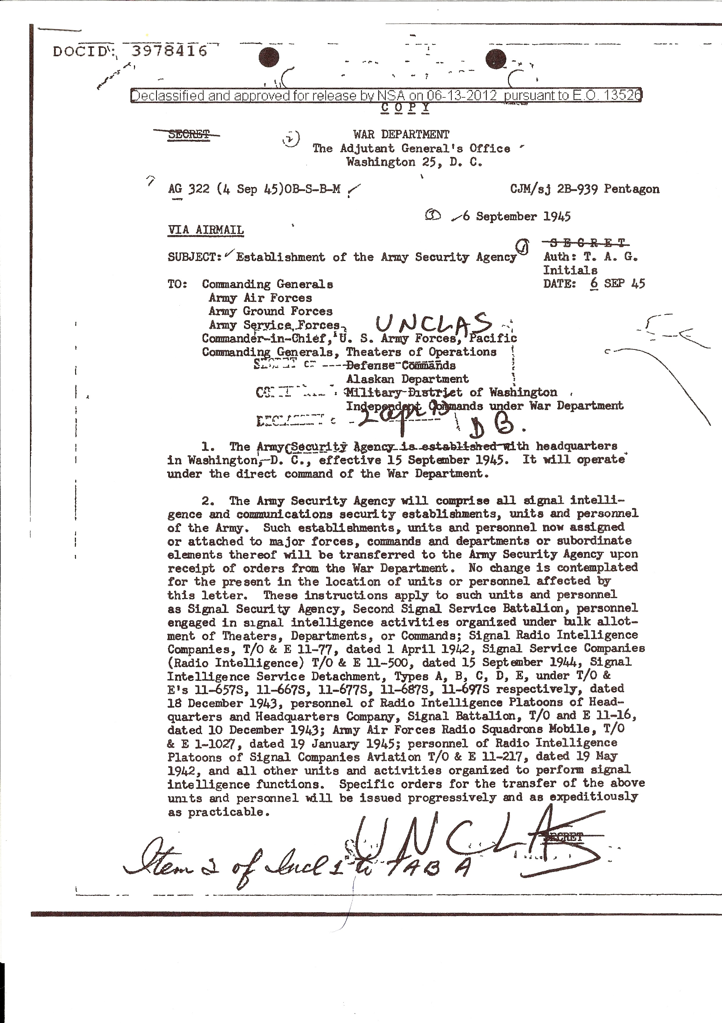

ASA History
Composed of soldiers trained in military intelligence, the ASA was tasked with monitoring and interpreting military communications of the Soviet Union, the People’s Republic of China, and their allies and client states around the world. The ASA was directly subordinate to the National Security Agency and all major field stations had NSA technical representatives present.
All gathered information had time-sensitive value depending on its importance and classification. Information was passed through intelligence channels within hours of intercept for the lowest-priority items, but in as little as 10 minutes for the most highly critical information

Personnel
ASA military occupational specialties (MOSs) included voice intercept operators, who were usually linguists with MOS 98G (plus a four character suffix (plnn) to indicate proficiency level and language code), Morse code intercept operators ("Ditty Boppers" or sometimes "Hogs" for their 05H designation), non-Morse (teletype and voice) intercept operators (05K), communications security/signal security specialists (05G) whose monitoring of military communications often led to soldiers being punished, direction-finding equipment operators ("Duffys" for their 05D designation), computer system operators (74E) who operated equipment at the NSA headquarters and out in the field,
Crypto-Clerks (72B), Cryptanalysis/Cryptanalytic Technician (crippies), (98B), communications traffic analysts (98C), voice intercept operators (Monterey-Marys) (98G) non-communications intercept/analysts (98J) (a.k.a. 989) – RADAR and telemetry, electronic cryptographic maintenance technicians (32F-G, and 33S), and Specialized Teletypewriter Equipment Repairman (31J B3).
Other specialists intercepted and analyzed radar transmissions and intercepted communications and data transmissions from missiles and satellites. (I was trained and identified as a 989.10. They hadn’t started training regarding missiles and satellites yet)
These occupations, which required a Top Secret clearance with Special Intelligence/crypto special clearances, were essential to U.S. Cold War efforts. ASA units usually operated in four groups using revolving shifts to provide coverage twenty-four hours a day, seven days a week. ASA troops were not allowed to discuss their operations with outsiders – in fact, they could not talk among themselves about their duties unless they were in a secure location. Even today, decades after they served, some of the missions still cannot be discussed. ASA personnel processing out of sensitive operations were debriefed and signed a document specifying a forty-year elapsed time before they could discuss what they had done or observed.
Owing to the sensitivity of the information with which they worked, ASA personnel were subject to travel restrictions during and sometimes after their time in service. The activities of the U.S. Army Security Agency have only recently been partially declassified. This turn of events has been accompanied by the appearance of a small number of ASA memoirs and novels.

Human resources (1945–1965)
The ASA, during the majority of the years of its existence, from 1945 to 1978, was largely a “Cold War” operation. ASA enlisted troops were usually recruited from the top range of scores in aptitude tests given during initial induction.
The Army itself exhibited little concern for the ASA until 1965, as it was a "joint venture" essentially under the control of a civilian organization. However, there was a general concern in the Department of the Army that enlisted technicians of all kinds should be given recognition and adequate pay in order to retain them. Accordingly, in 1954, Army Regulation 615–15 created the grades of Specialist Four, Five, Six, and Seven, (SP4, SP5, SP6, SP7) corresponding to Corporal (E4), Sergeant (E5), Staff Sergeant (E6), and Sergeant First Class (E7). …Promotion in the specialist grades was fairly rapid with specialists with two years of military experience reaching E5 and E6 in another two years. Due to the long training requirements, and initial four-year enlistment was normal. However despite sometimes-intensive efforts to retain personnel, reenlistment rates were very low.

Preliminary ARMY/NAVY activities leading to the formation of the ASA 1st and 2nd Special Activities Detachments.
In 1953, the USSR initiated, under the direction of the reactive propulsion engineer Sergey Korolyov, a program to develop an ICBM. Korolyov had constructed the R-1; a copy of the V-2 based on some captured materials, but later developed his own distinct design. This rocket, the R-7, was successfully tested in August 1957 becoming the world's first ICBM (Intercontinental Ballistic Missile) and, on October 4, 1957, placed the first artificial satellite in space, Sputnik. (I graduated from High School in 1957)
In the USA, competition between the U.S. armed services meant that each force developed its own ICBM program. The U.S. initiated ICBM research in 1946 with the MX-774. However, its funding was cancelled and only three partially successful launches in 1948, of an intermediate rocket, were ever conducted. In 1951, the U.S. began a new ICBM program called MX-774 and B-65 (later renamed Atlas). The first successful U.S. ICBM was the Atlas A. was launched on 17 December 1957, four months after the Soviet R-7 flight. (I worked on Atlas 2 Inertial Guidance system at Litton Systems in 1960)
Military units which deployed ICBMs would first be fielded in 1959, in both the Soviet Union and the United States. The R7 and Atlas both required a large launch facility, making them vulnerable to attack, and could not be kept in a ready state.
These early ICBMs also formed the basis of many space launch systems. Examples include Atlas, Redstone rocket, Titan, R-7, and Proton, which was derived from the earlier ICBMs but never deployed as an ICBM. The Eisenhower administration supported the development of solid-fueled missiles such as the LGM-30 Minuteman, Polaris and Skybolt. Modern ICBMs tend to be smaller than their ancestors, due to increased accuracy and smaller and lighter warheads, and use solid fuels, making them less useful as orbital launch vehicles.
Deployment of these systems was governed by the strategic theory of Mutually Assured Destruction. In the 1950s and 1960s, development began on Anti-Ballistic Missile systems by both the U.S. and USSR; the 1972 ABM treaty restricted these systems.
From an email to me from Dick Roosevelt
“Just to let you know…. prior to your stint in ASA as a back ender in some of the more modern aircraft, there were some of us in SAD 2 flying out of Adana (Turkey) in P2Vs and P4ms in 58, 59 & 60 out of Rota, Spain with ECMRON 2. During that time there was only one of us on each flight. There were no Army or Navy Aircrew wings for us. I have photos of our aircraft during that period provided by Don Gibbs USN that I will forward to you. I was at Adana when Powers (Francis Gary Powers) was shot down with the U2, used to watch him take off and land. Another ASA pers and I were the only Army pers involved with the mission and lived off the side of the runway in Squad tents we shared with the Navy crews when they rotated every 3 weeks”
“Photo credits should go to Don Gibbs USN Air crewman...these surfaced only last FEB from a box in his attic and are the only ones known to be in existence of the P2Vs and P4M in our operation at Incirlik AFB in Turkey.... time period 1958-1960, note the B47 in one photo, this was the Aircraft operated by the Air force we competed with. Don is crewman shown in the foreground of one of the first photos in his tan Navy flight suit.

“If my memory serves me, the SAD's were not activated until 1963-64, even though Army troops had been sitting ELINT positions in VQ aircraft since '58 (maybe as early as '57). I recall during my tour in the Missiles & Space Branch, Headquarters USASA (Jul'63-Jul'65) having some staff actions which I think were the "activation" of the SAD's-. - I recall the Detachment Commander~ a black dude, Captain I think, spunky and proud-- a lot of fun to have around, and I suspect he ran a good show. (The “black dude might have been SSgt Gene E Thomas. The Captain was Robert C Newland who was indeed spunky. We called him ‘bouncing bobby’)

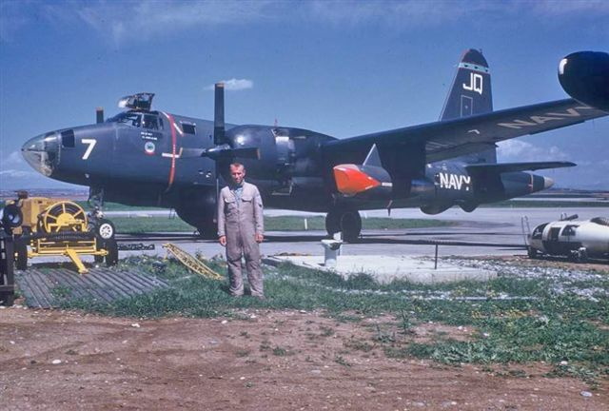
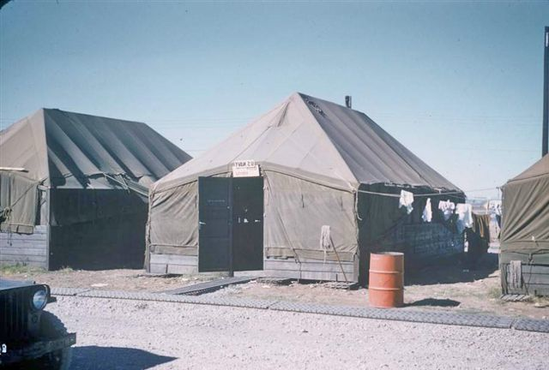
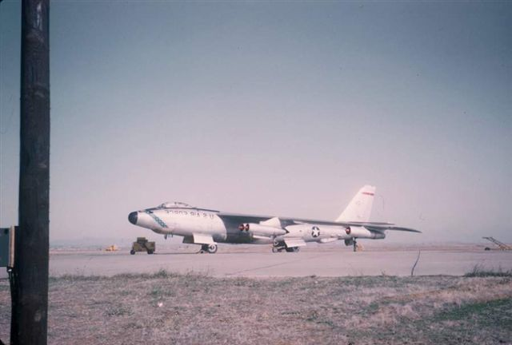
“My first involvement was in 57-58. At that time the ELINT operators were assigned to TUSLOG Det-4, Sinop, Turkey and rotated in TDY (temporary duty) status to Incirilik. I arrived Sinop Sep/Oct'57 and immediately became OIC (Officer In Charge) E-Ops (ELINT), but I don't recall if we had already had some flights with ECMRon-2 in P4M Mercator and P2V aircraft or if that didn't come until early '58. I do recall several occasions ~ our ELINT troops flying in those aircraft before the first EA3 Skywarrior showed up at Adana-- it also seems to me that all this occurred before the squadron moved to Rota (Spain). We were chasing missile telemetry and beacons and fusing signals associated with the Soviet missiles and space program. These signals were short lived and not routinely available, sometimes "early warning" wasn't sufficient to get the slow movers from Adana out over the Black Sea in time and at an altitude to get the early missile launch/f1ight signals of interest. Enter the A3DQ before an ELINT configured A3 was available; we (me, one of our maintenance troops, an EDL engineer and a Navy aviation-mechanic) replaced the nose radar with a dipole (antenna) cut to 55 MHz It was too long to fit across the width of the random enclosure, so we simply folded it accordion style until it would fit--. I also recall getting aluminum foil from the Air Force mess to put on the random bulkhead (to) act as a reflector. The A3 carried only three--, two up front to drive and bomb, and one EM in the back (flying backwards) as radioman (I. think he was also called the "airplane captain??). A VHF (Very High Frequency) receiver was installed in front of the operators seat, but the HF (High Frequency) radio (used to "receive instructions") had to be under the operator seat-- and to change/adjust freqs on the HF (which seemed to need to be done frequently) you had to get out of the operator seat (using a small walk around oxygen bottle) and get down on the deck to look under the seat. Another "interesting" aspect of that A3 experiment was that to get the SOI (Signal of Interest), we had to fly directly towards the signal source-- which often was head-on to the coast line, versus parallel-- but at least we got there faster and higher.”
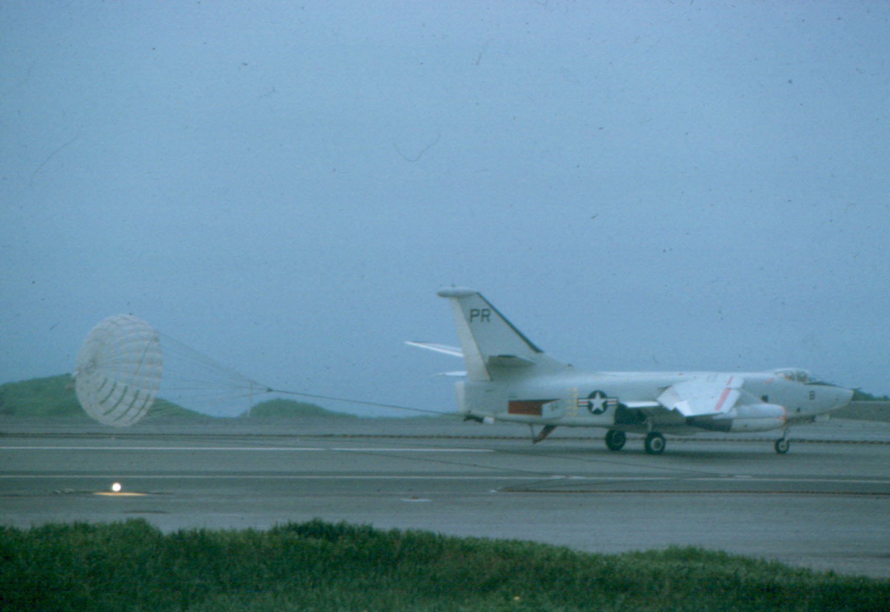
My involvement with VQ-1 was at Shemya, Jul'61-Aug'62. Again, I was OIC of ELINT (79th USASA Special Operations Unit – Army/Air Force Joint Operations Group "AAF/JOG”) and the Army operators flying with VQ-1 were assigned to Shemya—but did a lot of TDY to Atsugi for chamber checks/training and bailout drills. Some neat war stories about Shemya too-- like how do you handle a 25 knot crosswind factor for landing the EA3-- try anchor chains and cut tires to rig an arresting cable to cut down roll.
You can see the chains lying on either side of the runway.

VQ-1, PR-9 & 10, ASA Army
Our Chain of Command:
U. S. Army
Department of Defense (DOD)
National Security Agency (NSA)
Army Security Agency (ASA)
Army Security Agency Pacific (ASAPAC)
Special Activities Detachment One (SAD-1)
1961
ASA SSGT James R. Chapin, SP5 Leroy Scott, SP5 Robert A. Kroft, SP4 Rodney D. Jones and SP4 Philip L. Flint were assigned to VQ-1. I don’t know who the Army officer was. This crew flew the first ICBM reconnaissance missions with the new equipment installed in the two EA3B’s outfitted by Electronic Defense Labs (EDL) (ELINT) and Bendix (optical). They figured out how to operate the equipment.
There was no formal designation for this unit and they received hazardous duty pay, as the Army did not recognize them as aircrew members. “The Army doesn’t fly high altitude reconnaissance.”

1963-65
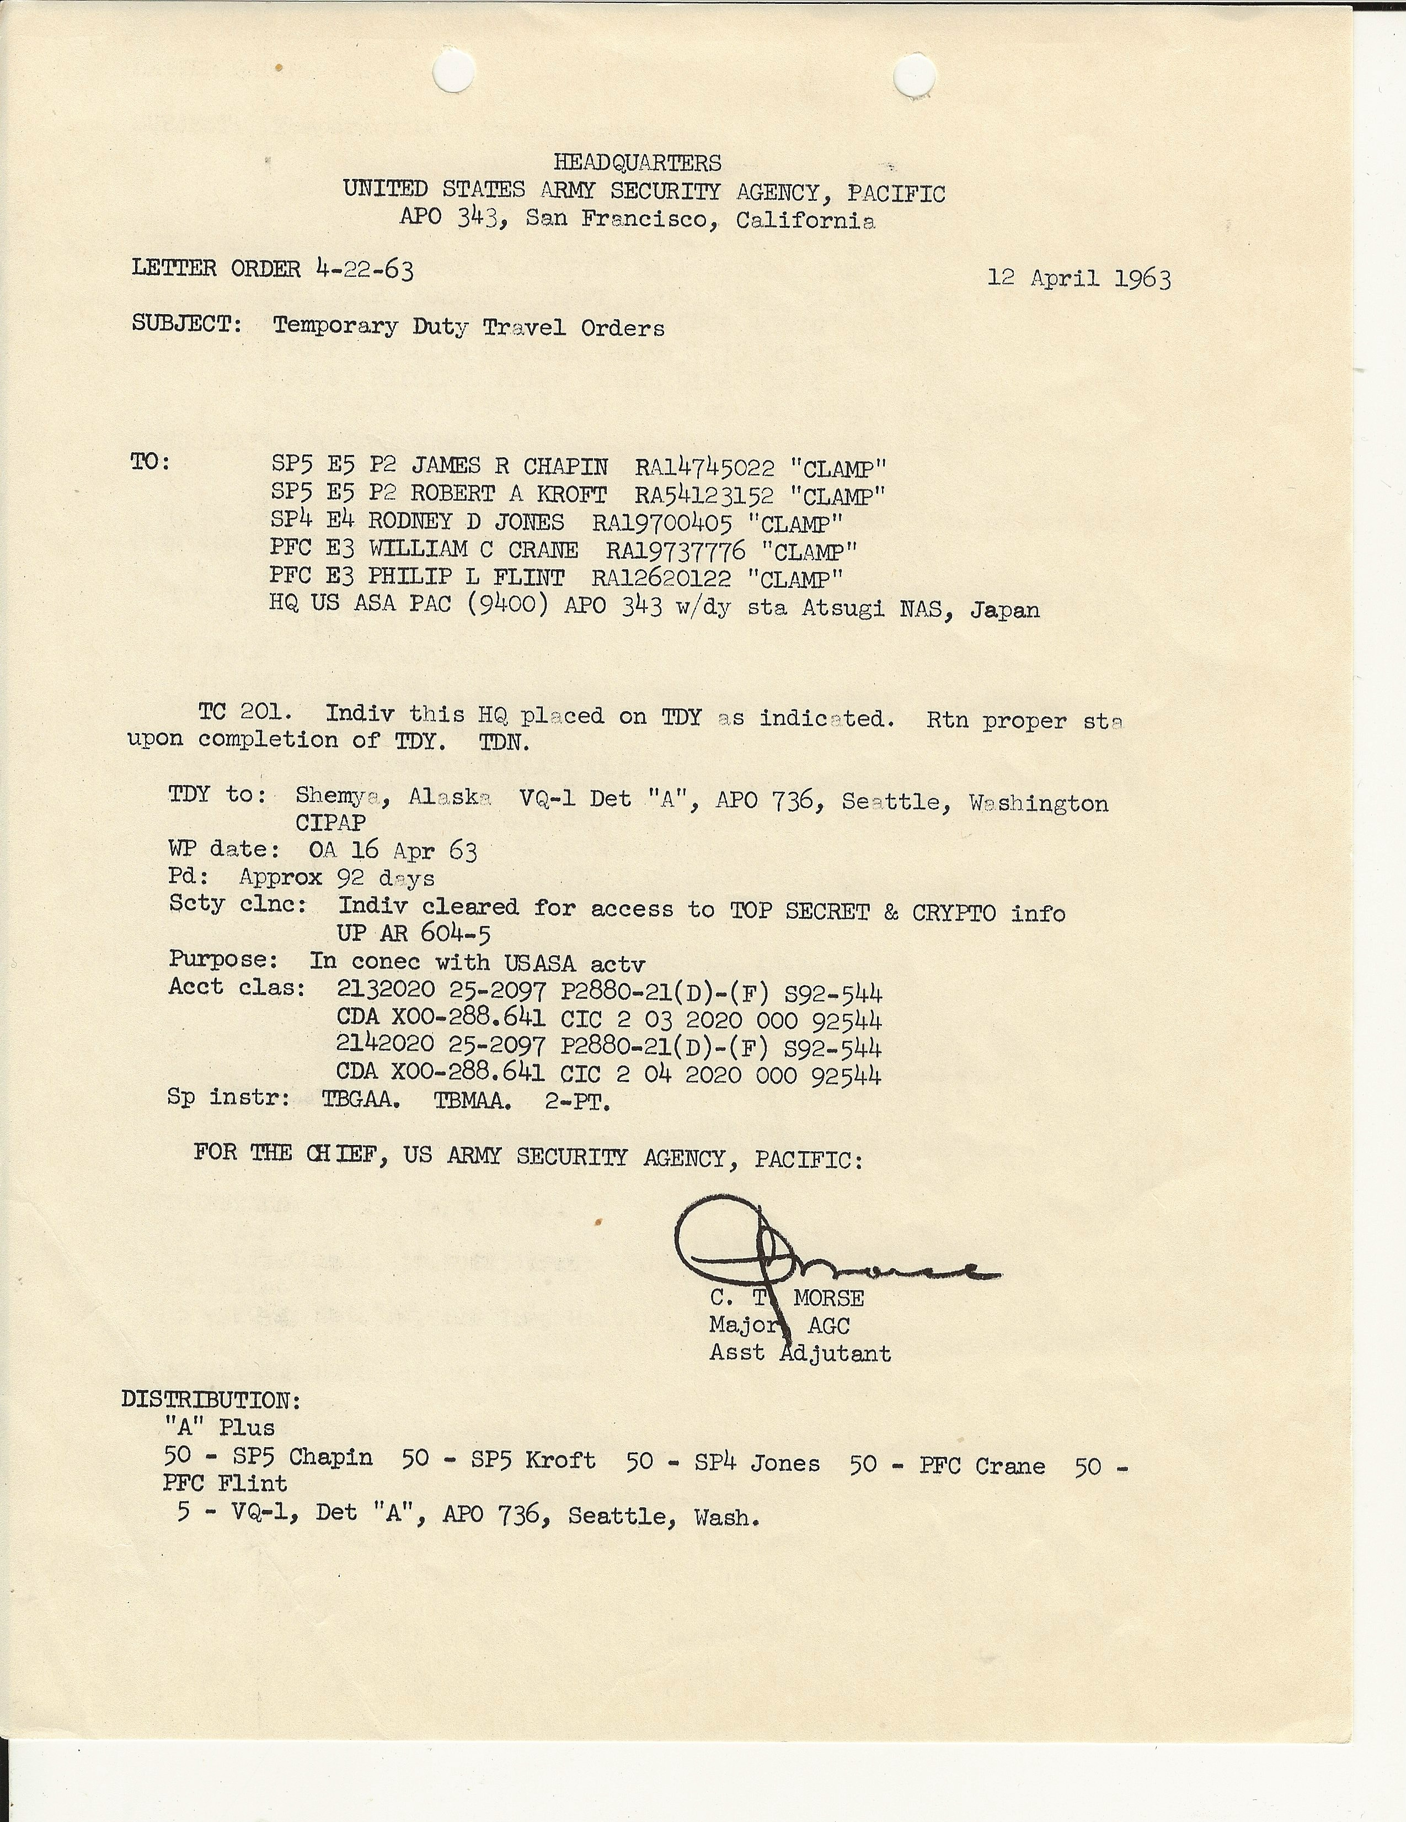
My first deployment to Shemya.

My orders to Shemya
Army Special Activities Detachment One & the Navy EA3B Skywarrior.
The following are excerpts from articles that I wrote for the Cold War Museum and an Air Force related sight regarding their similar mission.

Background
I have heard from several sources that in the late 1950’s there was a small Army group flying with Fleet Air Reconnaissance Squadron (VQ-1). I don’t know what their mission was but understand that they flew in P4M’s. I had contact with a Navy guy who indicated they flew out of Shemya, Alaska. In the early 1960’s there was intense interest by our government in Soviet missile development. At that time, the Air Force had primary focus on Air-to-Air and Air-to-Ground missiles. The Navy’s primary responsibility was to study Ship-to-Ship missiles and likewise the Army had the primary mission to study Ground-to-Ground Missiles.

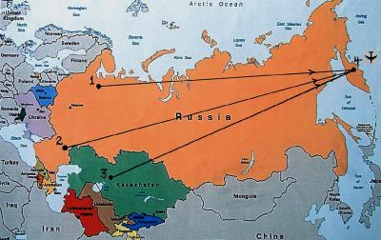

“The Soviet ICBM test project involved launching missiles from Plesetsk (1), Kapustin Yar (2) and Tyuratam / Baikonur (3). When the missile's re-entry vehicle (RV) entered the atmosphere and streaked toward the Klyuchi test range (4) on Kamchatka, the peninsula on the Far Eastern edge of the Soviet Union. ” Someone had to be there to watch.”
The U.S. ICBM program was just being deployed, over-flight reconnaissance was severely restricted with the successful introduction of Soviet Surface to Air missiles (SAM), and our early surveillance satellites could not loiter over a particular area. The Russian ICBM project was of particular interest to the United States. The Army needed a high altitude platform to collect optical and telemetry information. A jurisdictional disagreement between the Army and Air Force resulted in the Army teaming up with the Navy.
The EA3B was an unarmed ECM/reconnaissance variant of the A3D carrier based nuclear bomber. A total of 24 of the variant were built.
From about 1959 to 1972 the Army and Navy cooperated on an Electronic Reconnaissance project. As far as I can tell, there were only about 100 Army guys involved over the whole period. The project varied in application over those years. Our project required high altitude capabilities that the Army did not have. The Navy agreed to provide the flight crew and platform flown by Fleet Air Reconnaissance Squadron 1 (VQ1). The Army packed the back end of the plane with it's specialized gear. The chosen platform was the A3D-2Q Skywarrior later re-designated the EA3B.

The Mission from 1961-1964
In 1961, a Navy flight crew from Fleet Air Reconnaissance Squadron One (VQ-1) flew PR-9 and PR-10 to the States for installation of Army optical and telemetry gathering equipment. They were unique. The first Army group assigned to the project flew missions in 1961 & 1962 out of Shemya Air Force Base in the Aleutian Islands. I joined the group in 1963 as part of the 2nd group to work the mission. Our two aircraft were known as Sun-1 (PR-9 BuNo 146449) and Sun-2 (PR-10 BuNo 144854). During the spring of 1964 our Army group was formally identified as Special Activities Detachment One (SAD-1). Prior to that we did not have a formal name and I didn’t know our chain of command beyond our Army Captain. A second Army group identified as SAD-2 flew in a similar Army/Navy arrangement with VQ-2 with slightly different configured EA3Bs in Turkey. Theirs did not have optical capabilities. The back end crew consisted of 4 enlisted Army men who included an analyst, two Radio Intercept Operators and an optical recording operator, often a Russian linguist. Our Army Captain, who was also a Russian linguist, would man that position at times.
The optical equipment consisted of an ultra sensitive TV camera that was aimed by the Navy plane captain who sat behind the pilot. A conventional film movie camera that was pointed at a video display then recorded the closed circuit TV system. The camera could detect the light from a candle at 300 miles.
(A Russian ICBM burning up on re-entry.)
This picture was taken by the Air Force several years later but it demonstrates what we were observing.
The Navy navigator did the actual navigation while we were traveling at 500+ knots. Without radar and in radio silence, this was a challenging assignment at best given the state of navigational aids of the era. We had a Nikon 35mm camera with motor drive taking star pictures during the event. The Naval Observatory would later figure out where we actually were. At times they came back with a report that we were not where we thought we had been.
In the winter of 1964 we received one of the first airborne Loran receivers available, which was installed at my analyst position. I was sent to the Loran (LOng RAdio Navigation) school at the Pearl Harbor Submarine base. There were some very curious submariners in my class. On our first flight with it, I noted that we made an inappropriate turn and accidentally flew over an island with a known Russian SAM (Surface to Air Missile) site. The navigator didn’t appreciate my pointing that out since he was still using the much more primitive methods.
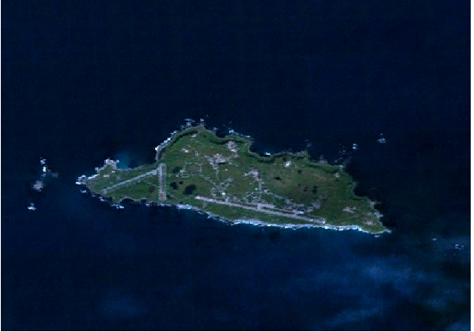
The nature of the mission required us to be “scramble ready” much of the time. We had very short notice to be on station off the Kamchatka Peninsula. Inevitable last minute ICBM launch delays often required in-flight refueling on our part. We flew summer missions out of Shemya AFB at the end of the Aleutian Islands. The weather and cross winds precluded working there in the winter. The EA3B was designed for carrier landings and with the large tail plus the narrow main landing gear it was limited to cross winds of less than 25 knots. The standard Navy response was to turn the runway into the wind. We couldn’t get the Air Force to rotate their runway to meet our needs. (Loran had been used only on ships until we received ours. Ours was a state-of-the-art solid state receiver the size of a car radio. The ship born unit was considerably larger)
Beautiful Shemya!
At times the winds would exceed the landing parameters while we were out on station. The nearest alternate landing site was 300 miles away at Adak. Additionally, we might not always have enough fuel to go on that far. We positioned a destroyer anchor chain down each side of the only runway and connected them with a cable. When needed, the cable could be propped up on a couple of old tires that had been cut in half and we would catch it with the tail hook. We would stop in very short order while making a spectacular show of sparks at night. The Air Force was really not too keen on that arrangement. I think they were really jealous that they couldn’t use it.

The seas around Shemya are so bad that there were no boats of any kind on the island. If we happened to go down off the end of the runway, there was no way to get to us so we just flew in light cotton summer flying suits. I understand that the guys after us had to follow regulations and get into cold weather “poopy suits.” I don’t think it would have done them much good since the nearest rescue plane was an amphibious Navy Grumman HU-16 Albatross that would have had to lumber out from Adak. By the time it would have gotten to them the cold water would have taken its toll.
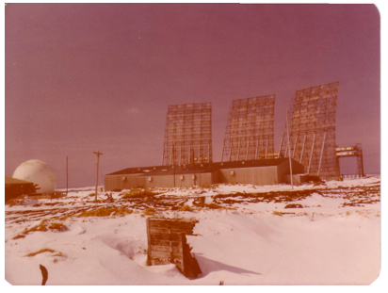
After each mission, I had to take the tapes up to AAFJOG (Joint Army Air Force Operations Group) and do preliminary analysis, which often took many hours. The next day we would do it all over again. A special Air Force plane was sent to carry the tapes and films to the NSA for further analysis after each of our flights. The guys at AAFJOG always shook their heads when I came in. They were watching us on the big over the horizon radar and knew about the other close encounters that we had.
Very Low Frequency over the horizon Radar with a range of about 2,000 miles that cooked any birds in is path.
We flew “Bed Check Charlie” flights out to the track every other day when there wasn't a mission just to keep the Russians aware that we were there and so they wouldn't get too excited when we came to their show. We had two crews and alternated 6 or 12 weeks on Shemya and then 6 weeks at Atsugi Naval Air Station, South of Tokyo.
In the winter we flew missions out of Barber’s Point NAS in Hawaii and Midway Island to cover the Russian Pacific missile range. Ground based listening stations in Europe and Asia would alert us as to when to fly.
We maintained complete radio silence from takeoff to landing. We always flew in total radio silence so I received the coded instruction giving us mission instructions, which kept me busy the entire flight. I would receive the code and use a one-time pad (secret decoding book) to figure out what to do next. That kept me busy the whole mission. I had to go to Navy Code School in Yokohama to learn the first ten letters of the alphabet in Morse code. Again, curious sailors were my bunkmates.
We had some interesting times. One time we got back from a mission where we took off in very heavy fog. The pilots were discussing the condition of the turn-around at the end of the runway when they realized that our two planes had taken off from opposite ends, of the runway at nearly the same time. The tower couldn't see us!
It was discouraging to stand at the side of the runway with below landing limits heavy fog and watch as one of our planes tried to land. After lining up with the brightest runway approach lights that I have ever seen, you could see the landing gear hanging down below the fog less than 50 feet above and the pilot had to divert because he still couldn’t see where he was.
Then there was the time that we took one of the Air Force guys up on a training run because he needed hours. We had a cockpit electrical fire when the pilot put the gear up. The cabin filled with smoke and the Plane Captain started shutting down every breaker that he could fly without. The real problem was that an A3 takes off with about one hour's worth of fuel weight more it can land with. All you can do is fly around and dump fuel. For some reason we never had another request for hours from the Air Force.
On the other hand, if our mission was aborted after we were airborne, the pilots could just “play”. We had no declared flight plan after the first 50 miles. We had Navy pilots who were trained to fly bombers and there was nobody watching them. Low-level bombing runs against the seals on the other islands were fun.
During this early period, the Air Force was developing their RC-135 aircraft known as Rivet Ball. Because we had TS Crypto clearance, we got to tour their plane. It left me with quite an impression. They just got in, started it up and drove away in style and comfort. On the other hand, we piled in and the ground crew fired us up with external 'huffers' and away we went. We prided ourselves in being able to get both of our planes out on the runway before the Air Force SAC guys could get theirs out of the hanger.
From what I can determine, as soon as they solved their initial video calibration and tracking problems, they took over the optical portion of our mission. Rivet Ball had 10 cameras that looked through optically clear windows. That had to be much better than our single camera looking through a Plexiglas cockpit window. Their all officer crew was shocked when one night at the chow hall they realized that very junior Army enlisted men were crewing in the back of the A3’s.
In 1965 the optical equipment was removed from PR-9 and updated telemetry receiving equipment was installed. The project then took on the name of Seabrine. PR-10 had another fate. While refueling on Shemya, there was a loud bang. The wing tank overpressure valve had failed. As no apparent damage was observed we continued to fly it. Later while the aircraft was back to the states for routine inspection, it was discovered that we had broken a wing spare. I was told that the aircraft was permanently removed from service.
As time passed, 1st SAD crewmembers were awarded Army & Navy aircrew Wings, some even earned membership in the Navy Tailhook Society for landing and launching off of carriers. They continued the mission until 1972 with service in the Pacific and Indian oceans.
In 1969, the Air Force RC 135 aircraft disappeared on a flight from Shemya AFB to Eielson AFB. The following comment is from the Air Force Rivet Ball web site and confirms the importance of the mission and the Army/Navy involvement.
“The loss of Rivet Ball, Rivet Amber and 19 crewmembers in 1969 was devastating for all concerned. It was also a severe setback to our intelligence network and its ability to monitor the Soviet missile threat. The need for a replacement was of the highest priority. The Air Force worked 24/7 on two replacement aircraft (RC-135S) named Cobra Ball I and Cobra Ball II. While Cobra Ball was under construction the Army (SAD-1) and Navy (VQ-I) returned with their EA-3B Skywarrior (“The Whale”) to help cover the gap until Cobra Ball was up and running.”
None of this story would have been possible without the dedication of hundreds of the very best and dedicated Navy enlisted ground crews. They kept our birds flying while stationed thousands of miles from their squadron support and worked in cold and windy conditions at all hours of the day and night. The Navy pilots were absolutely first class senior officers, with hundreds of hours. They always brought us back safely. I am humbled at the amount of support that was required to get a plane with four Army enlisted personnel safely into position to accomplish the mission.”
INSCOM the end of the ASA
On January 1, 1977, the United States Army Intelligence and Security Command (INSCOM] was organized at Arlington Hall Station, VA. The formation of INSCOM provided the Army with a single instrument to conduct multi-discipline intelligence and security operations and electronic warfare at the level above corps and to produce finished intelligence tailored to the Army’s needs.
The new major command merged divergent intelligence disciplines and traditions in a way that was unique to the Army. Its creation marked the most radical realignment of Army intelligence assets in a generation. Several major building blocks were consolidated to form the U.S. Army Intelligence and Security Command. They were the former U.S. Army Security Agency, the U.S. Army Intelligence Agency, the Counterintelligence and Human intelligence agency and several intelligence production units formerly controlled by the Assistant Chief of Staff for Intelligence and U.S. Army Forces Command.

emails re: early experience 1959-62 from Bill Davis
Hi Bill – I loved the article you wrote and based on my experience from 1959 through 1962 you are spot on.
On my first trip to Shemya (probably September 1959) I was a ground crewmember and we had only one P4M. I remember one night we were scrambled and the fog was so bad that the bus driver had to look out the left window with a flashlight to follow the road centerline to the hanger. We towed the plane out to a clear spot on the runway and the elint operators did what they could from the ground for several hours.
My subsequent trips to Shemya and Adak were as the Plane Captain (probably for PR-9). At that time the crew consisted of 7 (a Navy Pilot, Navigator, myself , 3 Army elint operators) and one tech rep that built the optical equipment I was operating (from Bendix if memory serves).
I loved your comments on the weather at Shemya. One night while returning to Adak, we had to land at Shemya to take on fuel. We got in there okay, but first the fuel truck had some moisture in the fuel and froze up when it came to service us. We had to send it to the hanger to thaw out before we could refuel. In the meantime a very treacherous crosswind developed. The pilot said “screw it, we will try it anyway”. He used the hand control for the nose wheel to turn the nose wheel somewhat into the wind to keep us lined up with the centerline of the runway. We got off ok, but when we landed at Adak, the nose wheel tire was shredded with lines going at a very odd angle. It did not blow on landing and I think that we were just plain lucky. We had to change the tire and as we started to jack the nose of the airplane up, the hydraulic seals in the nose jack blew out. The maintenance officer asked me what we could do to get the tire changed, as the plane was out of commission with the shredded nose wheel. I suggested to him that he take everyone except two guys and myself back to the barracks so that he could have deniability in case my plan blew up in my face.
The other two guys and I took an engine stand and put it under the nose jack point of the airplane and aligned it with the axis of the airplane. We then took a scrap piece of 12” x 12” lumber across the engine stand and perpendicular to the axis of the airplane. We then took a main mount jack and put it on the 12 x 12. We jacked up the engine stand and the main mount jack and proceeded to change the tire. When we got back to Japan, I showed the picture to our pilot (which was also the squadron maintenance officer). He just shook his head and muttered under his breath “nice work”.
VQ-1 Shemya A.F.B. Alaska Operations; VQ-1 Association Article re: 63-67 era. By Dick McClellan
In the Winter/Spring 2008 newsletter, Bill Crane wrote of his experiences as a U.S. Army “Back Ender” at Shemya A.F.B., Alaska in VQ-1’s special EA-3B aircraft, PR-9 and 10. His fine story jogged my memory and prompted me to add further discourse on Shemya operations.
To acquaint readers, Shemya Alaska is one of the western most islands in the Aleutian chain. A very small place, by any measurement. It was of strategic importance during WWII. Even now, it is used by US military to reconnoiter and gain intelligence related to Soviet intercontinental missile test programs. Shemya is not far by air to Soviets open ocean missile test range and atmospheric re-entry area; thus it has been of high importance to our intelligence folks.
Throughout the 1960’s and perhaps beyond, VQ-1 operated two very special EA-3B’s equipped and maintained (inside) by Bendix Corporation and the U.S. Army. Navy crews manned the front end while Army specialists worked the back end. Over time, all the Army troops earned and proudly wore Navy aircrew wings on their uniforms. I recently had a chance to see and visit with Bill Crane at the A-3 Skywarrior’s Reunion in Van Nuys California. So my story begins…
Yes, I remember flying with Bill and his crew in sometimes challenging operations during the early to mid 1960’s. I was a plane captain and my crew position was directly behind the pilot. My job on those missions was to visually sight re-entry of Soviet missiles during their terminal phase and then to aim, operate and direct a TV camera to record these events. I should say, many missions were flown with no, or only limited, success. If several seconds of re-entry were recorded I was the crew hero that day! I won’t go into those things Bill has already covered so well but I will expound on a few items in my memory that relates “Life on Shemya!”
First of all, we were all quartered in the hanger we flew from. Officers and enlisted aircrew and ground crews lived in open by type, two bunk/rack high beds. We had an all hands day room adjacent to our berthing area that served many purposes. Briefings, hanging out, playing Acey-Deucy, shoe shining and just B.S. were just some of the activities. A very loud “launch” alarm was installed in all the spaces, even the chow hall that was some distance away. That alarm could wake the dead! The aircrews could not stray from the hangar area without signing out as to an exact location and this was strictly enforced. The chow hall, club and hangar were essentially our life while on the ground. Sometimes shooting at seagulls at great range with .38 caliber pistols from our survival vests provided a small diversion. As I remember, we had plenty of .38 caliber ammunition up there!
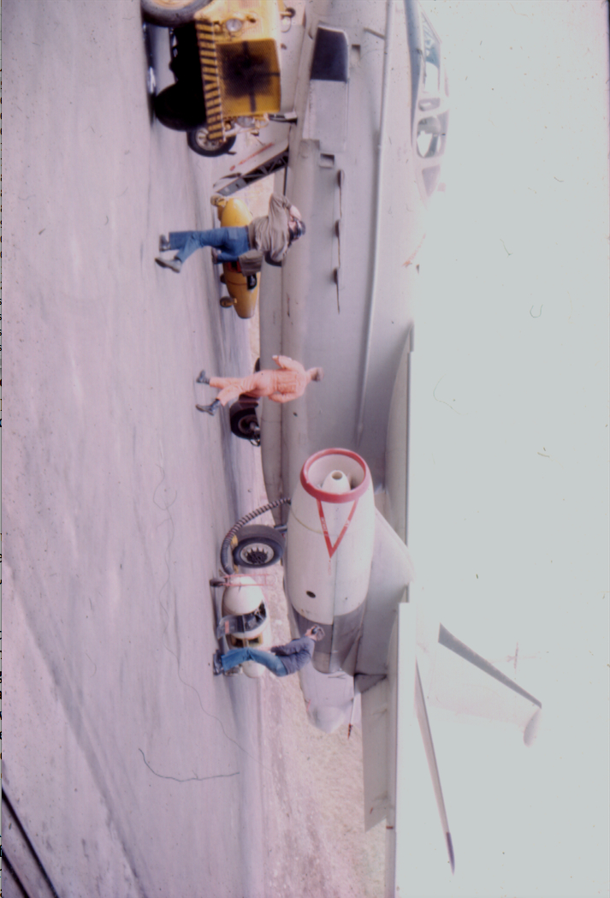
The aircraft were normally kept in the hangar except for the very few times when the weather was good. The aircraft were started and taxied from within the hangar only after the electric hangar doors at both ends of the hangar were opened. Both engines had engine start units (“huffers”, external starters) attached and were started simultaneously. Aircraft switches, levers, controls were left positioned “on” where possible and the plane automatically came alive as the engines spooled up. There was no time for checklists and normal ground checks. It was fire up and Go as quickly as possible. We joked of Grandpa Pettybone cringing and rolling over in his grave at every launch. Luckily, we never made his two-page spread in Naval Aviation News.

The Air Force had a “SAC” RC-135 that launched when we did and we always beat them in getting airborne! This created good-natured rivalry and humor at the club when socializing with those Air Force Crews and as a result, lasting friendships were made.
The weather was cold, damp, drizzly and overall depressing most of the time. Quite often, the fog was so intense that a “follow-me” truck was required to lead us to the runway during a launch. At other times when a “follow-me” was not available a sort of “GCA” by the ground control guys in the tower gave us coaching on the taxiways. If you’ve ever driven your car on a very dark road without the lights, you can savor the same experience – scary!!! We always managed to take off but we never knew if we could land back at Shemya due to weather. Our Diverts or alternates (Adak and Attu) were not always that great, but pilots always managed to put the A-3 down somehow, someplace. I can truthfully say, “We had some damn good pilots there!” A few names come to mind; Cunningham, Jones, New, Eldridge, Richardson and Huth.
Later on, the squadron acquired two KA-3B tanker aircraft from VAH-6 (bureau numbers 147455 and 147456). One of these aircraft was then normally deployed to Shemya in order to extend our “on station” time, thus increasing our chances of operational success. Also, when fuel was critical for the operational aircraft trying to divert to Adak or Attu, the tanker provided a measure of comfort and insurance.
Another item I remember well was our flight clothing. According to all the rules, we were supposed to wear “poopy suits” (anti-exposure suits) on all flights, as the water temperature at that latitude was very, very cold. The “poopy suits” were advertised as only extending your life five to seven minutes if you went into the frigid waters. So, being the nearest air/sea rescue was hundreds of miles from our area of operations, we flew very comfortably in our summer flying suits, putting our complete trust in the Pratt and Whitney J-57’s engines that powered the A-3. There were occasions when time did not permit changing into flight suits and crewman could be seen wearing a torso harness over a military uniform, civilian clothing or even over “PJs!” I should point out, Pilots and Navigators were the only ones who wore pajamas as real men (enlisted folks) did not own or wear “PJs”.
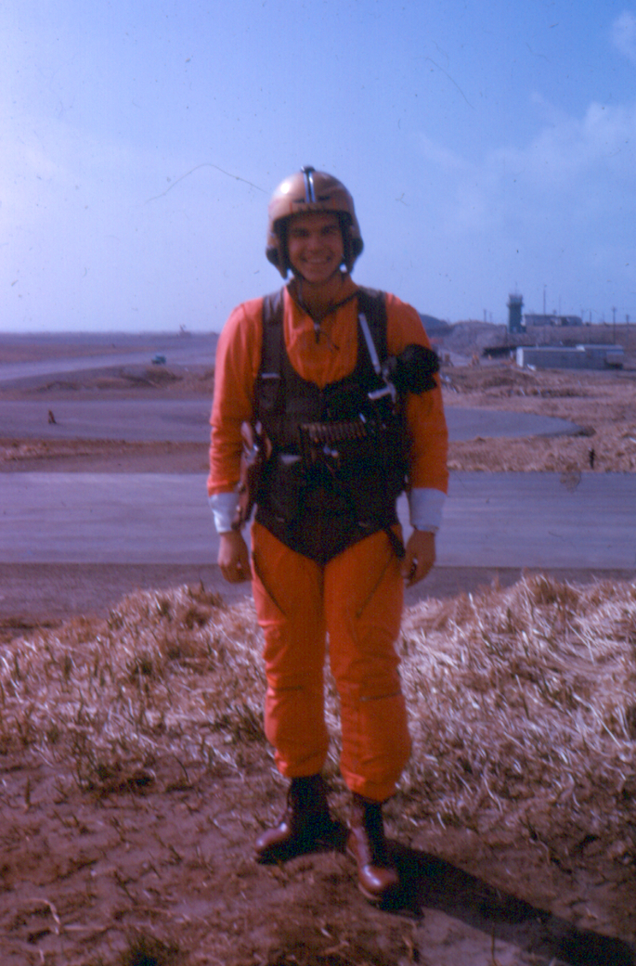
(Bill Crane in his summer suit.)
There were no women stationed or flying at Shemya. Occasionally, a commercial aircrew with Reeves Aleutian Airways would visit Shemya and they usually had one or two female attendants aboard. They were most popular and seemed to enjoy being the absolute center of attention at the club when they were required to stay overnight. I’m sure there were many indecent proposals sent their way during these visits. They expressed a keen interest in our aircraft and operations and visited our hangar and crews regularly. It has now been unofficially confirmed and declassified that one of these fine ladies had a short FAM HOP in one of our A-3’s. But that’s another story that perhaps retired Commander Jeff Richardson might enlighten us on in the next newsletter?
As I remember, we deployed to Shemya for four to six weeks. Incoming crews flew up from Atsugi in a regular EA-3B and the returning crew flew it back. The returning crew and aircraft always carried back blocks (a cubic foot I believe) of hard frozen prime picked crab meat that was later sawed up at the commissary. Of course, weather was never a factor for this flight. It must be mentioned that we always had the finest ground crews to keep the A-3’s flying. We always had 100 percent availability through their diligent and untiring efforts.

Email from Frank Capers, VQ-1 EA3B Navigator
Just stumbled on your description of Shemya Det on the net.
Frank Capers here ex navigator for Bud Kuhners’ crew from VQ-1. We must have known each other because. Although I don’t recall much from those days, I navigated on a flight where we flew over the Komandorskiye Islands (my story, and I am sticking to it, is that we were on track and had telemetry so held our course intentionally, success at any cost). I also recall the mission where we later discovered that the two planes had taken off from opposite ends of the runway crossing each other in the fog!!
I really enjoyed your story.
Email from a Shemya “home boy”
I received the following from one of the guys that worked in AAFJOG (Army Air Force Joint Operations Group) on Shemya.
“Knowing the survival potential in a ditching situation (or worse) for a Bering Sea or North Pacific region...having jumped into freezing water myself (once was more than enough to have a thousand needles almost stop your heart)...it takes tremendous courage to volunteer to fly that “then, potentially hostile“ area off Kamchatka, and to do the hard takeoff and landings dictated by that airfield on that speck of an island. I remember the alarms going off for the air crew alerts while sitting in the Mess Hall at Shemya, and laughing at the guys tripping over chairs and each other to get out the door for the ride to the air strip. Never appreciated, at that age; what was really being asked of those guys. We should have stood and saluted them, or cheered them on. They must have thought we were idiot “ground pounders.” REMFs (Rear Echelon Mother Figure i.e. slang military term; polite form) to say the least. I learned a saying later, “You gotta love it.” Several years later, we started modifying that saying to, “You don’t gotta love it, you just gotta do it.”
A typical mission
1964 Winter In Hawaii
In February of 1964 we were sent to Hawaii to work the Russian Pacific Missile Range. While the weather at NAS Barbers Point next to Pearl Harbor was much better than Shemya, the duty wasn’t much different. Again we spent 24/7 together as a scramble crew. Our housing there was up stairs in the hanger “Latrine”. There were two rooms. The office/day room was set up around the big round sink. Our sleeping quarters were in the next room with the showers and toilets etc. We actually got a total of one and a half days off. Nice way to spend 3 months in Hawaii. So close but no cigar!
After much political maneuvering, our pilot and commanding officer, Commander Jeffery Richardson, was able to get a small TV for us. We managed to shove mattresses out onto the roof so that we could get those good Hawaii rays while we waited for the Russians to get their act together.
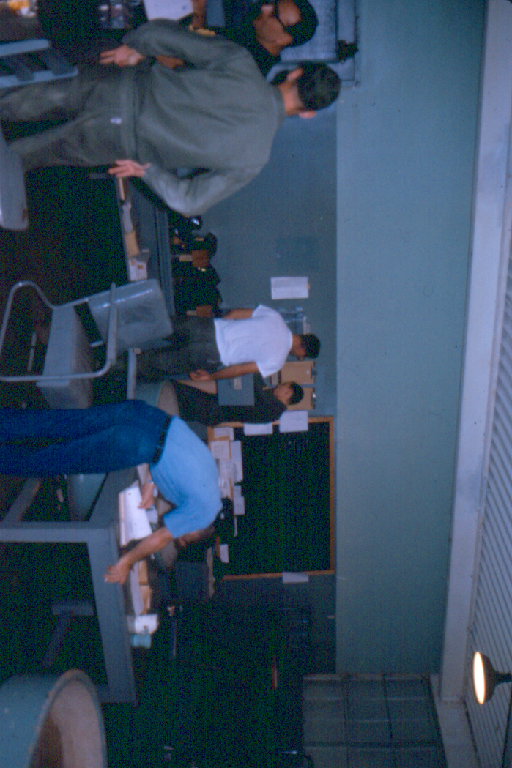
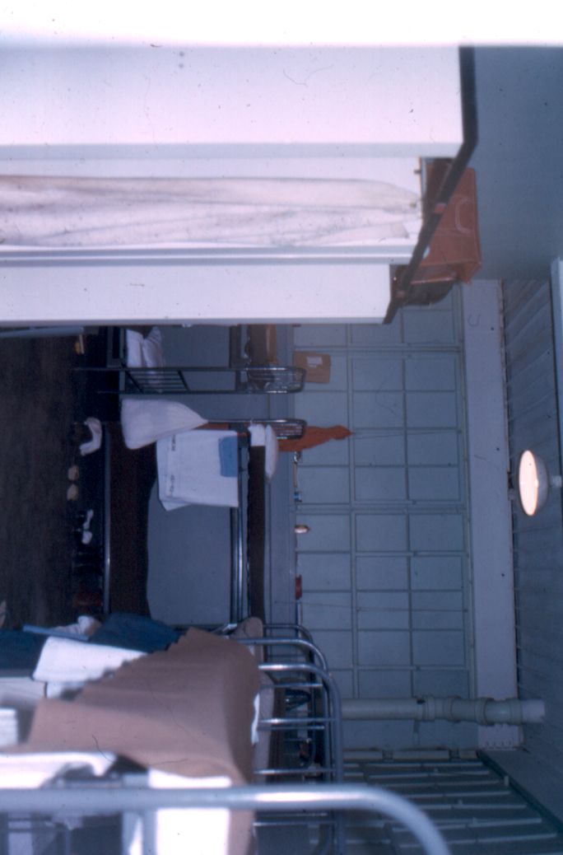
Showers⬇ Barbers Point Home sink ⬆

The Base regulations were that there would be no TV’s in the hangers. The Base commander was sticking to the regulations until out pilot/CEO explained our situation of being cooped up in the hanger for weeks on end. We got a small TV!

Billy Green before we got TV
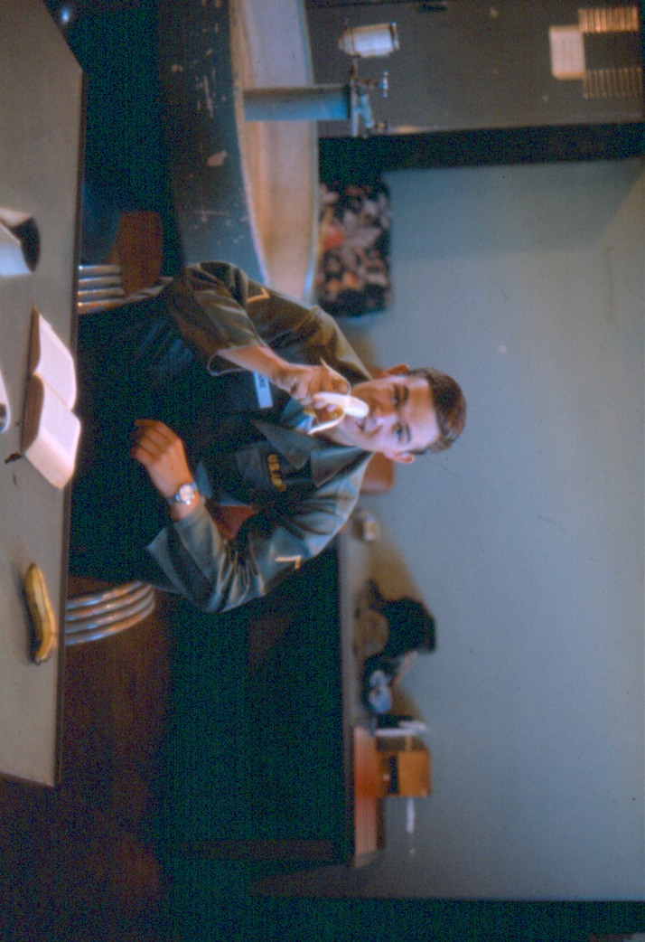
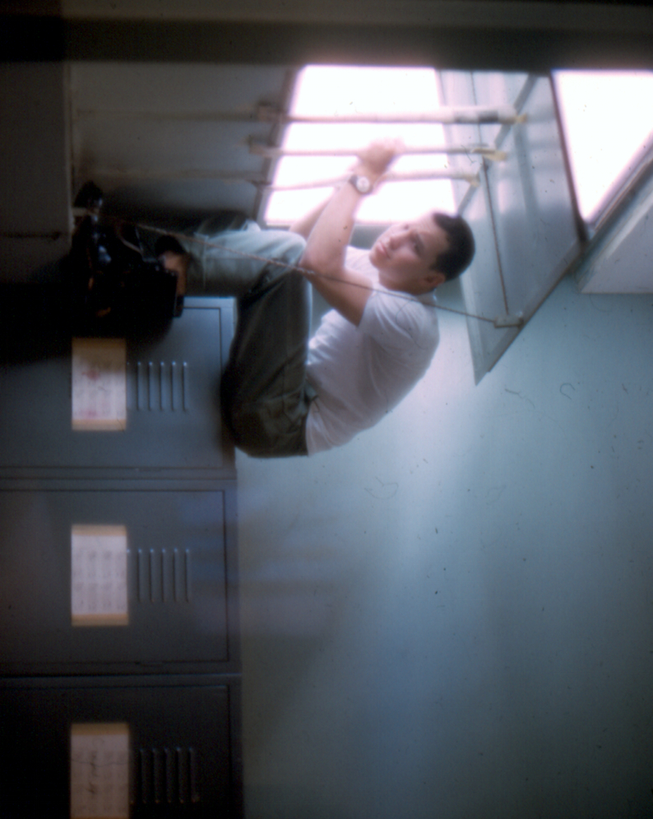

Bill Crane before we got TV

http://en.wikipedia.org/wiki/United_States_Army_Security_Agency
http://en.wikipedia.org/wiki/ICBM
Dick Roosevelt email to me 12/14/08
Dick Roosevelt email to me 15/18/08
We met briefly at a Navy reunion and I have lost his name.
Picture and description “Rivet Ball Amber” from “Tale of Two Aircraft” by King Hawes. http://community-2.webtv.net/@HH!B2!E8!1FD8DDA69D60/KingdonAviation/RivetBallAmberShemya/
http://www.6srw.com/
Email from Bill Davis USN 12/18/2007
Written by Dick McClellan VQ-1 1963-1967 and forwarded to me 2/2/2009. I believe that the article was written and published earlier
Frank Capers email to me 10/27/2006

