From the President
Greetings,
I hope this finds all well and enjoying life in this great country! The time for the annual VQ Association Reunion in Tempe, Arizona is fast approaching. There seems to be a lot of interest, so I encourage you to get your signup up information in as soon as possible. This will assure you a place at the table and will help the reunion planners.
The 2019 Reunion is scheduled for Nashville, TN and will be hosted by the inimitable Rich Kessmann. I’m sure Rich will have some information to pass on at Tempe. The Association has never had a reunion in Nashville and I for one am looking forward to visiting “ Opry Land!”
The VQ Association website has been revamped and updated. There is now a history section as well as photographs sorted by era and location. Sometime back we asked for inputs of stories about events over the years. All the inputs received now reside in the history section. We do need stories from the late 90's to present day, so if you have something, this is your chance to get your name up in lights!
A big thanks to all the board members who continue to do the business of the association quietly and efficiently. Sure makes my job easier! See you in Tempe.
With best regards,
Allan “Putt” Prevette
President
allanprevette@gmail.com
Phone: 805-482-1204
OUR V. P. EXPOUNDS A BIT
Hello to all from your forever association V. P. I can’t stress enough about making Phoenix/Tempe, AZ Fall reunion hotel reservations early, early!! Our reunion host can only block so may rooms for each night. When they’re gone they’re gone? Occasionally more rooms can be added at our negotiated rate but many times not. We don’t like reunion folks to have to find alternate accommodations down the street but this has happened several times. Any rooms we block we guarantee to be filled. Any rooms not filled, we’re on the hook to pay for out of association treasury – not good!! As usual, all beverages in ready room will be a “buck” -$1.00. Where can you drink for a buck and be among some of the greatest folks alive?? As “Small Stores” proprietor I’ll have some lapel/hat pins available for A-3’s, EP-3’s and EC121’s at the reunion small stores table this year.
Also, just a quick reminder to keep your association dues up to date. Can send along with your reunion sign-up sheet, $20.00 year/$30.00 for 2 years. We need these $$’s for association expenses, benevolence and more!! Keep our association treasurer Sandy McClellan happy!! Lots of new folks have finally found us and will be attending reunion this year – WOW!!GREAT!! See ya in Sept.
Dick McClellan V.P./X.O.

Page 1

Unmanned Aerial System Test to Begin in the Pacific (UPDATED) 4/4/2017

NATIONAL HARBOR, Md. — The U.S. Navy is moving ahead with plans to bring its MQ-4C Triton autonomous signals-intelligence aircraft to "early operational capability" by 2018, a service official said April 4.
The Northrop Grumman-built aircraft recently completed a preliminary design review and a successful first flight of an improved software suite which will enable EOC deployment for the aircraft’s baseline sensor suite, Sean Burke, PMA 262 program manager for U.S. Navy Naval Air Systems Command, told reporters at the Navy League’s annual Sea-Air-Space conference in National Harbor, Maryland.
The suite includes radar and electronic support measures, an automatic identification system and electro-optical infrared sensors, he added. The successful tests allowed Northrop Grumman to proceed with its plan to install a multi-intelligence suite of sensors on all Triton aircraft moving forward, with initial operational capability set for fiscal year 2021.
The Triton will replace the service’s EP-3 Aries II multi-intelligence reconnaissance aircraft. The unmanned aircraft is intended to be compatible with Boeing’s P-8, as well as the Lockheed Martin-built P-3, Burke said. The Navy is moving to replace its P-3 Orion anti-submarine maritime surveillance aircraft with the P-8 Poseidon multi-mission turbofan aircraft.
“We’ve now moved to where we add a signals intelligence capability to the Triton,” he said. "We will do that in the first primary upgrade with what we’re calling the Triton multi-int, so that we can retire the EP-3s.”
The Triton provides 24/7 coverage of its area of responsibility, flying at 56,000 feet and capable of dip maneuvers to see underneath cloud coverage, said Doug Shaffer, vice president of Triton programs at Northrop Grumman. It is an all-weather system, with anti-icing and anti-lightning capabilities and a Rolls Royce-developed engine, he added. “It really puts these platforms in reaches that maritime hasn’t had in the past,” he noted. Northrop Grumman is working to get the aircraft to initial operating capability by 2020, before the EP-3 fleet is set to retire starting in 2021, Burke said.
Two Triton aircraft are being delivered with the baseline software suite this summer to Point Mugu, California, for testing before being deployed to Naval Base Guam in 2018, he said.
The company will continue to test the upgraded signals intelligence sensors. Northrop Grumman is currently set to deliver 68 aircraft, according to the Navy’s program of record. It expects to complete a preliminary design review in 2021, he noted.
Though Burke declined to comment on whether the new sensors would be installed on P-8 aircraft or similar maritime surveillance aircraft, he said: “It’s called the common SIGINT payload, so the name could help define other opportunities.”
Northrop also plans to test a sense-and-avoid radar system that could help the Navy avoid mid-air collisions and other possible issues in flight. That will be included in the following set of integrated functional capability (IFC) testing, expected to occur in 2025, after the aircraft are planned to be delivered to the service, Burke said.
“We said we wanted to deliver the multi-int capability on time. If you try to put the sense-and-avoid radar in there as well, that pushes out that timeline and that’s not acceptable,” he said.
The radar requires a higher degree of test and certification requirements, “so when we looked at trying to pack all of that into the IFC timeline, it was too much complexity and too much content,” he added, noting that funding is always a concern as well.
Once delivered, the Triton will be stationed at several bases around the world, including: Naval Air Station Sigonella in Italy, Naval Air Station Patuxent River in Maryland, Naval Station Mayport in Florida and Naval Air Station Whidbey Island in Washington. Two main operating bases will be located in Point Mugu, California, and in Guam, Burke said.
CORRECTION: This article has been updated with the correct engine on the P-8 Poseidon multi-mission aircraft, and to reflect that two Triton aircraft with the baseline configuration will be tested at Point Mugu before being deployed operationally to Naval Base Guam.
Page 2
2-STEPPER
Chuck Landers ADC USN (Ret)
A goodly number of years ago, I served as a plane captain/crew chief on Navy planes in S.E. Asia.
While our aircraft (Lockheed, EC121, propeller & radial reciprocating engine powered) were pretty stalwart sturdy airplanes they were, like a number of its “attendees”, aging rapidly & prematurely in our “occasionally” hostile environments.
The heat, humidity, the torrential monsoons, not to mention the “occasional” enemy rocket attacks on our base were contributing to the excess wear & tear on our aircraft (and us!)
Our plane was hard down for an engine change. The closest engine we could acquire (these engines were something of a rarity), was coming out of Guam in a “couple” days.
I assisted our ground pounder mechanics in wrenching off the prop & the engine & robbing all the parts for our replacement engine.
After 18 or 20 hours in that climate, we were all pretty whipped! We crashed out in the mechanics hooch (an air-conditioned “CONEX” box). What bliss & comfort, to our unwashed, oil, gas & grease-smeared bodies!
A chief on our crew (which for the purpose of this story I shall call “Curtis X” & some pal of his, a Navy Corpsman SEAL I’ll call “Sea Ray” decided to throw a BBQ party for the “ground pounders” (mechs, electricians, & metal smiths).
They went into the “Dog Patch”, a suburb of beautiful Da Nang & bartered with the locals for their version of lobster, “big” shrimps, veggies, etc., using their multi-lingual skills. Yen, Pesos, Green, Baht, MPC & the oft-used commodity, sandbags (to build bunkers with) were thrown into the mix. They further argued ribeye steaks from some unknowing Admiral or General’s agreeable steward or cook with some well-placed cases of San Miguel beer.
The party got underway on one of the empty aircraft revetments aka the parking lot. Curtis X & Sea Ray made up strange marinades & slathered them all over our feast. One of our metal smiths made a beautiful grill out of a 10-gallon hydraulic oil drum. As we had no charcoal, we used sand saturated with JF-4 (jet fuel). Admittedly, it gave a strange oily, smoky flavor to our party fare. Amazingly after 2 or 3 beers cooled to an icy 85°, one did not tend to notice it much. These two gents had befriended some ARVN (Army of the Republic of Vietnam) officers during their cumshaw/bartering expedition & had invited them to the gala.
As the party progressed, we informed Curtis X that during his morning foray, a plane had arrived with paychecks & much desired mail from our loved ones at our home base in Japan. We went to the duty office a scant 50 yards & discovered a ruckus going on there. A snake had crawled into the duty office hooch entry. Curtis X smacked the thing with a broom, got his mail, picked up the stunned reptile, & returned to the party.
I will never forget the look on the Vietnamese officers’ faces when Curtis X came around the corner carrying that snake. They dropped their food screaming, “2-stepper! 2-stepper!” The last I saw of them they were heading for Saigon (a lengthy distance to the south) at an extremely high rate of speed.
To be honest, I am not a fancier or am I enamored of snakes. I think phobia is a more appropriate term here. In God’s infinite wisdom & in the grand scheme of things, I’m sure there is a place for these crawly things. I’d just prefer that their place & my place are not in the same proximity…by about a mile or so.
I do not know a lot about snakes, or what this thing was. It was very colorful as I recall, & quite feisty even after being smacked by Curtis X. I dunno if this was a Krait or a cousin of the dreaded nasty “Habu” of Okinawa. Evidently, a “2 stepper” was a highly venomous & lethal snake and the current theory at that time was if you got bitten by one of these things, you took 1,2 steps & keeled over dead.
Sea Ray, a highly experienced navy Corpsman & Navy SEAL took one look at Curtis X & the now wriggling snake. He pulled out his “K-bar” knife (looked like a bowie knife to me!) deftly sliced off its head, skinned & disemboweled it, chopped it into 3 to 4inch long pieces & threw it into the mystery marinade —still wriggling! After 10, 15 minutes in the mystery marinade, it quit wriggling (some) & Sea Ray proceeded to barbeque it.
I personally am not a survivalist, even after a couple of Navy survival school (D West, JEST, SERE, etc). So, I stuck with the dead cow, tangy spicy shrimps & veggie goulash stew.
By this time Curtis X had regained much of his composure, if not entirely, & his sobriety. But as he & Sea Ray munched on the “2-stepper”, I just had to ask — “Does it taste like chicken?” & they both responded: “Hell no! Tastes like a snake cooked in Jet fuel! And then they smiled.
But thank you Sea Ray & Curtis X, for the Ground Pounders crew party that hot, muggy, steamy day.

Law of Biomechanics: The severity of the itch is inversely proportional to the reach!
Page 3
Hall of Honor
By Keith May
We serve with HONOR in the VQ community. Even if no longer active duty or you’re a spouse or family member you still serve this community with honor.
There is a place where people we honor are recognized. That place is the Hall of Honor. This year’s inductees include one of our most influential community heroes, CAPT Don East. Don will be recognized as a Hall of Honor inductee in the Fall this year at the West Coast MPA Symposium in Whidbey Island, WA. Afterword, his picture and plaque will be mounted in the Hall in Jacksonville.
Previous year’s VQ honorees are CAPT Mike Lopez-Alegria and CAPT Vince Anania. Current candidates include CDR Rick Payne.
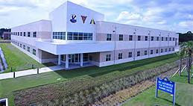
The Hall of Honor is located in the P-8 Integrated Training Center, Naval Air Station, Jacksonville, FL. There are pictures and other information at: (http://www.maritimepatrolassociation.org/hallofhonor/hohdisplay.html).

A few things to know about the Hall of Honor:
- It is managed by the Maritime Patrol Association (MPA) – [maritimepatrolassociation.org].
- Nominees do not have to be deceased to have their name submitted.
- The Hall of Honor is in a secure building. If you can get entry to NAS Jacksonville, you can make arrangements with an MPA representative to get a tour of the Hall.
- There are three enlisted Sailors in the Hall.
- If not selected each candidate stays on the nominee list for three years and gets a fresh review each year.

CALL TO ACTION – Please think about who you might nominate as a candidate for the Hall of Heroes. It doesn’t have to be someone who saved an aircraft or who commanded a squadron. The nominee can be anyone with superior performance and who contributed significantly to our community. Don’t forget about our enlisted Sailors and government civilians. Nominations need to be more than just their bio. Testimonials about the nominee are highly encouraged.

NOTE TO RETIREES AND ANNUITANTS,
The newest edition of Navy Shift Colors is now available. Web Site: www.shiftcolors.navy.mil
http://www.public.navy.mil/bupers-npc/reference/publications/shiftcolors/Documents/Shift%20Colors%20Spring-Summer%202018.pdf
Navy Shift Colors is the Navy's official newsletter for Retired Sailors and surviving spouses. It updates the retired Navy community about changes to laws, policies, programs, and benefits that affect them.
All Retired Sailors and surviving spouses with active myPay accounts now receive Navy Shift Colors electronically at their email address in myPay. Update your email address in myPay by visiting:
https://mypay.dfas.mil/mypay.aspx
Web site hyperlinks contained in this email may not appear as active links in some email clients that have this feature disabled due to increased cybersecurity protocols. If the link is no longer active you will need to copy it from the email and paste it into the web address field of your browser.
Retired Pay
DFAS Cleveland
Page 4
NOTE TO ALL RETIREES
The following message is sent on behalf of Arlington National Cemetery.
As a military retiree, your input is requested to help determine the future of Arlington National Cemetery. Military and civilian leaders are facing difficult decisions as they work to preserve Arlington National Cemetery as the shrine to the nation's heroes and history. With limited space for expansion, eligibility rules are being considered to extend the site's role as an active military cemetery for decades to come.
Your input is important and can help shape the future of Arlington National Cemetery. The eligibility survey is available now at www.arlingtoncemetery.mil/eligibility-survey<http://www.arlingtoncemetery.mil/eligibility-survey>
You can learn more about Arlington National Cemetery by visiting www.arlingtoncemetery.mil<http://www.arlingtoncemetery.mil>.
Retired Pay
Defense Finance and Accounting Service

Tempe, AZ VQ Association Reunion, Come one, come all!, September 20-23, 2018

Come and join us in Tempe, Arizona, September 20-23, 2018. Reunion hosts Mike and Janet Chicvara have gone all out to make this a great get together!
The reunion will start with the opening of the Ready Room on Thursday. Friday there is an outing to the Ping Golf Club factory for those interested and Friday evening members who have signed up can go watch a Major League Baseball Game where the Arizona Diamondbacks will take on the Colorado Rockies.
Bright and early Saturday morning the golf tourney will kick off. Winners of this contest will have their names put on the perpetual trophy and will have bragging rights for the year. That evening the banquet will be held in the hotel (no traveling). The next day, Sunday, there will be a membership meeting followed by a brunch. The Ready Room will start to break down on Sunday afternoon. There is a lot to do in Tempe! For those who are interested in games of chance, there are several Indian Casinos in the area, with the closest being a mere 8 miles from the hotel. Information will be available at the hotel and in the Ready Room. We really hope to see you there!
Page 5
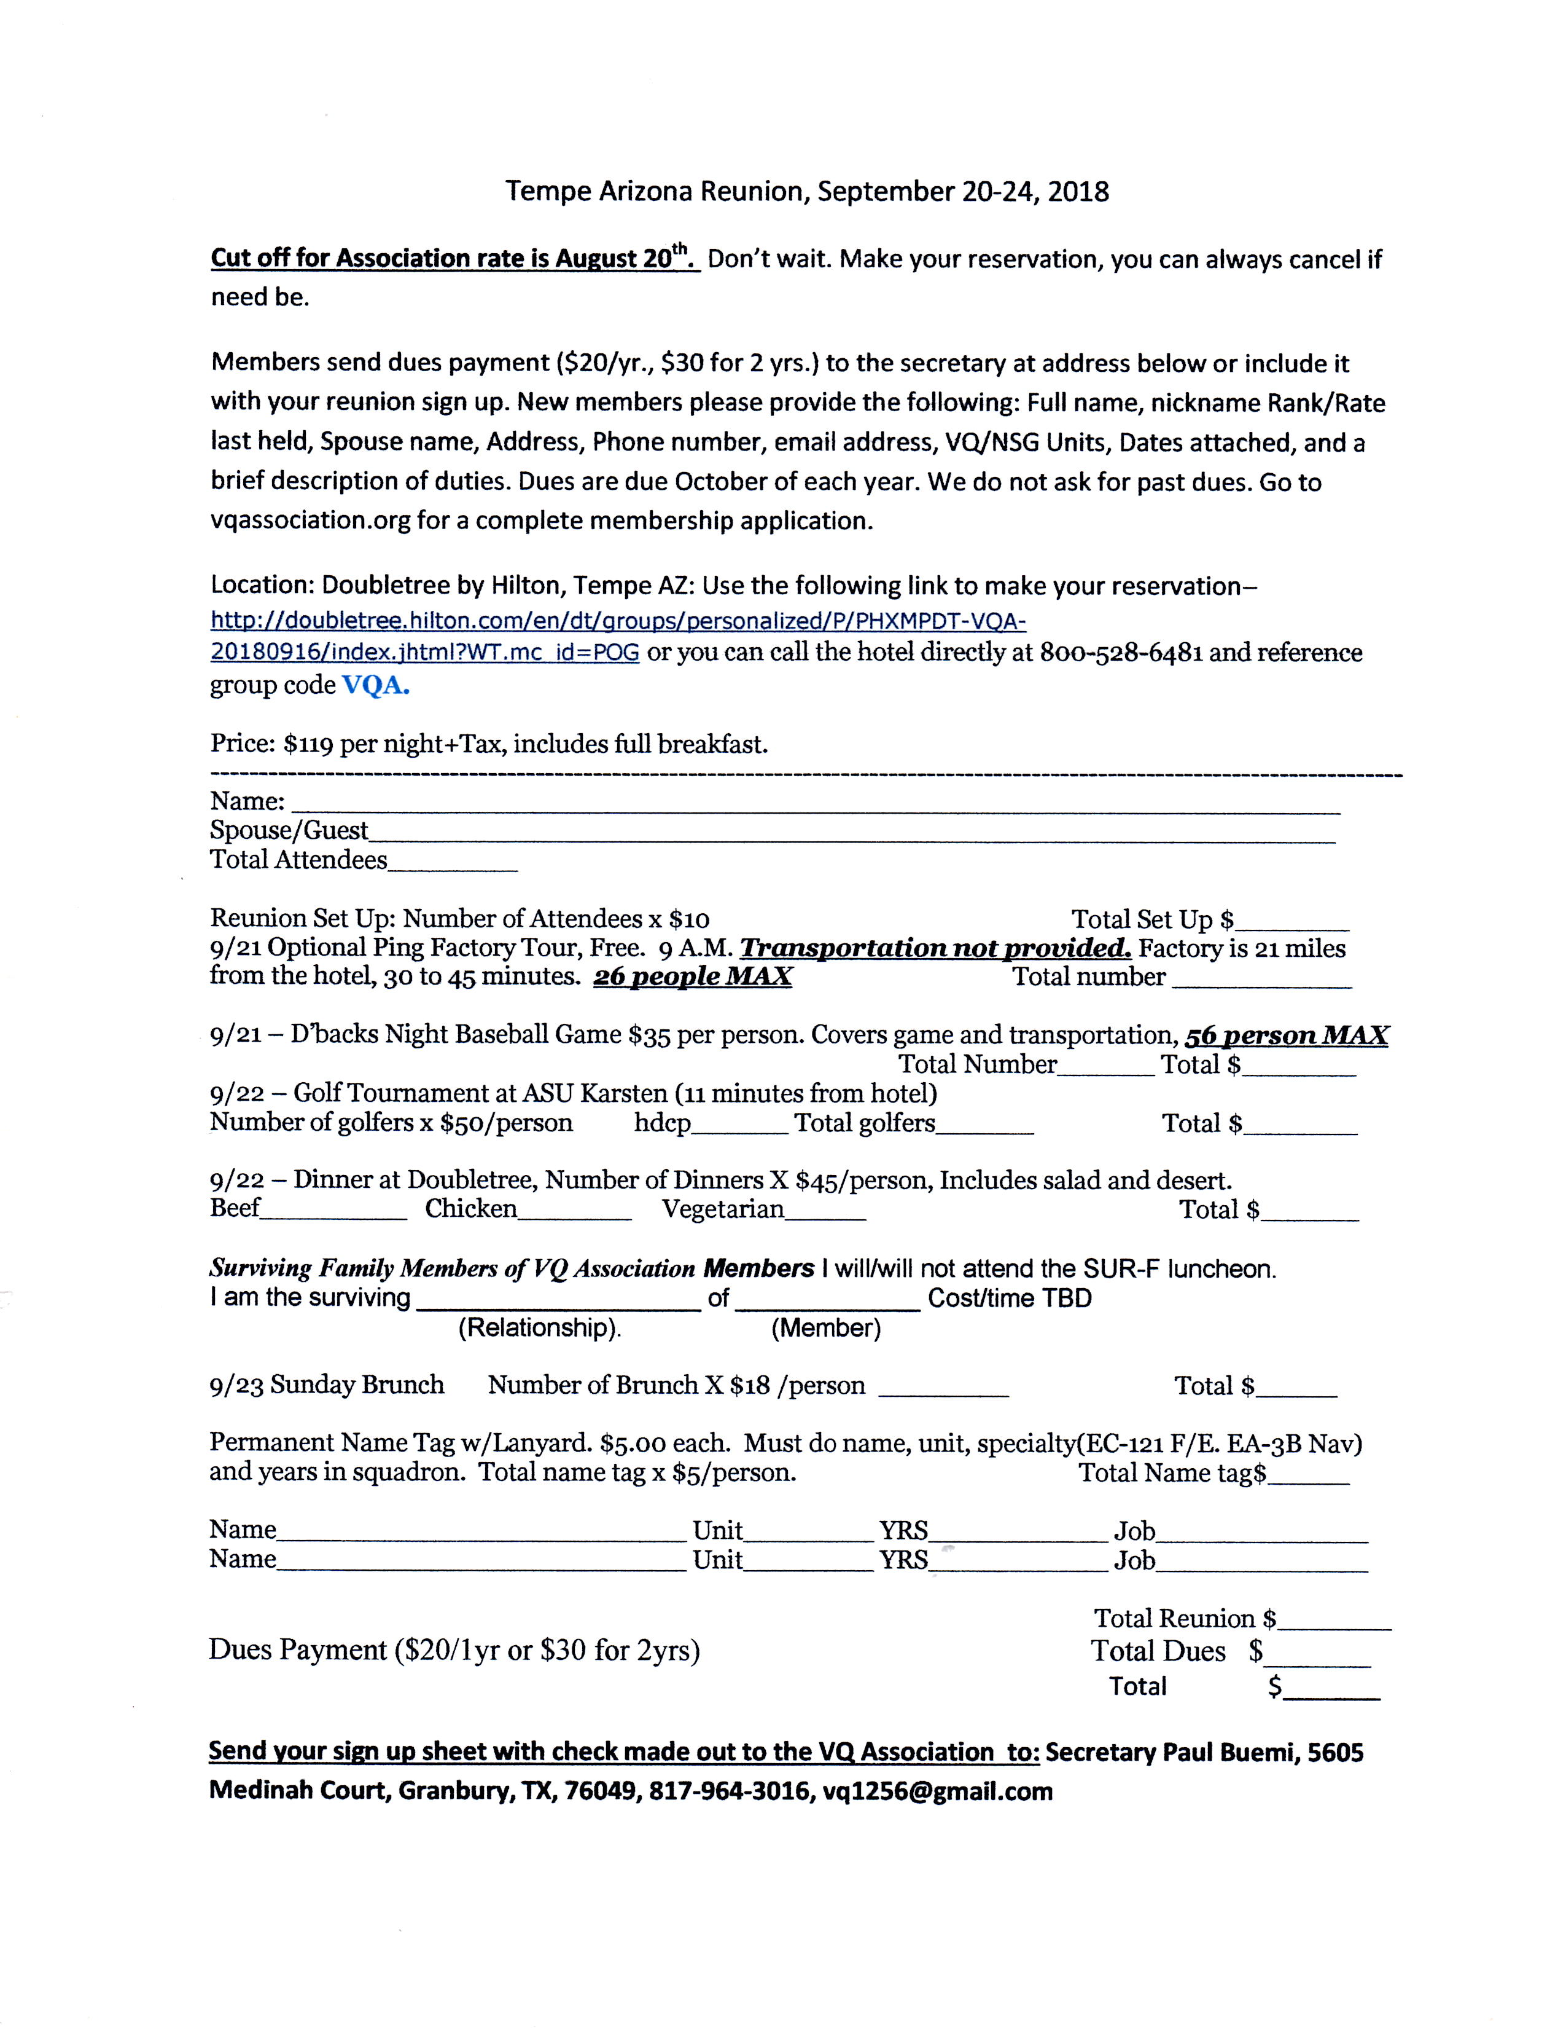
Page 6

*
* Note: Item # 121 should be $2.00, not $12.00
Page 7

VQ Association Reunion, Tempe, AZ
September 20-23, 2018

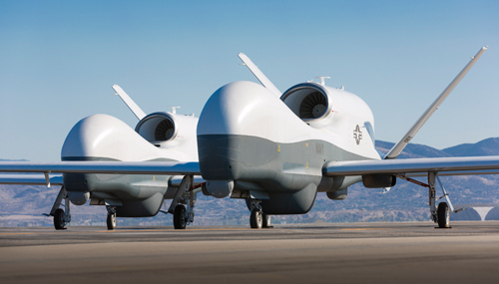
PR-1 and 2? (see inside article)

